IEEE TRANSACTIONS ON IMAGE PROCESSING, VOL. 9, NO. 8, AUGUST 2000
Landmark Matching via Large Deformation
Diffeomorphisms
Sarang C. Joshi and Michael I. Miller

Abstract—This paper describes the generation of large deformation diffeomorphisms

�� ��� ���
� for landmark matching generated as solutions to the transport equation
��
� �� ��
��
�� and �
�� � , with the image map defined as � �� and therefore controlled via the velocity field ��

�� 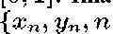 ��. Imagery are assumed characterized via sets of landmarks
�� � ���

. The optimal diffeomorphic match is constructed to minimize a running smoothness cost
� associated with a linear differential operator
on the velocity field generating the diffeomorphism while simultaneously minimizing the matching end point condition of the landmarks.

Both inexact and exact landmark matching is studied here. Given noisy landmarks

matched to
measured with error covariances 6
, then the matching problem is solved generating the optimal diffeomorphism � � 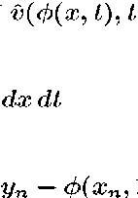

�� � ��

�

where
���������� �

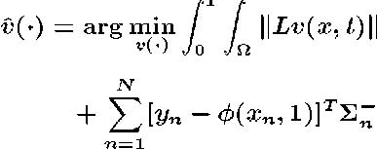 �
� � ��

� � � ���6 �� � ���

(1)

��
Conditions for the existence of solutions in the space of diffeomorphisms are established, with a gradient algorithm provided for generating the optimal flow solving the minimum problem. Results on matching two-dimensional (2-D) and three-dimensional (3-D) imagery are presented in the the macaque monkey.
Index Terms—Deformable templates, medical imaging, pattern theory.
I. INTRODUCTION

ECENT revolutionary advances in the field of medical imaging have facilitated digital imaging modalities such as magnetic resonance (MR), X-ray computed tomography (CT), and cryosection imaging (CI), to name a few, and are enabling extremally detailed study of anatomy. Although the study of anatomical variability can be traced back to the beginnings of modern science, the exquisite resolution and the three-dimensional (3-D) and four-dimensional (4-D) capabilities of these imaging modalities, combined with the advances in digital computation, is only now enabling the detailed and pre-

Manuscript received June 16, 1998; revised November 22, 1999. This work was supported by the NIH under Grants RO1-MH525158-01A1, RO1-NS35368-02, and NSF BIR-9 424264. The associate editor coordinating the review of this manuscript and approving it for publication was Prof. Glenn Healey.
S. C. Joshi is with the University of North Carolina, Chapel Hill, NC 27599 USA.
M. I. Miller is with the Center for Imaging Science, The Johns Hopkins Uni
versity, Baltimore, MD 21218 USA (e-mail: mim@cis.jhu.edu). Publisher Item Identifier S 1057-7149(00)05337-9.
cise computational study of the infinite biological variability of anatomy. This is emerging as the discipline that we are coming to call computational anatomy [1], [2] in which the main aim of our own work is to develop mathematical and software tools specialized to the understanding of the variability of brain anatomy in humans and primate monkeys [3]–[12].
The transformations

are constructed from the group of diffeomorphisms of the coordinate system , defined by vector fields of displacements

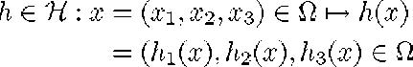
Within the framework of computational anatomy, the single most important component is the generation of large deformation diffeomorphisms. Given any two anatomical images

assumed to be in the same homogeneous anatomy (see [2]) compute a diffeomorphism from one anatomy to the other:
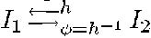 . In our work, not only are the global structures of deep nuclei important but as well we study the differential geometric features associated with the finest geometric structures including sulcal trajectories and cortical folds. Notions such as Riemannian length, Gaussian curvature, and surface area measures of highly complex folded structures are at the heart of our investigative work and others [13]. Methods which allow for the quantitative study of shape associated with Riemannian lengths, curvatures, and surface area measures are of crucial importance. It is therefore natural to organize the transformations around the continuum, emphasizing the properties of diffeomorphisms as they map the various tangent spaces and curvature features of the embedded submanifolds.

The approach is motivated by the image matching problem formulated via flows previously by Rabbitt and Christensen and posed as a control formulation in Dupuis et al. [12]. The basic protocol [5] followed for generation of the registration maps employs a hierarchy of transformations “increasing” the dimensionality successively via the fusion of landmark and image matching. Low-dimensional, nonrigid, coarse registration including the affine motions of global scale, rotation and translation, proceeds to high-dimensional, fine image matching registration resulting in the final maps [1]. One of the fundamental limitations of our previous application of the compositional approach is that the landmark matching was based on small deformation kinematics, implying it will not necessarily produce a diffeomorphism. Therefore, the ultimate goal of forming a group cascade as championed by Matejic [14] might not succeed as landmark matching will not in general provide diffeomorphisms. This is the principal focus of this paper, to extend

1057–7149$10.00 © 2000 IEEE

