Computer Vision
Comp 256, Fall 2003
Marc Pollefeys

Assignment 2
Epipolar Geometry and Stereo
(due date: 22/10/2003)

The goal of this assignment is to make yourself familiar with some of the concepts of epipolar geometry and stereo. You will use the image pair shown below throughout the assignment. The first step consists of computing the epipolar geometry. Then, the image pair has to be rectified and finally stereo matching can be performed between the rectified image pairs. These images and some results, as obtained from our Shape-from-Video pipeline, can be found in stereodata.tgz (on the course homepage).

As with previous assignment, I would like you to write a report describing your experiments. Performing the basic assignment gets you 7 out of 10 points, creativity can buy you extra points.

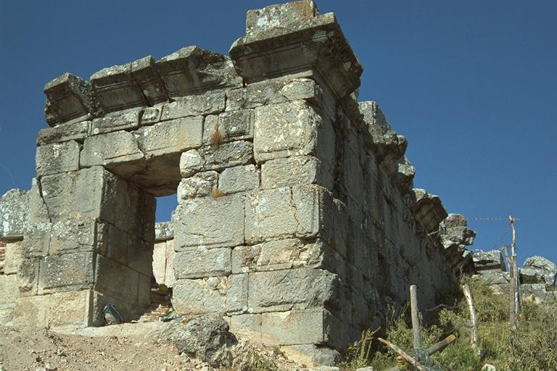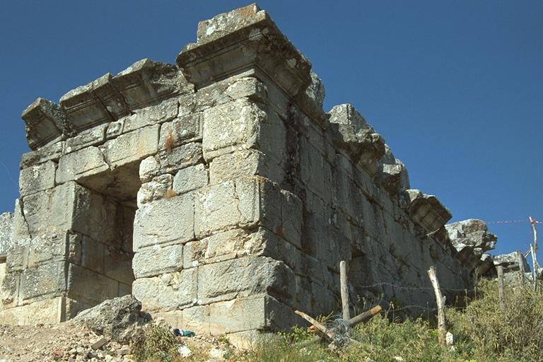

To compute the epipolar geometry, extract 8 or more corresponding points from those images (8 points will probably not be sufficient to yield accurate results, report your observations). You can extract these by hand. Remember to follow Hartley’s suggestion to normalize the data, to obtain reasonable results with the simple linear algorithm.
(include a pair of images with the features you used and corresponding epipolar lines overlaid -for both images- in the report).

Next, compute rectifying homographies between the two views and apply those to the images. Verify that the epipolar correspondence is satisfied for the full image (give special attention to details that are at different depths). If the epipolar geometry is too bad, return to step one and add some corresponding points where the error is the largest.
(include those rectified images in the report, can you tell something about the way I moved in between taking those two pictures?)

The final step of this assignment consists of performing stereo matching. The goal is to write your own simple stereo algorithm (there are many stereo algorithms available on-line, but I want you to write it yourself). For every pixel in one image, take a small window around it and compare it to potential matches (think disparity range, check what the actual range is in the images) in the other image. Select the match that yields the highest similarity score. You can for example use Sum-of-Square-Differences (SSD) or zero-mean normalized cross-correlation (ZNCC). You can perform this in both directions and check for consistency. Experiment with different correlation window sizes, report. You can store stereo results in disparity images, invalidate matches that are not consistent through left-right/right-left verification. Show those in your report.

For extra points you can reconstruct a depth map (range image) from the disparities and also produce a 3D model.

Good luck, Marc

PS: If you are interested to know, this is the corner of the roman baths in the ruins of the ancient city of Sagalassos in Turkey. The city is located high up on a mountain flank and was abandoned in the 6-7 century AD after earthquakes had disrupted the cities economy. What you see is not a door, but a second floor window. This was almost the only part of the building that was visible a few years ago. However, now, after several years of excavation, it is clear that Sagalassos had a monumental complex of Roman baths with several cold and warm water baths. What makes it different from other ancient thermae is that the baths are on the second floor, so that the first floor has impressive vaulted ceilings that even today would take tons of dynamite to get through.

