Collaborative Applications
Prasun Dewan
UNC-Chapel Hill

Abstract
Several useful collaboration applications have been developed recently that go beyond the email, bulletin board, videoconferencing, and instant messaging systems in use today. They provide novel support for threading in mail, chat, and bulletin boards; temporal ordering of chat conversations; graphical, mediated, and synchronous chat; variable-grained, multimedia annotations; document-based notifications; automatic presence, location and availability identification; automatic camera placement and video construction in lecture presentations and discussion groups; and compression and browsing of stored video.

Introduction
This chapter surveys some of the recent papers on successful collaborative applications. There are at three related reasons for doing this survey. First, it provides a concise description of the surveyed work. Second, in order to condense the information, it abstracts out several aspects of the work. In addition to reducing detail, the abstraction can be used to identify related areas where some research result may be applied. For example, discussions of lecture videos and research articles are abstracted to discussion of computer-stored artifacts, which is used to present flexible document browsing as a possible extension of flexible video browsing. Finally, it integrates the various research efforts, showing important relationships among them. It does so both by abstracting and by making explicit links between the surveyed papers so that they together tell a cohesive story. The integration is a first step towards a single, general platform for supporting collaboration.

This chapter is targeted at beginners to the field of collaboration who would like to get a flavor of the work in this area, practitioners interested in design, implementation and evaluation ideas, and researchers interested in unexplored avenues. It focuses on the semantics and benefits of collaborative applications, without looking at their architecture or implementation, which are discussed elsewhere (Dewan 1993; Dewan 1998).

Dual Goals of Collaborative Applications
There are two main reasons for building collaborative applications. The popular reason is that it can allow geographically dispersed users to collaborate with each other in much in the same way co-located ones do by trying to mimic, over the network, natural modes of collaboration, thereby giving the collaborators the illusion of “being there” in one location. For instance, it can support video conferencing. However, (Hollan and Stornetta May 1992) have argued that for collaboration technology to be really successful, it must go “beyond being there” by supporting modes of collaboration that cannot be supported in face to face collaboration. A simple example of this is allowing users in a meeting to have private channels of communication. We first discuss technology (studied or developed by the surveyed work) for mimicking natural collaboration, and then technology for augmenting/replacing natural collaboration. Sometimes the same technology supports both goals – in that case we first discuss those aspects that support the first goal and then those that support the second goal. Unless otherwise stated, each of the discussed technologies was found, in experiments, to be useful. Thus, failed efforts are not discussed here, though some of them are presented in the surveyed papers.

Towards Being There: Mimicking Natural Collaboration
Perhaps the simplest way to transport people to the worlds of their collaborators is to provide audio-based collaboration through regular phones. The most complex is to support telepresence through a “sea of cameras” that creates, in real-time, a 3-D virtual environment for remote participants. The surveyed work shows several intermediate points between these two extremes.

Single audio/video stream transmission.
The video and audio of a site is transmitted to one or more remote sites, allowing a meeting among multiple sites (Jancke, Venolia et al. 2001). This technology can be used to support meeting between remote individuals or groups. An example of this is video walls, an implementation of which has been recently evaluated to connect three kitchens. In addition to the two remote kitchens, the screen also shows the image captured by the local camera, and an image (such as a CNN program) that attracts the attention of the local visitors to the kitchen. This technology was found to be moderately useful, enabling a few of the possible spontaneous collaborations.

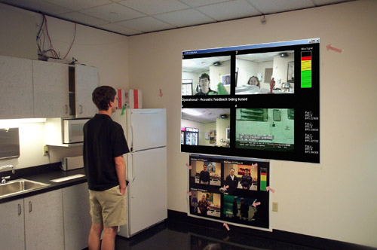
The possible collaborations could increase if the kitchen videos were also broadcast to desktops. On the other hand this would increase privacy concerns as it results in asymmetric viewing – the kitchen users would not be able to see the desktop users and thus know who was watching them.

This technology was developed to support social interaction, but it (together with the next two technologies, which improve on it) could just as well support distributed meetings, as many of them involve groups of people at different sites collaborating with each other (Mark, Grudin et al. 99).

Figure 1 Connected Kitchens (Jancke, Venolia et al. 2001)

Overview + speaker
When the meeting involves a remote group, the above technique does not allow a remote speaker to be distinguished from the others. Moreover, if a single conventional camera is used, only members of the group in front of the camera will be captured. In (Rui, Gupta et al. 2001), an omni-directional camera (consisting of multiple cameras) sends an overview image to the remote site. In addition, a shot captured by the camera, whose position can be determined automatically by a speaker detection system or manually by the user, sends the image of the current speaker to the remote site (Figure 2). A button is created at the bottom for each participant that can be pressed to select the person whose image is displayed as the speaker.

A simple approach to detecting the speaker is to have multiple microphones placed at different locations in the room, and use the differences between the times a speaker’s voice reaches the different microphones. For example, if each person has his own microphone, that microphone would receive the audio first, and thus would indicate the location of the speaker. More complex triangulation techniques would be necessary if there is not a one to one mapping between speakers and microphones – for example if there was a fixed size microphone array in the room.

Multipoint Lecture
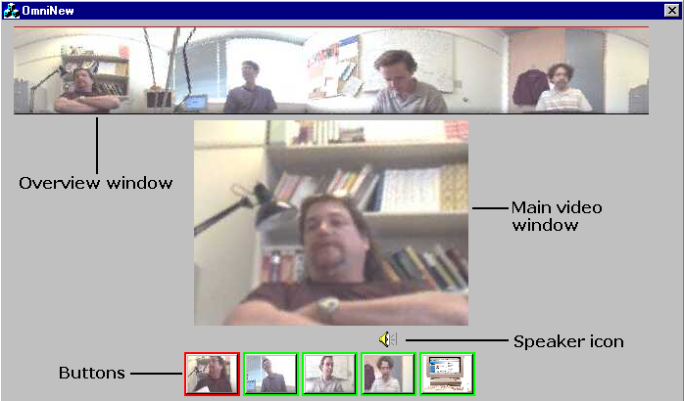
Neither of the techniques above can accommodate multiple remote sites. In the special case of a lecture to multiple remote sites, the following configuration has been tested (Jancke, Grudin et al. 2000). In the lecture room, a large screen shows a concatenation of representations (videos/images/text descriptions) of remote participants. Remote participants can ask questions and vote. Information about their vote and whether they are waiting for questions is attached to their representations. The lecturer uses audio to communicate with the remote attendees, while the latter use text to communicate with the former. The current question is also shown on the large screen.
Figure 2 Overview, speaker and persons selection buttons (Rui, Gupta et al. 2001)
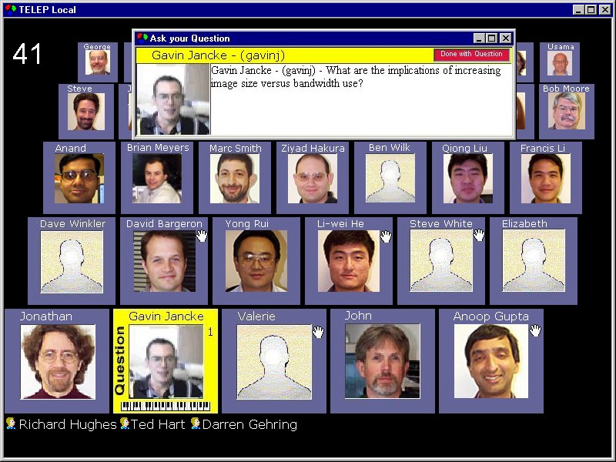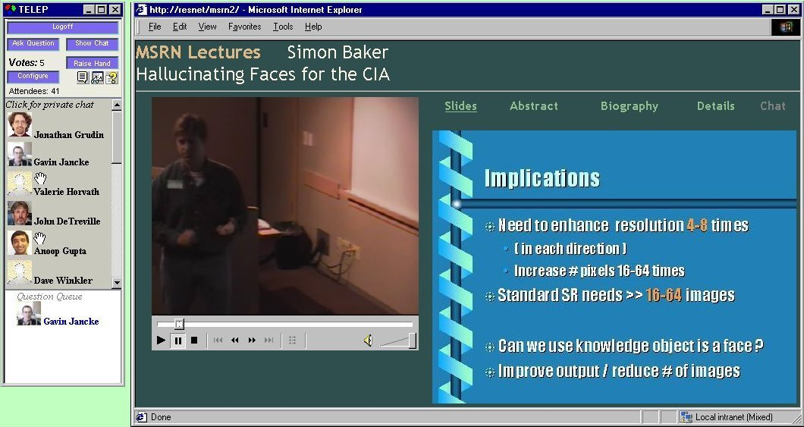

Figure 3: Display at lecture (left) and remote site (right) (Jancke, Grudin et al. 2000)
Each of the desktops of the remote sites shows images of the speaker and the slides (Figure 3, right window). Similarly representations of the remote audience members are shown, together with their vote status in a scrollable view at the lecture site (Figure 3, left window). So far, experience has shown that questioners never queue up – in fact questions are seldom asked from remote sites.

Video-production based lecture
Unlike the previous scheme, (Liu, Rui et al. 2001) and (Rui, Gupta et al. 2003) show the local audience to the remote participants. The same screen region is used to show both the audience and the lecturer. This region is fed images captured by a lecturer-tracking camera; an audience-tracking camera, which can track an audience member currently speaking; and an overview camera, which shows both the audience and the speaker.

The following rules, based on practices of professional video producers, are used to determine how the cameras are placed, how their images are multiplexed into the shared remote window, and how they are framed
- Switch to speaking audience members as soon as they are reliably tracked.
- If neither an audience member nor the lecturer is currently being reliably tracked, show the overview image.
- If the lecturer is being reliably tracked and no audience member is speaking, occasionally show a random audience member shot.
- Frame the lecturer so that there is half a head room above him in the picture.
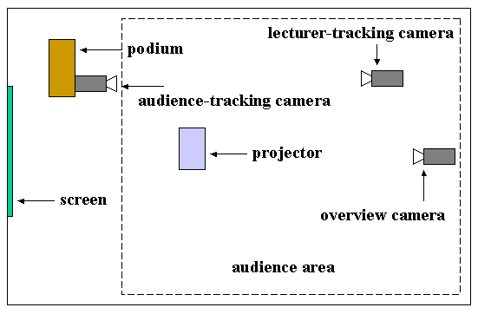
- The time when a particular shot (which depend on the current camera and its position) is being displayed should have a minimum and maximum limit, which depend on the camera. The above rule helps in satisfying this rule.
- Two consecutive shots should be very different, otherwise a jerky effect is created.
- Start with a shot of the overview camera.
- Place the lecturer-tracking camera so that any line along which he moves is not crossed by the camera tracking him, that is, always show a moving lecturer from the same side (Figure 4).
- Similarly, place the audience-tracking camera so that a line connecting the lecturer and a speaking audience member is never crossed (Figure 4).
Figure 4: Cameras and their placement (Liu, Rui et al. 2001)

Slides Video vs. Application Sharing
There are two ways of displaying slides remotely: One is to transmit a video of the slides, while the other is to allow the remote site to share the application displaying the slides. The projects described above have taken the first approach, which has the disadvantage that it consumes more communication bandwidth, and is thus more costly. Researchers have also investigated sharing of Power Point slides using NetMeeting(Mark, Grudin et al. 99). Their experience identifies some problems with this system/approach:
- Homogeneous computing environment: The groups studied used different computers. NetMeeting does not work well with screens with different resolutions and the time of the study did not work on Unix platforms. Thus, special PCs had to be bought at many sites, especially for conference rooms, to create a uniform computing environment, and managers were reluctant to incur this cost.
- Firewalls: Special conference servers had to be created that bridged the intranet behind the firewall and the internet.
- 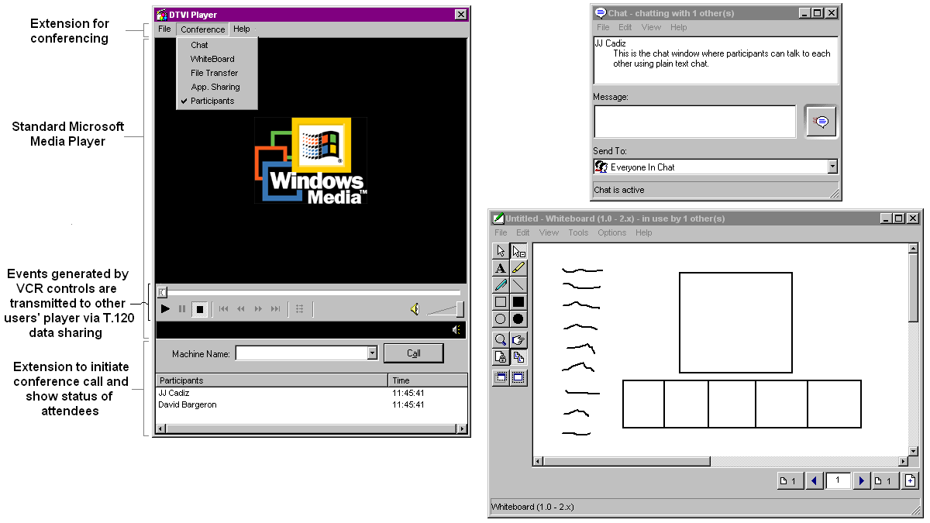Heavyweight: The extra step required by this approach of creating and maintaining a shared session was a serious problem for the users, which was solved in some sites by having special technical staff responsible for this task.
- Delay: It often took up to 15 minutes to set up a shared session and sometimes as much as 30 minutes, a large fraction of the meeting time.
Despite these problems, people preferred to use NetMeeting from their buildings rather than travel. Moreover, application sharing provides several features such as remote input not supported by video conferencing. Nonetheless, the above findings show several directions along which application sharing can be improved.

One example where remote input is useful is collaborative viewing (and discussion) of a video, which has been studied in (Cadiz, Balachandran et al. 2000). Figure 5 shows the interface created to support this activity.
Figure 5 Collaborative Video Viewing (Cadiz, Balachandran et al. 2000)
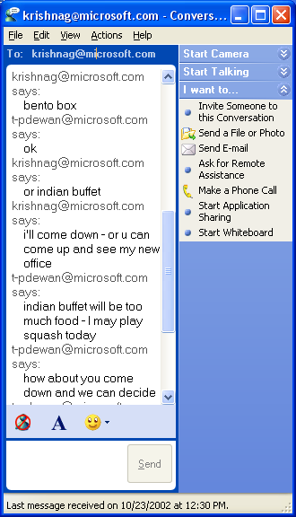
The video windows of all users are synchronized, and each user can execute the VCR controls such as stop, play, rewind, and fast forward.

State-of-the-art Chat
So far, we have looked at primarily audio/video interfaces for communication among collaborators. Chat can also serve this purpose, as illustrated by the questioner’s text message displayed in Figure 3. It is possible to have more elaborate chat interfaces that show the whole history of the conversation. Figure 6 shows an actual use of such an interface between t-pdewan and krishnag for scheduling lunch. It also shows a serious problem with such interfaces – the conversing parties can concurrently type messages without being aware of what the other is typing, leading to misinterpretation. In this example, it seems that that t-pdewan’s message asking krishnag to come down to his office was a response to the question the latter asked him regarding where they meet. In fact, these messages were sent concurrently, and had t-pdewan seen krishnag’s concurrent message, he would indeed have gone up – a different outcome from what actually happened.
Figure 6 Misleading concurrent input in chat

Horizontal Time Line
This is a well-recognized problem. Flow Chat (Vronay, Smith et al. 99), shown in Figure 7, addresses it using two techniques.
- To allow users typing concurrently to view each other’s input, it display’s a user’s message to others, not when it is complete, as in the previous picture, but as it is typed. The color of the text changes in response to the user pausing or committing the text.
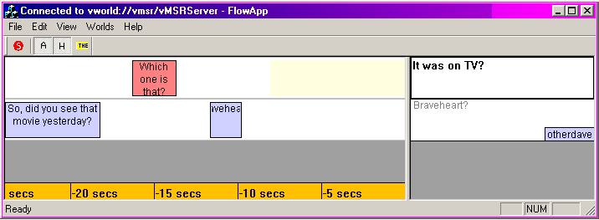
- To accurately reflect the sequencing of user’s input in the history, it shows the conversation on a traditional time line. Each message in the history is put in a box whose left edge and right edges corresponds to the times when the message was started and completed, respectively. The top and bottom edges fit in a row devoted to the user who wrote the message. Next to the row is text box that can be used by the user to enter a new message. The contents of the message are shown in the time line after it is finished. However, a box with zero width is created in the time line when the message is started, whose width is increased as time passes.
Figure 7 Horizontal time line in Flow Chat (Vronay, Smith et al. 99),
The first technique would have prevented the two users of the Figure 6 from misunderstanding each other, and the second one would have prevented a third party observing the conversation history from misunderstanding what happened.

Vertical Time Line
A scrolling horizontal time line uses space effectively when the number of users is large and the conversations are short. When this is not the case, the dual approach of creating vertical time lines can be used (Vronay 2002), which is implemented in Freeway (Figure 8). Each user now is given a column, which consists of messages that “balloon” over the user’s head as in cartoons. The balloons scroll or flow upwards as new messages are entered by the user.

Supporting large number of users
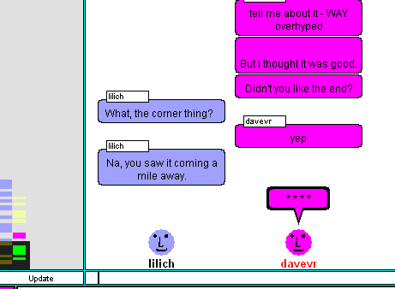Neither Flow Chat nor Freeway, as described above, is really suitable for a very large number of users (greater than 10), for two reasons:
- It becomes distracting to see other users’ input incrementally when a large number of users are typing concurrently, possibly in multiple threads of conversation.
- There is too much vertical (horizontal) space between messages in the same thread if the rows (columns) of the users participating in the thread are far way from each other in the horizontal (vertical) time line. The likelihood of this happening increases when there are a large number of users.

Figure 8 Vertical time line in Freeway (Vronay 2002)
Freeway addresses the first problem by not showing incremental input. Instead, it only shows a placeholder balloon with stars, which get replaced with actual text when the message is committed. Both Flow Chat and Freeway address the second problem by allowing users to move near each other by adjusting their row and column numbers, respectively. However, users did not use this feature much because of the effort required, which motivates research in automatic row/column management.

Graphical Chat
Making one’s row or column near another user’s corresponds to, in the real world, moving closer to a person to communicate more effectively. V-Chat (Smith, Farnham et al. 2000) better supports this concept by supporting avatars in a chat window (Figure 9). Users can move their avatars in a 3-D space. Users can communicate with users whose avatars are within the lines of site of their avatars. They can also make their avatars perform gestures to express anger, shrugs, flirting, sadness, smiles, silliness, and waves. This concept has not been integrated with time-lines, but could conceivably. Users close to each other in the graphical space could be placed in nearby rows/columns. Studies indicate that users conversing with each other automatically move their avatars close to each other.

The discussion in this section started with video-based communication and ended with text-based communication. This is just one way in which the range of technologies supporting “being there” can be organized in a logical progression. There are other effective ways of doing so. For example, in (Chidambaram and Jones 1993), these technologies are placed on a continuum from lean media such as text to rich media such as face-to-face interaction.

Beyond Being There: Augmenting Natural Collaboration
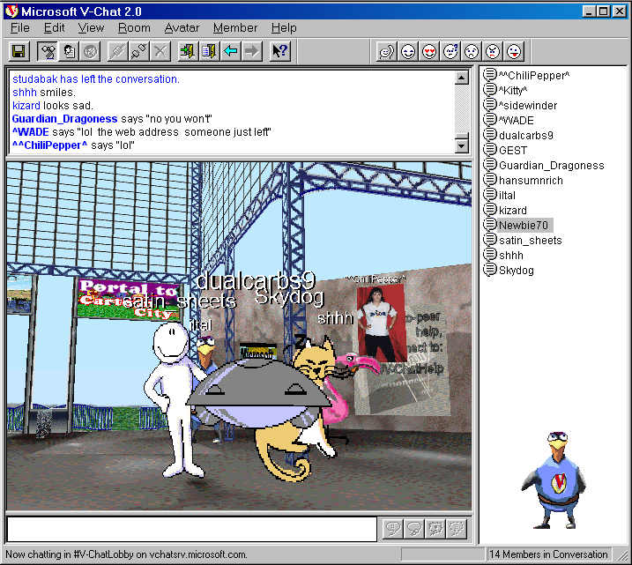
So far, we have looked at how natural collaboration can be approximated by collaboration technology. As mentioned before, a dual goal of such technology is to support modes not found in face-to-face collaboration. As (Grudin 2002) points out, one must be careful in the ways we try to change natural collaboration, which has remained constant over many years and may well be tied to our fundamental psychology.

Anonymity
It is possible for collaborators to perform anonymous actions. This can be useful even in face-to-face collaboration. An example is studied in (Davis, Zaner et al. 2002), where PDAs are used to propose ideas anonymously to the group, thereby allowing these ideas to be judged independently of the perceived status of the persons making them. In an experiment that studied the above example scenario, it was not clear, however, if perceived status did actual harm. The example, however, demonstrates an important example of use of small wireless computers in collaboration.
Figure 9 Avatars in V-Chat (Smith, Farnham et al. 2000)

Multitasking
Another example of augmenting natural collaboration is multi-tasking. For instance, a user viewing a presentation remotely can be involved in other activities, which should be a useful feature, given that, as we see below in the discussion of asynchronous meeting browsing, a live presentation is not an efficient mechanism to convey information – the time taken to make a presentation is far more than the time required to understand it. Thus, viewing with multitasking can be considered an intermediate point between focused viewing and asynchronous meeting browsing.

A study has found that remote viewers used multitasking frequently but felt that it reduced their commitment to the discussion and they were less engaged (Mark, Grudin et al. 99). The lack of engagement of some of the participants may not be a problem when they come with different skills. Experience with a multipoint lecture system (S. A. White, A. Gupta et al. 2000) shows this lack of engagement helped in corporate training as the more experience students could tune out of some discussions, and knowing this was possible, the lecturers felt more comfortable talking about issues that were not of general interest.

Control of Presence Information
A related feature not found in face to face collaboration is the absence of presence information about remote students. (Presence information about a person normally refers to data regarding the location, in-use computers, and activities of the person.) This is a well-liked feature. As shown in the TELEP figure (Figure 3), several remote students preferred to transmit static images or text rather than live video. On the other hand, lack of presence information was found to be a problem in other situations, as remote collaborators were constantly polled to determine if they were still there (Mark, Grudin et al. 99). This justifies a TELEP-like feature that allows users to determine if presence information is shown at remote sites.

A more indirect and automatic way to determine presence information, which works in a discussion-based collaboration, is to show the recent activity of the participants.

Meeting Browsing
Another way to augment natural collaboration is to relax the constraint that everyone has to meet at the same time. A meeting can be recorded, and then replayed by people who did not attend. The idea of asynchronously replaying meetings is not new: videotaping meetings achieves this purpose. (Li, Gupta et al. 2000) show it is possible to improve on this idea by providing a user interface that is more sophisticated than current video/media players.

Figure 10 shows the user interface. It provides several features missing in current systems:
- Pause removal control: All pauses in speech and associated video are filtered out.
- Time compression control: The playback speed is increased without changing the audio pitch. The speeded up video can be stored at a server or the client - the choice involves trading off flexibility in choosing playback speed for reduced network traffic (Omoigui, He et al. 99).
- Table of contents: This is manually generated by an editor.
- User bookmarks: A user viewing the video can annotate portions of it, which serve as bookmarks for later revisiting the video.
- Shot boundaries: These are automatically generated by detecting shot transitions.
- Flexible jump-back/next: It is possible to jump to a next/previous boundary/ bookmark/slide transition or to jump by a fixed time interval, using overloaded next and previous commands.
Pause removal and time compression were found to be useful in sports videos and lectures, where there is a clear separation of interesting and non-interesting portions, but not in carefully crafted TV dramas. Up to 147% playback speed was attained in the studies. Similarly, shot boundaries were found to be particularly useful in sports programs, which have high variations in video contents as opposed to lectures, which have low variations in video contents. The table of contents was found to be particularly useful in lecture presentations.

(He, Sanocki et al. 1999) explore two additional alternatives for summarizing audio/video presentations of slides:
- Assume that the time spent on a slide is proportional to the importance of the slide. Assume also that important things about a slide are explained in the beginning of the presentation of the slide. Summarize a slide by allocating to a slide a time at the beginning portion of the slide discussion whose length is proportional to the total time given to the slide by the speaker.
- Pitch-based summary: It has been observed that the pitch of a user’s voice increases when explaining a more important topic. Summarize a presentation by including portions associated with high-pitch speech.
Both techniques were found to be acceptable and about equally good though not as good as summaries generated by authors of the presentations.

(Cutler, Rui et al. 2002) explore two additional ways for browsing an archived presentation, which requires special instrumentation while the meeting is being carried out:
- Whiteboard content-based browsing: Users can view and hear the recording from the point a particular whiteboard stroke was created. This feature was found be moderately useful.
- Speaker-based filtering: Users can filter out portions of a video in which a particular person was speaking.

Figure 10 Browsing video (Li, Gupta et al. 2000)
(He, Sanocki et al. 2000) propose additional text-based summarization schemes applicable to slide presentations:
- Slides only: The audio/video of the speaker or the audience is not presented.
- Slides + text transcript: Same as above except that a text transcript of speaker audio is also seen.
- Slides + highlighted text transcript: Same as above except that the key points of the text transcript are highlighted.
For slides with high information density, all three methods were found to be as effective as author-generated audio/video summaries. For slides with low information density, the highlighted text transcript was found to be as effective as the audio/video summaries.

Divergent views and concurrent input
Yet another related feature is allowing collaborators to see different views of shared state and concurrently edit it. It allows users to create their preferred views, and to work on different parts of the shared state, thereby increasing the concurrency of collaboration. This idea has been explored earlier in several works (Stefik, Bobrow et al. April 1987; Dewan and Choudhary April 1991). It requires special support for concurrency control (Munson and Dewan November 1996), access control (Dewan and Shen Nov 1998; Shen and Dewan November 1992), merging (Munson and Dewan June 1997), and undo (Choudhary and Dewan October 1995), which are beyond the scope of this chapter.

Chat History
We have seen above what seems to be another example of augmenting natural collaboration – chat programs show the history of messages exchanged, which would not happen in the alternative of a face-to-face audio-based conversation. On the other hand, this would happen in a face-to-face conversation carried out by exchanging notes. Thus, whether the notion of chat history augments natural collaboration depends on what we consider is the alternative. The user interfaces for supporting it, however, can be far more sophisticated than that supported by note exchanges, as we see below.

Chat history can inform a newcomer to the conversation about the current context. However, it is not used much, because looking at it distracts users from the current context. Freeway addresses these problems in two ways:
- Snap back scrolling: It is possible to press a button and drag the scrollbar to any part of the history. When the button is released, the view scrolled back to the previous scroll position.
- Overview pane: Only a portion of the history is shown in the chat window. A miniature of the entire history is shown in a separate window (on the left in Figure 8). A rectangle marks the portion of the miniature that is displayed in the scroll window, which can be dragged to change the contents of the chat window. As before, at the completion of the drag operation, the chat window snaps back to its original view.

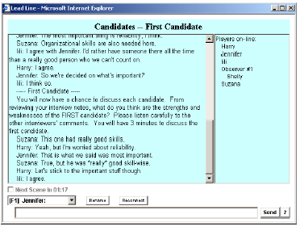
While users liked and used these features, newcomers still asked other participants about previous discussions rather than looking at the history. Therefore, more work needs to be done to make it effective. An important disadvantage of keeping a history that late comers can look at is that people might be careful what they say since they do not know who may later join the conversation (Grudin 2002). Thus, there should be a way to enter messages that are not displayed to late joiners, which brings up new user interface issues.

Scripted Collaboration
(Farnham, Chesley et al. 2000) show that another way to augment natural chat is to have the computer provide a script for the session, which suggests the discussion topics and how long each topic should be discussed. Figure 11 shows the use of a script to discuss interview candidates. The script automates the role of a meeting facilitator (Mark, Grudin et al. 99). It has been found to be useful. After using it automatically in a scripted discussion, users manually enforced its rules in a subsequent non-scripted interview discussion.

Figure 11 Scripted Collaboration (Farnham, Chesley et al. 2000)

Threaded Chat
A computer-provided script is one way of structuring a chat conversation. Threading the discussion is another method. As we saw in the chat discussion, in a large chat room, it is important to separate the various threads of discussion. Moving representations of communicating users close to each other is one way to achieve this effect, but does not work when a user is in more that one thread concurrently or the threads are hierarchical. Therefore, one can imagine a chat interface that supports bulletin-board-like threaded messages. (Smith, Cadiz et al. 2000) have developed such an interface, shown in Figure 12. A new chat message can be entered as a response to a previous message, and is shown below it after indenting it with respect to the latter. Independently composed messages are shown at the same indentation level and are sorted by message arrival times. Messages are thus arranged into a tree in which messages at the same indentation level as a message are its siblings and those immediately following it at the next indentation level are its children. A user responds to a message by clicking on it and typing new text. As soon as the user starts typing, a new entry is added at the appropriate location in the window. However, this entry does not show incremental user input. It simply displays a message indicating new text is being entered, which is replaced with the actual text when the user commits the input. Studies have shown that users pay too much attention to typing correctness when their incremental input is broadcast. In non-incremental input, they simply went back and corrected spelling errors before sending their message. It seem useful to give users the option to determine if incremental is input is transmitted or received in the manner described in (Dewan and Choudhary April 1991).

(Grudin 2002) wonders whether users should care about spelling errors in chat– it is meant to be an informal, lightweight alternative to email, which at one time was meant to be an informal alternative to postal mail. He points out that one of the reasons for using chat today is to escape from the formality of email, thus focusing on spelling issues may be counterproductive.

In comparison to a traditional chat interface, the interface, as described above, makes it difficult for the newcomer to determine what the latest messages are. This problem is addressed by fading the font of new items to grey.

Messages can be further characterized as questions, answers, and comments, which can be used in recording and displaying statistics about the kinds of chat messages, which are shown in a separate pane. The system automatically classifies the message depending on the presence of a question mark in it or its parent message (the message to which it is a response).

The basic idea of threads has been useful in bulletin boards – is it useful in the more synchronous chats supported by the interface above? Studies showed that, in comparison to traditional chat, the interface above required fewer messages to complete a task and resulted in balanced participation, though task performance did not change and users felt less comfortable with it. One reason for the discomfort may be the extra step required to click on a message before responding to it. Perhaps this problem can be solved by integrating threaded chat with the notion of moving one’s computer representation (avatar, column, or row) – a user moves to a thread once by clicking on a message in the thread. Subsequently, the most recent message or the root message is automatically clicked by default.
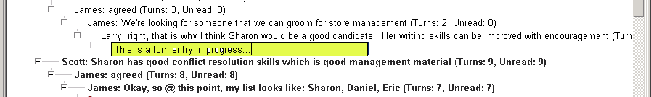
Figure 12 Threaded Chat (Smith, Cadiz et al. 2000)

Threaded Email
If threads can be useful in organizing bulletin boards and chat messages, what about email? It seems intuitive, at least in retrospect, that concepts from bulletin boards transfer to chat, because both contain messages broadcast to multiple users, only some of which may be of interest to a particular user. Moreover, in both cases, there is no notion of deleting messages. In contrast, all messages in a mail box are directed at its owner, who can delete messages. Are threads still useful?

This question is addressed by (Venolia, Dabbish et al.). They give four reasons for supporting threaded email. Threads keep a message with those related to it, thereby giving better local context. They also give better global context as the contents of the mailbox can be decomposed into a small number of threads as opposed to large number of individual messages. This is particularly important when a user encounters a large number of unread messages. Moreover, one can perform a single operation such as delete or forward on the root of a thread that applies to all of its children. Finally, one can define thread-specific operations such as “delete all messages in the thread and unsubscribe future messages in it,” and “forward all messages in the thread and subscription to future messages in it.” The first two reasons apply also to chat and bulletin boards. It would be useful to investigate how the above thread-based operations can be applied to bulletin boards and chat interfaces.

Venolia et al. designed a new kind of user interface, shown in Figure 13, to test threaded mail. It differs from conventional thread-based user interfaces in three related ways. First, it uses explicit lines rather than indentation to indicate child-parent relationship, thereby saving on scarce display space. Second, because it shows this relationship explicitly, it does not keep all children of a node together. Instead, it inter-mixes messages from different threads, ordering them by their arrival time, thereby allowing the user to easily identify the most recent messages. Third, it groups threads by day. Finally, for each thread, it provides summary information such as the users participating in it. Users have liked this user interface, specially the local context it provides. One can imagine porting some of its features, such as grouping by day or summary information, to chat and bulletin boards.

Yet another interface for threads has been developed by (Smith and Fiore 2001), which is shown in Figure 14. Like the previous interface, it shows explicit lines between parent and children nodes. The nodes, in the tree display, however, do not show the text of the messages. Instead, they are rendered as rectangular boxes giving summary information about the message. For example, a dotted box is used for a message from the author of the root post and a half shaded box for a message from the most prolific contributor. Clicking over a box displays the contents of the message in a different pane of the user interface. This interface allows the viewer to get a quick summary of the discussion and the people involved in it. It was developed for bulletin boards but could be applicable to chat and mail also.

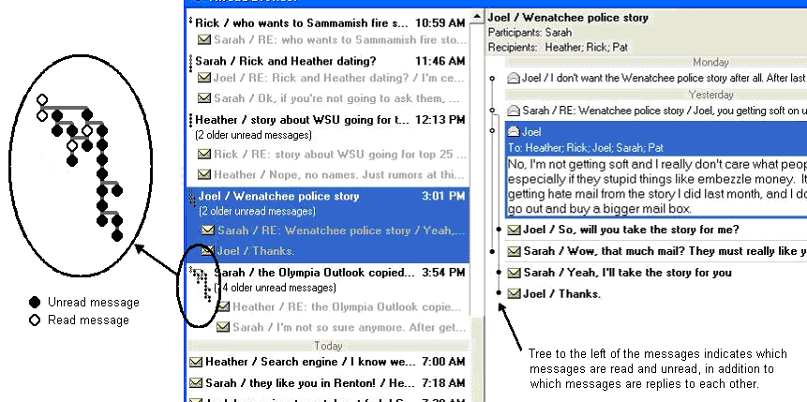

Figure 13 Threaded email (Venolia, Dabbish et al.)

Threaded Articles Discussions and Annotations
Chat, bulletin boards, and email provide support for general discussions. Some of these discussions are about documents. It is possible to build a specialized user interface for such discussions. Two examples of such an interface are described and compared by (Brush, Bargeron et al.). The first example links a document to the discussion threads about it. The second example provides finer-granularity linking, associating fragments of a document with discussion threads, which are essentially threaded annotations. The annotation-based system also provides mechanisms to summarize the whole document and make private annotations. The summaries, however, are not discussions and thus not threaded.

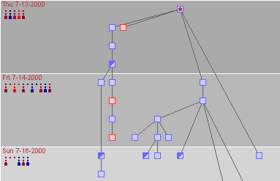
Studies comparing the user-interfaces, not surprisingly, found that the finer-granularity linkage allowed students to more easily make detailed points about the article, since they did not have to reproduce the target of their comment in their discussions, and thus created more comments. On the other hand, they had a slight preference for the coarser-granularity. One reason was that they read paper copies of the article, often at home, where they did not have access to the tool. As a result, they had to redo work when commenting. Second, and more interesting, the coarser-granularity encouraged them to make high-level comments about the whole article, which were generally preferred. The annotation-based system did not provide an easy and well known way to associate a discussion with the whole document. To create such an association, people attached the discussion to the document title or to a section header, which not elegant or natural to everyone.
Figure 14 Graphical overview of threads (Smith and Fiore 2001)

Variable-granularity annotations to changing documents
This problem is fixed by Office 2000 by allowing threaded annotations to be associated both with the whole document and a particular fragment (Figure 15). Like Bush et al, (Cadiz, Gupta et al. 2000) studied the use of these annotations, focusing not on completed (and, in fact, published) research articles, about which one is more interested in general comments indicating what was learnt, but on specification drafts, where more comments about fragments can be expected. Since specification drafts can (and are expected to) change, the following issue is raised: When a fragment changes, what should happen to its annotations, which are essentially now “orphans”? As indicated in Figure 15 (right, bottom window), orphan annotations are displayed with annotations about the whole document.

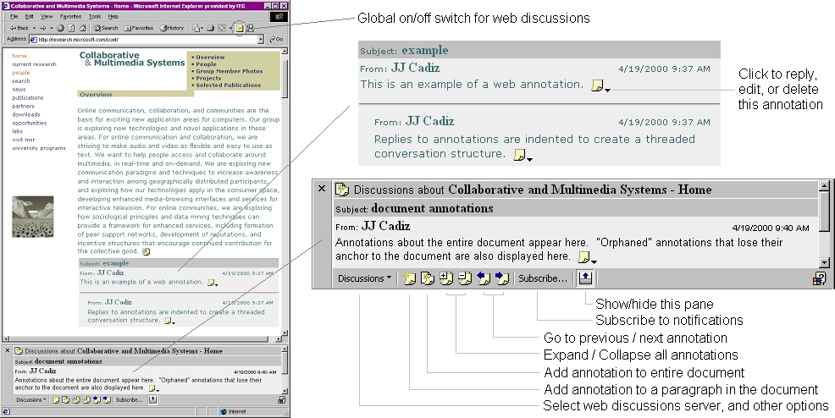
Figure 15 Variable-grained annotations with orphaning (Cadiz, Gupta et al. 2000)
Annotations are an alternative to the more traditional channels of commenting such as email, telephone, or face-to-face meetings. However, the latter provide not only a way to send comments but also a mechanism to notify concerned parties about the comment. To make annotations more useful, automatic notifications, shown in Figure 16, were sent by email when documents were changed. Users could decide on the frequency of notification sent to them.

To what extent would people really use annotations over the more traditional commenting channels? In a large field study carried over ten months, Cadiz et al. found there was significant use with an average of 20 annotations per person. Interestingly, users did not make either very high-level comments (since the author would probably not get it) or very nitpicky comments such as spelling mistakes (since most would not be interested in it.) Moreover, they continued to use other channels when they needed immediate response, since delivery of notifications depended on subscription frequency and thus was not guaranteed to be immediate. Furthermore, they felt that the notifications did not give them enough information – in particular, the content of the annotation. In addition, a person making a comment does not know who is subscribing to notification that is automatically generated, and often ends up manually sending email to the subscribers. Finally, a significant fraction of people stopped using the system after making the first annotation. One of the reasons given for this is that they did not like orphan annotations losing their context.
The following change(s) happened to the document http://product/overview/index.htm:

Event: | Discussion items were inserted or modified in the document
By: | rsmith
Time: | 7/28/99 11:01:04 AM
Event: | Discussion items were inserted or modified in the document
By: | ajones
Time: | 7/28/99 12:09:27 PM

Click here to stop receiving this notification.

Figure 16 Automatically generated notification (Cadiz, Gupta et al. 2000)
A fix to the lack of nitpicky comments may be to create special editor-like annotations for document changes, which could be simply applied by the authors, who would not have to retype the correction. In fact, these could be generated by the “annotator” editing a copy of the document or a fragment copied from the document in the spirit of live text (Fraser and Krishnamurthy August 1990). Users may still not be willing to put the effort into making such comments because in this shared activity the person making the effort is not the one who reaps its fruits, a problem observed in organizations (Grudin 2001). We see below fixes to other problems mentioned above.

Robust annotations
A simple way to address the orphan annotation problem seems to be to attach them to, not the whole document, but the smallest document unit containing the fragment to which they are originally attached. (Brush, Bargeron et al. 2001) discuss a more sophisticated algorithm that did not orphan an annotation if the fragment to which it was attached changed in minor ways. More specifically, it saved a deleted fragment, cut words from the back and front of it until it was partially matched with some fragment in the changed document or it was less than 15 characters long. In case of match, It attached annotations of the deleted fragment to the matched fragment. In lab studies, users liked this algorithm when the difference between the original and matched fragment was small and not when it was large. The authors of PREP have had to also wrestle with the problem of finding corresponding pieces of text in documents, and have developed a sophisticated and flexible diffing (Neuwirth, Chandok et al. October 1992) scheme to address this problem. It seems useful and straightforward to apply their algorithm to orphan annotation problem. The users of the annotation system suggested a more intriguing approach – identify and use keywords to determine corresponding text fragments.

It useful to provide threaded annotations for not only documents, but also other objects such as lecture presentations, as shown in (Bargeron, Gupta et al. 99; Bargeron, Grudin et al. 2002). A discussion is associated not with a fragment of a document, but a point in the video stream and the associated slide, as shown in Figure 17. Similarly, it may be useful to create annotations for spreadsheets, programs, and power point slides.

However, as we see here, separate kinds of annotation-/thread- based mechanisms exist for different kinds of objects with. For example, as we saw in the section of video browsing, it is useful to create a flexible overloaded Next commands for navigating to the next annotation, next section, and in general, the next unit, where the unit can change. Such a command could be useful for navigating through documents also. Thus, it would be useful to create a single, unified annotation/thread- based mechanism.

Notifications
Consider now the issue of notifications about document comments. As mentioned before, the Web Discussions notification scheme describe above was found to have several problems. (Brush, Bargeron et al.) made some modifications to address these problems. They allowed an annotation maker to determine who will receive notifications about it, thereby saving on duplicate mail messages. They also generated notifications that were more descriptive, giving the comment, identifying the kind of annotation (reply or comment), and in case of a reply, giving a link to the actual annotation that can be followed to look at its context in the containing thread (Figure 18). As in Web discussions, these were sent as email messages

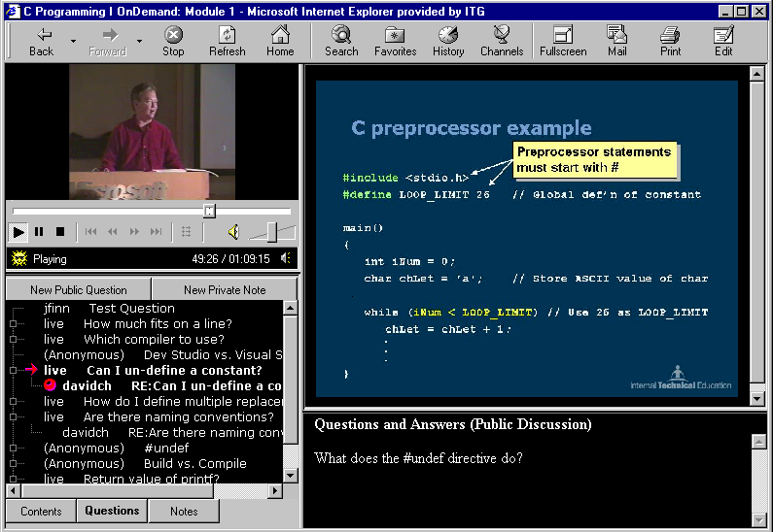
Figure 17 Annotating a Presentation (Brush, Bargeron et al.)
Sometimes, a user wished to continuously poll for information rather than receive a notification for each kind of change. Brush et al. supported this information awareness through a separate window, called a Slideshow (Cadiz, Venolia et al. 02) which was created for viewing all information about which the user was expected to have only peripheral awareness. The source of each piece of information was associated with an icon called a ticket, which appeared in the display of the source. A user subscribed to the source by dragging the ticket to the Sideshow (Figure 19(a)). When contained in the Sideshow, the ticket shows summary information about changes to the source. In the case of an annotated document, it shows the number of annotations and the number created on the current day (Figure 19(b), right window). When the mouse is moved over the ticket, a new window, called the tool tip window is displayed, which contains more detailed information, shown in Figure 19(b), left window. Studies found that users liked annotation awareness provided by the automatically emailed notifications and the Slideshow window. However, using them over Web Discussions did not seem to improve task performance.

It may be useful to integrate the two awareness mechanisms by inserting links or copies of the notifications that are currently sent by email into the tooltip window, thereby reducing the clutter in mail boxes. Another way to integrate the two is to not send notifications when it is known that the user is polling the tooltip window or the document itself. (Grudin 1994) observed that managers and executives who with the aid of their staff constantly polled the calendar found meeting notifications a nuisance. It is quite likely that spurious change notifications are as annoying. Perhaps the application-logging techniques developed by Horvitz et al, discussed later, can be adapted to provide this capability

Disruptions caused by messages
While a message (such as email, instant message, or document comment notification) about some activity improves the performance of that activity, it potentially decreases the performance of the foreground task of the person to whom it is sent. (Czerwinski, Cutrell et al. 2000) studied the effect of instant messages on the performance of two kinds of tasks: a mundane search task requiring no thinking and a more complex search task requiring abstract thinking. They found that the performance of the straightforward task decreased significantly because of the instant messages, but the performance of the complex task did not change. As society gets more sophisticated, the tasks they perform will also get more abstract, and thus if one can generalize the above results, messages will not have a deleterious effect. Nonetheless, it may be useful to build a mechanism that suppresses messages of low priority– especially if the foreground task is a mundane one.
This is an automatic notification. More information...
Click here to update your notification settings.
The changes that just occurred are:
On http://server/Notify.htm
colinb added a reply to a comment by duncanbb on 9/12/2001 3:20 PM
RE: test annotation
This is the text of an example annotation.
Click to update your notification settings.

Figure 18 A Descriptive Notification (Brush, Bargeron et al.)

Prioritizing Messages
(Horvitz, Koch et al. 2002) have built such a system for email. It prioritizes unread email messages and lists them by priority, as shown in Figure 20. The priority of a message is a function of the cost of delayed review, which is calculated based on several criteria including the organizational relationship with the sender, how near the sending time is to key times mentioned in messages scanned so far, the presence of questions and predefined phrases in the messages, tenses, and capitalization.
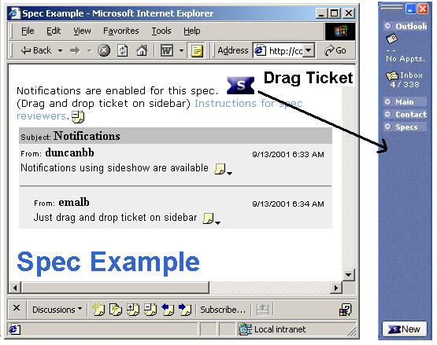
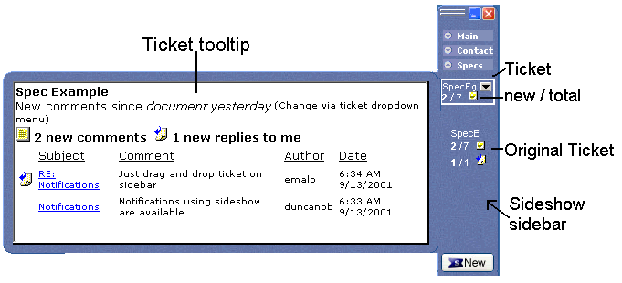
(b) Ticket displays number of annotations and replies.
The tooltip window shows details when a user mouses over the ticket
(a) Subscribe by dragging ticket to Sideshow
Figure 19: Slideshow continuous awareness (Brush, Bargeron et al.)

Automatic redirection of message and per device presence and availability forecasting
This prioritization is also used for determining which messages should be sent to a user’s mobile device. The goal is to cause disruption to the mobile user only if necessary. If the user has not been active at the desktop for a time greater than some parameter, and if the message has priority greater than some threshold, then the message can be sent to the mobile device. (These parameters can be set dynamically based on whether the user is in a meeting or not.) It would be even better if this is done only when the person is likely to be away for some time, a. A person’s presence in a location is forecast using calendar information for the period, if it exists. If it does not, then it can be calculated based on how long the user has been away from the office, log of the user’s activities for various days of the week and phases within the day such as morning, lunch, afternoon, evening and night. This information is used to calculate the probability of users returning within some time, r, given that they have been away for some time, a, during a particular phase of a particular day, as shown in Figure 21. It was found that this estimate was fairly reliable.
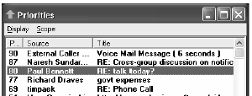
This (continuously updated) estimate can be used to automatically fill unmarked portions of a user’s calendar, as shown in Figure 22, which can be viewed by those who have access to it. In addition, it can be sent as “out of office email” response to urgent messages (Figure 24). One can imagine providing this information in response to other incoming messages such as invitation to join a NetMeeting conference.

Figure 20 Automatically prioritizing messages (Horvitz, Koch et al. 2002)
So far, we have assumed that users have two devices: their office desktop and mobile device. In general, they may have access to multiple kinds of devices. Horvitz et al. generate logs of activities for all of their devices, which are used to provide fine-grained presence information by device. With each device, the capabilities of the device are also recorded. This information can be used, for instance, to determine how long it will be before a user has access to a device allowing teleconferencing.
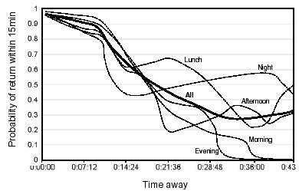
Presence, of course, is not the same as availability. For example, a user may have access to a teleconferencing device but not be available for the conference. Similarly, a user may be at the desktop but not be ready to read new email. Moreover, current availability is not enough to carry out some collaboration for an extended period of time. For example, a user who has returned to his office may not stay long enough to carry out the collaboration. Horvitz et al. address these problems also, that is, they try to forecast continuous presence (for some period of time) and availability. For instance, they can forecast the likelihood that a person will return to his office for at least 15 minutes given that he has been away for 25 minutes (Figure 23).

Figure 21 Probability of returning within 15 minutes (Horvitz, Koch et al. 2002)
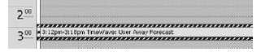
Predictions about continuous presence and availability of a person are made by reading calendars, monitoring attendance of scheduled meetings based on meeting kind, tracing application start, focus, and interaction times, and allowing users to set interruptability levels. For example, monitoring application usage can be used to predict when a person will next read email. Similarly, the probability a person will actually attend a scheduled meeting depends on whether attendance is optional or required, the number of attendees, and if it is a recurrent meeting, the person’s history of attending the meeting.
Figure 22 Presence prediction in shared calendar (Horvitz, Koch et al. 2002)
One potential extension to this work is to use information about deadlines to determine availability. For example, I do not wish to be interrupted an hour before class time or the day before a paper or proposal deadline. Information about deadlines could be determined from the
- calendar – the beginning of a meeting is a deadline to get things prepared for it,
- to-do lists, if they list the time by which a task has to be done,
- project tracking software,
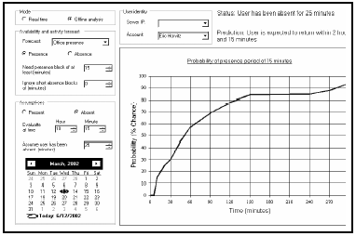
- documents created by the user, which may have pointers to dates by which they are due. For example, an NSF electronic proposal contains the name of the program to which it is being submitted, which can be used to find on the web the date by which it is due.
Another possible extension is to use application logging to determine if a notification should actually be sent or not – if a user has been polling some data then there is no need to send him a notification when it is changed. As mentioned before, Grudin observed that managers and executives who with the aid if their staff constantly polled the calendar found meeting notifications a nuisance.

Application logging could also be used to automatically convert a series of email message exchanges in real-time to an instant message conversation.
Figure 23 Automated presence response (Horvitz, Koch et al. 2002)

Conclusions
This paper has several lessons for practitioners looking to learn from existing research. Today, collaboration products are divided into systems supporting mail, instant messaging, presence, application sharing infrastructures, and custom extensions to popular applications such as word processors, spreadsheets, and program development environments. The surveyed work presents opportunities for extending these products with new features:
- Messaging (Instant or Mail): Those working with messaging may wish to determine if the benefits of snap-back scrolling, time flow, scripted collaboration, threads, and graphical chat apply to their target audience.
- Presence: Those looking at presence can learn from the user interfaces shown here that allow a collaborator to be aware of remote users– in particular the TELEP user interface for showing a large number of remote students. Related to this is the work on notifications and automatic forecasting of presence.
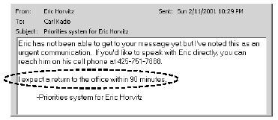
- Custom extensions: Most of the custom extensions to single-user tools support annotations. The surveyed work evaluates the usefulness of existing annotation support, and proposes several new techniques such as robust annotations to overcome its weakness.

By comparing and contrasting the surveyed efforts, this paper also identifies some specific new areas of research that extend existing directions of research:
Figure 24 Forecasting continuous presence (Horvitz, Koch et al. 2002)

- An integrated thread-based annotation mechanism that applies to instant messaging, mail, news, and commenting of multimedia objects.
- Automatically creating annotations that request rephrasing by editing a copy of the document/fragment, which can then be simply accepted by the author to create the rephrase.
- Creating robust annotations by flexibly diffing a revision with the original.
- Extensions to application logging that use deadlines to detect interruptability, convert real-time mail messages into instant messaging conversations, and suppress a notification if the users is constantly polling the source of the notification.
- Control over when a user’s input is transmitted to other users in a chat window, whiteboard, or some other application.

Acknowledgments
Jonathan Grudin and the anonymous reviewer provided numerous comments for improving this chapter. This work was supported in part by Microsoft Corporation and NSF grants IIS 9977362, ANI 0229998, IIS 0312328, and EIA 0303590.

References
D.

A comparison of synchronous and asynchronous collaboration is beyond the scope of this paper. (Dewan 91) shows that there are multiple degrees of synchrony in collaboration and presents scenarios where the different degrees may be appropriate.

