Controlling Access in Collaborative Environments
Srinivas Krishnan
University of North Carolina at Chapel Hill
krishnan@cs.unc.edu

Abstract
In collaborative systems users require varied access to a set of shared resources. Unlike traditional OS-centric access control systems, these systems need dynamic access changes and low latency access to resources. In this paper we shall study access control systems as applied in a distributed collaborative environment, and explore strategies that allow for “low-latency” access operations by using a methodology known as “optimistic access control”. We shall also briefly discuss strategies used to solve the problem of update ordering in a replicated access control system. Finally, we shall study a p2p environment, which allows for building a highly resilient access control system.

Introduction
Collaborative systems strive to provide an interface for users to work on a shared resource. Each one of these collaborative sessions however consists of users who have varying trust levels of each other. This leads to a middleware providing a layer of protection around the shared resource, and allowing each user to access the shared resource in a manner that will not breach the “degree of trust” present amongst the participants. The layer of protection is provided by the access control mechanisms present in the system. Traditional access control mechanisms have relied on a “deny-first” mechanism. This model however does not apply directly to collaborative models, whose aim is foster sharing of information. Further, unlike traditional single-user models, collaborative applications have to allow for dynamic change of access permissions, as users can join and leave in an ad-hoc manner. This leads to building access control systems for an N-user collaborative environment becoming a challenging distributed systems problem.

Access Control is a function of the information it is trying to protect. A defense contractor working on a proposal and a high school team working on a term project cannot use a system with similar access control policies. However, the goal is to make the system as transparent and generic as possible, such that we can apply the same operations to achieve similar goals albeit with more constrains added. This leads to a framework being created on top of a set of basic operations. In this paper we shall provide a study of the various access control mechanisms that exist and how they apply to the collaborative workspace. Further, we study some of the common issues that plague distributed access control mechanisms and the solutions to those problems.

This paper is organized as follows, Section 2 discusses the requirements for building a robust access control system; Section 3 presents some of the common implementations of Access Control systems; Section 4 provides details on building an Access Control system with low latency of operations; Section 5 looks at the ordering problem in a distributed Access Control system and a solution to the problem, and finally, Section 6 dissects an access control system on top of a P2Penvironment and provides details on a implementation of such a system.

Access Control System Requirements

Access control systems can either be centralized or replicated, as shown in Figures 1 & 2. This depends on the resources and semantics of the collaborative applications. A centralized architecture is easy to maintain, however does not scale well when we have to protect resources that are not located in a central server. Replication is mostly done for high availability and resiliency of the system. Further, in a collaborative environment there might be hierarchy of privileges and the access servers might be distributed to provide mutual exclusion for added security.

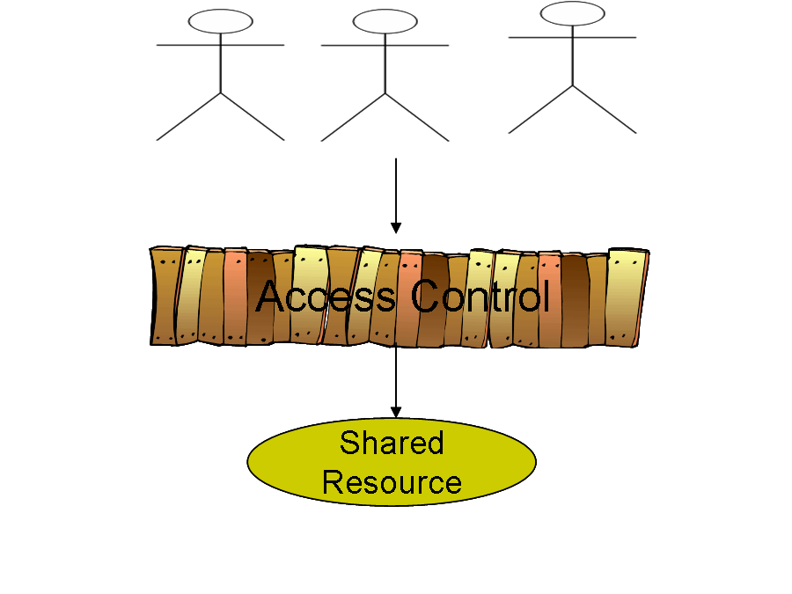  Figure 1: N-User Collaborative System | 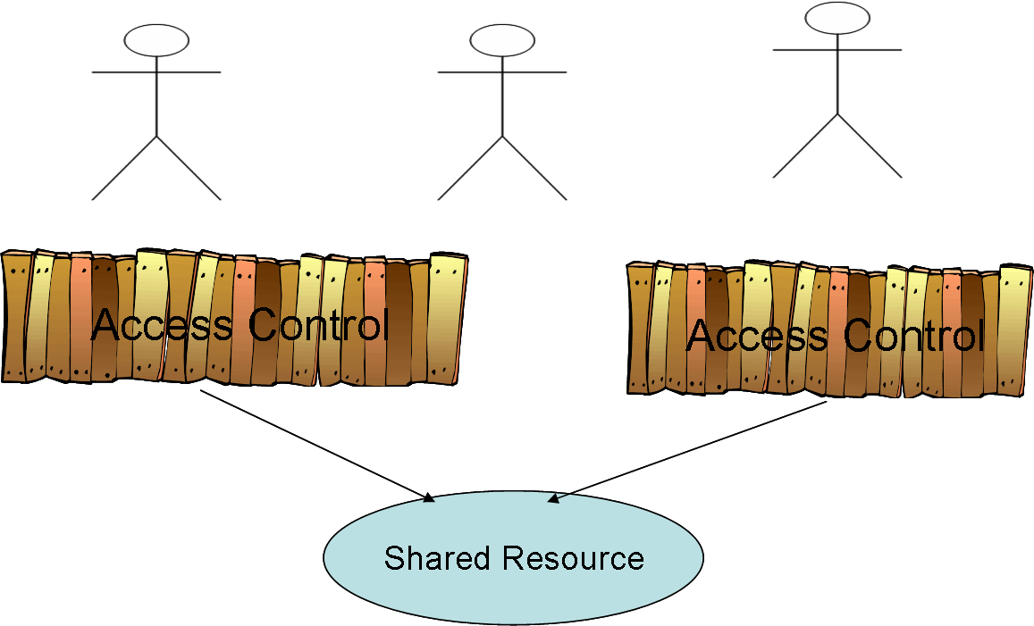  Figure 2: Replicated Access Control System

The goals of building an Access Control system are as follows:
- Maintaining consistency of shared resource
- Idempotency of Operations
- Scalability
- Dynamic change of access permissions
- Transparency
- Ease of Administration

Access control systems are required to provide consistency amongst the shared resources. Consistency can be either enforced strictly, where the system ensures that no access to the resource shall cause any unwarranted changes, or with certain latitude, which ensures that the system shall reach a quiescent state eventually. The balance to be made is between performance and security. Idempotency of operations provides for a rich set of operations whose effect can be always be pre-determined. This leads to designing schemes and rules for access control systems that are simpler and allows for a concept known as “optimistic access control”, which depends on operations having the same effect at any given time.

The goal of scalability is to allow these systems to scale in multiple dimensions: number of users and synchronization amongst various access control modules in a replicated environment. Dynamic changing of permissions is a goal meant primarily for collaborative environments, where a user’s needs change as they interact with other users, rights need to be suddenly revoked or given without having to ask all the users to exit the environment. The final two goals are secondary goals, transparency refers to the ease with which a user can access a shared resource without any explicit operations on part of the user. Ease of administration requires that access control systems should provide a rich set of operators that can be applied both for global updates as well as fine grained updates. This reduces the burden of administrators having to maintain and modify per-object state.

Access Control Implementations

In this section we shall study the common implementations of access control in collaborative systems. First, we shall study the base data structure used in most systems, the access matrix. We shall then look at more refined schemes which involve roles and spaces. While concentrating on these systems we shall primarily focus on how they are applied in a collaborative environment. Our goal is to study systems in light of the requirements laid out in section 2.

Access Control Matrix

Access matrices [7] were originally developed to provide security for Operating System. There were meant to be for asynchronous access in a single user environment. However, with the advent of time-sharing OS like UNIX this concept was further developed for multi-user environments. The access matrix is described in figure 3, where all the users and objects of a system are stored in a table. Each column of the table represents the objects present in the system and the rows represent the users who will access them. The cells of the table contain the permission the given user for the object. Common permissions are Read, Write and Ownership.

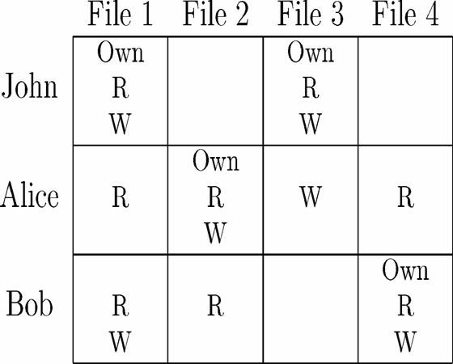
Figure 3: Traditional Access Matrix Model [7]

Whenever a user tries to access an object, the access control system looks up the object and validates the requested operation with the permissions in the matrix. This is enforced by the OS having a process which mediates all access to the objects present in the system.

Access matrices however do not scale too well, as they grow both with the number of users and objects being added to a system. In a replicated collaborative environment maintaining a single table requires locking of global state, which reduces performance, further it is a single point of failure. This leads to a more robust implementation of Access Matrix: Access Control Lists and Capability Lists [7].

Access Control Lists shard the Access Matrix by rows and have the objects maintain a list of access matrices, as depicted in Figure 4. Each access matrix is just a single cell based on the user and the permissions they have on the object, which is stored in the cell.

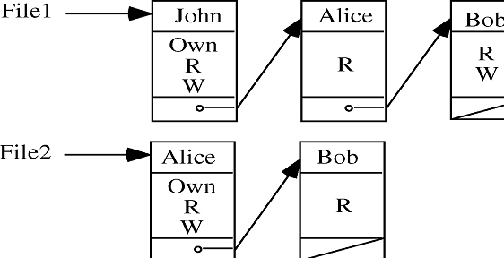  Figure 4: Access Control Lists | 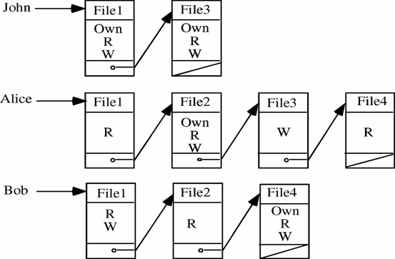  Figure 5: Capability Lists

The access control system instead of performing a lookup on a table, will just traverse the linked list, and perform the required operation. Now, as the table is sharded, there are no single points of failure and there can also be multiple access operations in parallel, albeit to different objects.

Capability lists are just another way of chunking the access matrix, this time by rows. The lookup operation is similar to Access matrices. The decision to use ACLs or CCLs is dependent on access patterns and semantics of the system. If each user is going to be using a particular set of objects with high probability then it is more efficient to use CCLs instead of ACLs. An example of a system using Access Matrices in a collaborative environment is Google Docs. GDocs use a centralized access control system, with each explicitly inviting other users to collaborate on a document by specifying the permission set for the invited users. The process of inviting, adds the invited user to the document’s ACL, and the invitee’s CCL.

The general Access Matrix model works well in a non-dynamic environment. When used in a collaborative environment, we need to take into account users changing responsibilities quite frequently. ACLs and CCLs cannot support dynamic change of permissions very well. Hence, the administrator of collaborative environments often sets stricter permissions, as multiple users with varying levels of privileges will try to access shared resources.
This leads to lowered experience for the user, as there is a lag between access to the object and time at which the user can access the object. Hence, the access behavior and requirements need to pre-determined so that an administrator can perform the operations necessary to let the user access the objects for that session. Further, if permissions are short-lived, i.e. only for a session, the administrator has to explicitly revoke the permissions as well. This can be envisioned in a presentation scenario, where the presenter does not want the users to have access to the slides after the end of his presentation. As ACLs and CCLs do not have concept of a session, the system needs to maintain a list of all objects being accessed in that session and to determine the permissions there needs to be traversal of the list multiple times. The lack of dynamic permission change also prevents ACLs to provide fine grained semantics at a sub-object level.

Role Based Access Control

Due to the problems of dynamic rights and per object accesses, Role Based Access Control (RBAC) [5] class of systems was developed. In Role Based Access control system there are concepts of global roles, and access permissions assigned to these roles instead of users. Roles are created by breaking the user space into a logical hierarchy, based on job functions and the type of system that is being modeled. Permissions are also broken into sets and each role is assigned a permission set.

Each user before entering the collaborative goes through a two-step authentication process, as depicted in Figure 6: Role-Based Access Control . The user first contacts a role server, which looks up the users and assigns him a subset of roles he needs for working inside the collaborative session. Each role is also dynamically assigned permissions at this moment. Once, the role is assigned it cannot be changed until the user reauthenticates with the system, which usually means the end of a “session”.
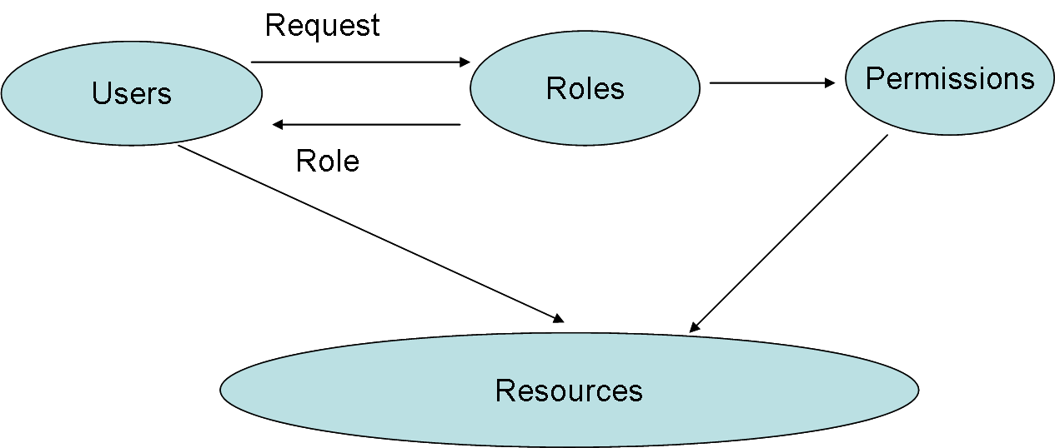
Figure 6: Role-Based Access Control

Role-based Access control systems have the notion of a session inherently tied to the system. Session is a per-user abstraction that encapsulates the roles assigned to the user and objects he can perform operations on. Session starts when the user authenticates with the system and ends when he exits the system. There are also timed sessions, where a user’s role expires within a set time interval. These sessions are used for sensitive information e.g. defense contractors collaborating on projects.

The flexibility of RBAC systems comes from decoupling users, objects and permissions. Access to objects can be changed without explicitly changing permissions on the protected objects. Users can be assigned new permissions every session, once again without changing any underlying data structures except for the ones which maintain the mapping of users to roles.

This leads to collaborative systems built on top of RBACs becoming easy to maintain with low overhead. However, the concept that simplifies rights management: “session”, also prevents dynamic reassignment of roles. As mentioned before, roles cannot be changed within a single session. Users have to reauthenticate to obtain new roles, these roles however have 1-1 relationship with the objects permissions. Each role also needs to be generic enough to accommodate for all the objects, a user might access within a session, often a user is assigned a set of roles to prevent creating user specific roles. Spatial Access Control

RBAC systems provide part of the solution for dynamic rights management by associating notion of sessions and roles. However, migration of roles within a session still remains a problem. Spatial access control systems were created to help solve the problem of role migration within a session. The system takes a different approach from RBAC systems. Instead of splitting users into groups, Spatial Access control divides the collaborative environment into abstract spaces. Users migrate from space to space in a session based on a set of predefined rules. We can model spatial access control like a state machine, with the rules defining the transitions from state to state.

The transitions rules are modeled using an Access Graph, where the nodes are the spaces. The access graph is used to sketch “virtual paths” for users inside the collaborative environment. Resources are accessed based on the space a user is at time t. This is explained further in Figure 7.

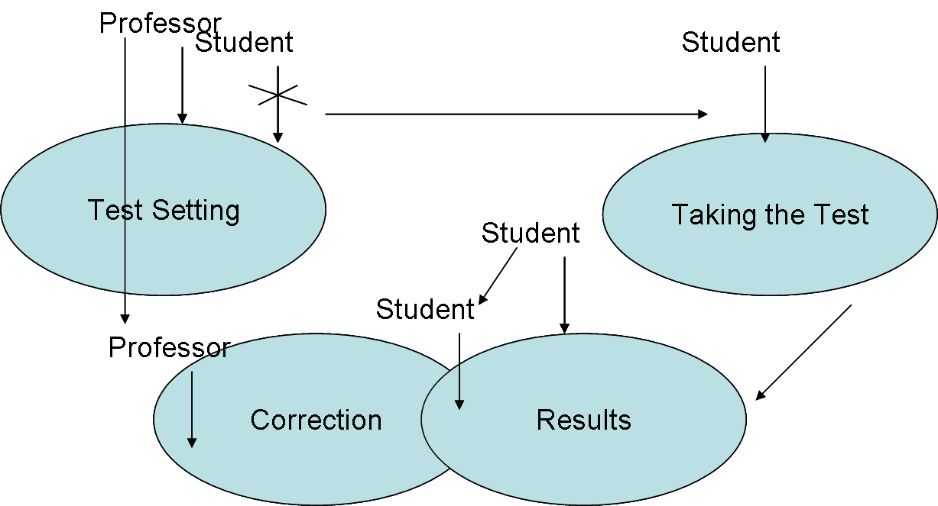
Figure 7: Spatial Access Control in Test Taking Environment

A testing environment is modeled above: the professor has access to all the different virtual spaces, while the student can only move to “Taking the Test”, “Results” and a subsection of “Correction”. The subsection of correction that is available to the student only allows them to look at the test after the tests are corrected, such that the students can clarify any doubts they might have over the corrections. Spatial access control allows for fine-grained access control to be implemented by creating subsections of logical spaces.

Both RBAC and SPAC implementations of access control systems need prior knowledge of the objects, or the collaborative environment they will be working on. This requires a certain level constant rule pruning by the administrators, to achieve a set of rules that are generic enough to match most of the daily access patterns. Also, every access needs to cross-checked with the underlying access data-structures; this requires locking of the data structures, which reduce performance as noticeable to the user. We shall study how to reduce user-perceptible latency in the next section.

Optimistic Access Control`
The major part of latency in an access operation comes from locking the global data-structures and verifying the operations are valid. Further, in a collaborative environment “transparency” of operations leads to better user experience. As mentioned in section 2, transparency refers to whether or not a user needs to explicitly request or provide permissions. We use a technique called “optimistic access control” to reduce latency

“Make the user ask forgiveness not permission” [4], refers to a principle developed to solve an essential problem in access control systems, how to allow users to elevate their privileges when the situation demands. This is depicted in Figure 8. John an employee for an insurance company, accesses the company’s files on a daily basis, with a reduced permission set. However, there is a fire in the building and John is the only employee present. He however cannot backup the system as he does not have access to the system.

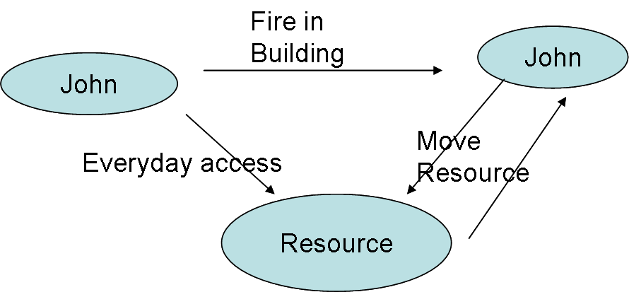
Access Denied
Figure 8: Case for Optimistic Access Control

Certain UNIX systems provide elevated access to a certain group of individual, who can elevate their privileges by executing the command sudo. However, not all users cannot execute the command and also the actions cannot once taken cannot be undone. [4] have tackled this problem by defining an access control system, the operations, and the transactions that can occur in the system.

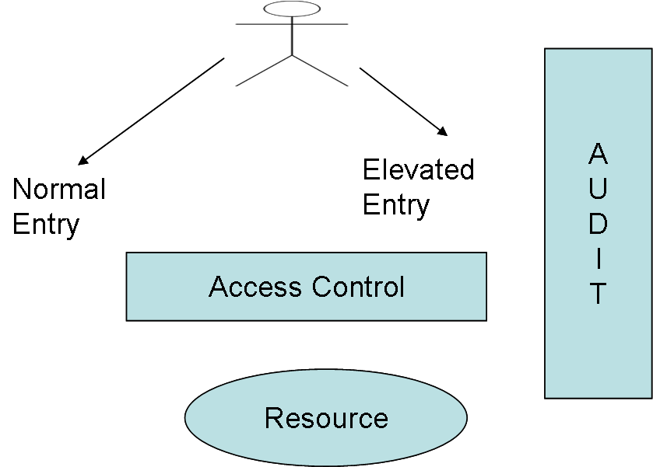
Figure 9: Optimistic Access Control

Optimistic access control systems are built by providing multiple entry points to the system, with an auditing framework. The resources are split into two halves: items with guaranteed protection and ones without. The ones with guaranteed protection can have only a certain set of transactions known as “Partially-formed transactions” . Each “partially-formed” transaction has a compensating transformation procedure (CTP) that will undo actions of partially-formed transaction. Further, the rules described below ensure that the system is fully defined by PTI and CTPS:

- All Partial Transaction must have Compensating TP
- Only transactions that are “certified” can run
- All users must be certified
- Administrators need to run audits and are the only one who can modify PTPs

Now that we have defined the semantics of optimistic access control, let us apply it to building a collaborative access control system. Here we use a Role Based Access Control subsystem and apply Optimistic Access Control. Also, instead of using Optimistic Access Control for elevation of privileges during special situations, we use it as the norm instead of the exception.

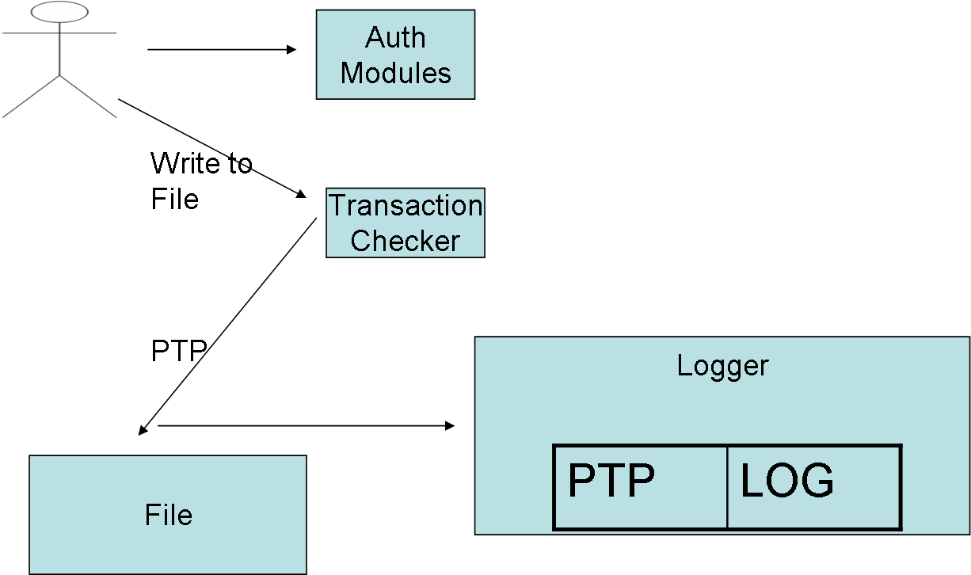
Figure 10: Collaborative Optimistic Access Control

This approach is taken to reduce latency of access control operations. Each operation a user executes passes through a transaction checker, to ensure it is a PTP. The PTP is then allowed to operate on the resource instead of waiting to check all the access control data structures. Also, to allow for a CTP, each PTP that executes on the system is logged with a timestamp and the PTP operation. These types of systems can be effectively used in environments that do not share sensitive information, like textual collaboration. To ensure consistency of the shared object, an auditing process routinely checks the access permissions with the logger. If a mismatch is found between the PTP and the privileges of the user, the process undoes the change from the file. So, the user who accesses the file sees a lowered time of access, while preserving the quiescent state of the system.

Implementation Issues

Distributed access control systems have problems with the order of updates reaching the modules. There can be multiple operations that can occur on a single resource, for example: operation can give User1 permissions to access the object, a concurrent operation can remove User1’s permissions. However, when they reach the access control module the order of updates is reversed, due to network delays. The system cannot depend on a coarse distributed clock like NTP to solve the problem. The solutions that have been proposed has been locking, however concurrent updates might occur once the lock is released. Instead we have to use a distributed logical time clock.

Causality is achieved by “virtual time-stamping” each update using a logical time clock. In this case we shall choose Lamport Time [3]. Lamport time has been used in distributed systems successfully to provide causality to distributed operations. Lamport Time requires a global and local semantics. The local semantics are of sending and receiving messages. The ordering is achieved by the notion of a counter.

- Send Message: Stamp the message with a 2 tuple: Process Id and the Local Counter of the system
- Receive Message: Adopt the greater of the local and the remote counter received.

The global semantics depend on choosing a Time Function that translates the counter into time stamps and a tie-break rule. When multiple updates are received they are processed in order of their virtual time and ties are broken using the tie-beak rule. The tie-break rule could be as simple as using a role hierarchy.

Replicated Access Control: P2P Systems

Most distributed collaborative systems are not truly peer-to-peer. There is usually central infrastructure that allows these systems to function. However, in a true peer-to-peer collaborative environment nodes may join and leave in an arbitrary manner. There also cannot be an expectation of a central system to provide services like access control. Hence, p2p collaborative environments require a true replicated and distributed access control system. Also, these systems are dynamic as nodes can join and leave without any set semantics. As there is no central repository user management becomes a main concern. Further as the trust levels are truly varied in a p2p environment, we cannot distribute the access control data structures amongst all the peers. This requires our access control system to scale in two dimensions; dynamically adding users as well as providing for multiple access control modules.

MOTION is a P2P system [2] which solves the problem by having a layered approach. They define a collection of super nodes known as L1 peers. These nodes are trusted by all and are primarily administrative nodes. All other nodes enter the system by authenticating with a L1 node. Each L2 peers is required to use a certificate to access any shared resource in the system. These certificates are issued by the L1 peers and are similar to Capability Lists. Once a certificate has been issued, a notification is sent to the nodes where the resources are located.

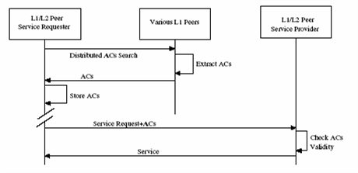
Figure 11: Motion Architecture [2]

The process of retrieving and using the access certificates is described in Figure 11. The peers searches for an appropriate access certificate (AC), the certificate is retrieved from an L1 peer, if one does not exist it is created. The requester stores the AC and sends the AC whenever he wants to perform an operation. The semantics of this system are quite simple, but essentially it is yet another way of chunking the Access Matrix. Storing an AC for each operation does not seem to scale well with N-nodes offering objects to be shared. Further, the validation process requires that we need a notification mechanism for each one of the nodes offering a resource, whenever an AC is issued.

In order to scale this system, we can use Role Based Access Control or Spatial Access Control. In a role based system, essentially a hierarchy of roles will need to be established with the L1 peers at the top of the hierarchy. We can associate a class of resources with a given role, and have L2 peers acquire their role from the L1 peer. Validation is as simple as authenticating the given role when the object is shared.

P2P environments can also be used to provide mutual exclusion amongst resources. We can create overlays of the P2P network, where each overlay signifies a logical resource set. Access to the resource is controlled by deciding on which users can join the overlay. This concept is similar to spatial access control. Each overlay has at least 1 L1 peer who issues the roles to the user, as the user migrates from one overlay to another, we can have dynamic changing of roles as well. Also, any updates that need to be created can be sent to the core overlay of the L1 peer managing the roles, reducing the number of messages sent back and forth.

In a P2P environment it is not always easy to pick L1 peers who can scale well with the number of users joining the network, as the node’s available resources are not always known. However, if the objects are replicated at multiple nodes, we can use an optimistic strategy to reduce any wait time the joining nodes would have before he can access shared resource. Once the node is authenticated and is waiting to join an overlay or be assigned a role, it can start accessing local resources, as long as the resource has been replicated elsewhere. The copies are made such that the primary copy, which is replicated, is not broadcasted and the secondary copies are shared. Once an operation has been committed on the secondary copy, after being verified, we sync with all the nodes that maintain the primary copy. This way we can use the nodes as a substitute for the logging service described in section 4.

P2P systems provide endless opportunity to be used in collaborative for providing a robust and resilient service. The ideas we have described in this section are simply tip of the iceberg

Conclusion

Collaboration and controlling access are two opposite ends of the spectrum that need to be merged in order to build collaborative environments, where people can work with a certain level of confidence. This paper has described some of the common ways access control systems are built and ways to extend them to fit the collaborative space. Collaborative applications also have requirements of low response time of operations, which can be achieved by using optimistic algorithms albeit for a subset of the collaborative space. With the advent of P2P systems, a new tool has been provided to try and solve the problem of balancing control and sharing. This paper has laid out some of the groundwork that can be used to build such a system, while staying true to the original goal of collaboration and sharing.

References

- Chengzheng Sun, "Optional and Responsive Fine-Grain Locking in Internet-Based Collaborative Systems," IEEE Transactions on Parallel and Distributed Systems ,vol. 13, no. 9, pp. 994-1008, September, 2002.
- Fenkam, P.; Dustdar, S.; Kirda, E.; Reif, G.; Gall, H., "Towards an access control system for mobile peer-to-peer collaborative environments," Enabling Technologies: Infrastructure for Collaborative Enterprises, 2002. WET ICE 2002. Proceedings. Eleventh IEEE International Workshops on , vol., no.pp. 95- 100, 2002
- Lamport, L. 1978. Time, clocks, and the ordering of events in a distributed system. Commun. ACM 21, 7 (Jul. 1978), 558-565.
- Povey, D. 2000. Optimistic security: a new access control paradigm. In Proceedings of the 1999 Workshop on New Security Paradigms (Caledon Hills, Ontario, Canada, September 22 - 24, 1999). NSPW '99. ACM Press, New York, NY, 40-45.
- Sandhu, R. S., Coyne, E. J., Feinstein, H. L., and Youman, C. E. 1996. Role-Based Access Control Models. Computer 29, 2 (Feb. 1996), 38-47.
- Strom, R.; Banavar, G.; Miller, K.; Prakash, A.; Ward, M., "Concurrency control and view notification algorithms for collaborative replicated objects," Computers, IEEE Transactions on , vol.47, no.4pp.458-471, Apr 1998
- Tolone, W., Ahn, G., Pai, T., and Hong, S. 2005. Access control in collaborative systems. ACM Comput. Surv. 37, 1 (Mar. 2005), 29-41.

