Crafting a Technical Argument

Prasun Dewan
University of North Carolina
Comp 911, Fall ’08

This is a quick survey of common writing problems in the survey papers submitted by previous students of this class. The advice given here should apply not only to survey papers but also theses, which, like survey papers, have relatively lax page limits and are expected to be written for a relatively general audience. Some of it may not be relevant to conference papers as they have stringent page limits, are written for an audience that is assumed to have expertise in the topic of the paper, and are expected to focus more on positioning new research with respect to previous work rather than teach the reader about the subject area. Nonetheless, most of it should apply to any technical paper or talk that tries to make an argument (rather than simply provide a series of facts). The writing problems and their solutions are illustrated using excerpts from the papers. The evaluation of selected excerpts from a paper is not meant to be a judgment of the whole paper. In fact, often a paper demonstrated both the problem and its solution. Portions of the excerpts on which the reader should focus are underlined.

Create intra-para flow

The biggest problem with most papers is the lack of flow, both between successive sentences in a paragraph and successive paragraphs in the same or different sections. The following example illustrates an intra-paragraph flow problem:

Excerpt 1

Abstract— As hardware improves and scientific data sets grow, the task of creating perceptually intuitive images becomes correspondingly more difficult. Multivariate volume visualization (MVV) is a particular subset of the data visualization field that produces imagery for spatially-embedded data volumes with multiple scalar values at each volume coordinate. The fundamental difficulty with these massive data sets is that there is too much data to naively display at one time. Some form of data reduction is required. This paper presents a representative selection of modern MVV techniques that each attempt to solve this problem.

The flow issues here are pretty subtle and perhaps not even noticeable. However, by addressing them, we can demonstrate what good flow looks like in the extreme case.

The problem is that the third sentence in the paragraph builds on the idea expressed in the first sentence, while the second sentence expresses an independent theme. The first sentence tells us without justification that visualizing large data sets is difficult:

As hardware improves and scientific data sets grow, the task of creating perceptually intuitive images becomes correspondingly more difficult.

The third sentence provides the justification:

The fundamental difficulty with these massive data sets is that there is too much data to naively display at one time.

The second sentence, on the other hand, simply describes the scope of the paper:

Multivariate volume visualization (MVV) is a particular subset of the data visualization field that produces imagery for spatially-embedded data volumes with multiple scalar values at each volume coordinate.

The third sentence, thus, should follow the first one. Perhaps a simpler way to rationalize this order is to say that the phrase “these massive data sets” should be in a sentence that follows the one in which the data sets were introduced. Let us swap the position of the second and third two sentences:

Abstract— As hardware improves and scientific data sets grow, the task of creating perceptually intuitive images becomes correspondingly more difficult. The fundamental difficulty with these massive data sets is that there is too much data to naively display at one time. Multivariate volume visualization (MVV) is a particular subset of the data visualization field that produces imagery for spatially-embedded data volumes with multiple scalar values at each volume coordinate. Some form of data reduction is required. This paper presents a representative selection of modern MVV techniques that each attempt to solve this problem.

This modification actually aggravates the flow problem as now the fourth sentence is out of place. Let us move it so it follows the second sentence:

Abstract— As hardware improves and scientific data sets grow, the task of creating perceptually intuitive images becomes correspondingly more difficult. The fundamental difficulty with these massive data sets is that there is too much data to naively display at one time. Some form of data reduction is required. Multivariate volume visualization (MVV) is a particular subset of the data visualization field that produces imagery for spatially-embedded data volumes with multiple scalar values at each volume coordinate. This paper presents a representative selection of modern MVV techniques that each attempt to solve this problem.

This is better but still not perfect. The last sentence contains the phrase “this problem,” which refers to the need for data reduction. Thus, the sentence before it should be the one that refers to data reduction. So we can move it too:

Abstract— As hardware improves and scientific data sets grow, the task of creating perceptually intuitive images becomes correspondingly more difficult. The fundamental difficulty with these massive data sets is that there is too much data to naively display at one time. Some form of data reduction is required. This paper presents a representative selection of modern MVV techniques that each attempt to solve this problem. Multivariate volume visualization (MVV) is a particular subset of the data visualization field that produces imagery for spatially-embedded data volumes with multiple scalar values at each volume coordinate.

However, now we have the problem that MVV is defined after it is referenced. No movement of the sentences in this paragraph is going to fix this problem. We can rewrite the last two sentences to provide the final solution:

Abstract— As hardware improves and scientific data sets grow, the task of creating perceptually intuitive images becomes correspondingly more difficult. The fundamental difficulty with these massive data sets is that there is too much data to naively display at one time. Some form of data reduction is required. This paper presents a representative selection of techniques that each attempt to solve this problem. It focuses on multivariate volume visualization (MVV), which is a particular subset of the data visualization field that produces imagery for spatially-embedded data volumes with multiple scalar values at each volume coordinate.

Of course there are other possible rewrites of the paragraph. Here is one that requires fewer changes to the original excerpt:

Abstract— Multivariate volume visualization (MVV) is a particular subset of the data visualization field that produces imagery for spatially-embedded data volumes with multiple scalar values at each volume coordinate. As hardware improves and scientific data sets grow, the task of creating perceptually intuitive MVV becomes correspondingly more difficult The fundamental difficulty with these massive data sets is that there is too much data to naively display at one time. Some form of data reduction is required. This paper presents a representative selection of modern MVV techniques that each attempt to solve this problem.

This rewrite is does not have the same meaning as the original. The rewrite claims only that multivariate volume visualization is difficult while the original claimed all visualizations are difficult. The paper focuses on multivariate volume visualization, so the new semantics are acceptable. “Multivariate volume visualization” is in the title of the paper: Techniques for Multivariate Volume Visualization. So it is, in fact, a good idea to provide the definition at the start of the abstract.

The problems with the original sequence of sentences are subtle only when the sentences are part of a paper. When they are part of a talk, they become more glaring. The reason is that in a talk, the audience members may remember only the previous sentence and, thus, it is important to keep related sentences together. In a paper, on the other hand, the reader has access to all of the sentences and can search the paper for the connecting sentence. Nonetheless, it is important to reduce the amount of searches the reader performs.

Create inter-para, inter-section flow

The lack of flow between paragraphs of the same or different sections of a paper is a more commonplace and bigger problem. Here is an excerpt from a paper that contains examples that illustrate both this problem and its solution:

Excerpt 2

Broadly speaking, segmentation algorithms can be classified into three categories: pixel-based, edge-based and region-based methods.

1.2.1 Pixel-based Algorithms

Pixel-based methods directly work in the feature (histogram) domain, and spatial information isn’t taken into consideration.

Thresholding
Thresholding is the simplest approach among pixel-based methods.
…
These values may seem arbitrary, but the reasons for choosing them become much more apparent after inspection of the image’s histogram in figure 1.2 where clear intersections of the Gaussian distributions occur around intensities 20, 40, 75, and 140.
Finite Mixture Models (FMM)
Finite mixture models assume that the input image (or images) consists of a fixed number of distinct objects (or tissue types).

Let us consider first the following part of this excerpt:

These values may seem arbitrary, but the reasons for choosing them become much more apparent after inspection of the image’s histogram in figure 1.2 where clear intersections of the Gaussian distributions occur around intensities 20, 40, 75, and 140.
Finite Mixture Models (FMM)
Finite mixture models assume that the input image (or images) consists of a fixed number of distinct objects (or tissue types).

Formula 1.4 is not connected to the text before it. The text in the Finite Mixture Models is not connected to Formula 1.4. Thus, there is no story connecting the three parts. Maybe there are implicit connections among them, but a good paper/talk should make them explicit.

On the other hand, the first paragraph of section 1.2.1 is connected to the paragraph before it:

Broadly speaking, segmentation algorithms can be classified into three categories: pixel-based, edge-based and region-based methods.

1.2.1 Pixel-based Algorithms

Pixel-based methods directly work in the feature (histogram) domain, and spatial information isn’t taken into consideration.

The reason is that a description of pixel-based techniques is exactly what the reader expects next. It seems that the writer could have used this technique of enumerating the next level of topics to address the lack of connection between the sections on thresholding and finite mixture models:

1.2.1 Pixel-based Algorithms

Pixel-based methods directly work in the feature (histogram) domain, and spatial information isn’t taken into consideration. They can be classified as thresholding, finite mixture models, and K-Means.

Thresholding
Thresholding is the simplest approach among pixel-based methods.
…
These values may seem arbitrary, but the reasons for choosing them become much more apparent after inspection of the image’s histogram in figure 1.2 where clear intersections of the Gaussian distributions occur around intensities 20, 40, 75, and 140.
Finite Mixture Models (FMM)
Finite mixture models assume that the input image (or images) consists of a fixed number of distinct objects (or tissue types).

The added underlined sentence tells the reader to expect a description of finite mixture models after thresholding. Do we now have to explicitly connect the end of the description of the former to the start of the description of the latter?

It is easy to argue that the answer is yes. The description of finite mixture models is long and it is possible that the reader has forgotten that finite mixture models are the next item in the menu. More fundamentally, the reader has no idea why a model more complicated than thresholding is necessary and thus may not be motivated to learn more.

The best flow occurs in this part of the excerpt:

Pixel-based methods directly work in the feature (histogram) domain, and spatial information isn’t taken into consideration.

Thresholding
Thresholding is the simplest approach among pixel-based methods.

The first sentence of the thresholding section gives the reason why thresholding is interesting: the fact that it is the simplest method. A similar motivation is needed for finite mixture models. One way to provide it is to, at the end of the description of thresholding, give some problem with it that is addressed by finite mixture models. In general, it is possible to connect a series of alternative techniques by using one or more drawbacks of a technique to motivate the subsequent technique. This approach is illustrated in the following excerpt:

Excerpt 3

3.1 Direct Volume Rendering
….
Direct volume rendering and all of its successors use color transfer functions. These functions describe the mapping between data values and RGBA color values and are most commonly implemented as a simple lookup table.
…

3.2 Isosurfaces
Even using modern volume texture compositing techniques, direct volume rendering is a computationally expensive process for large data sets. The isosurface is a volume visualization technique that is geometry-based, which plays directly into the primary task of graphics hardware: rendering triangles. Rather than specifying a range of values and their corresponding color and opacity values, isosurfaces instead require the user to specify only a particular data value of interest, known as an isovalue.
…

The section on issosurfaces starts with a problem with direct volume rendering, the subject of the previous section, that is addressed by isosurfaces. Applying this problem-solution-problem connection approach is not easy as it is rare for techniques to be placed linearly on some goodness scale. Typically they make different tradeoffs. To apply this approach, we may need to change the metric used to connect two techniques presented in succession. For example, after the providing the description of issosurfaces, we can look at the metric of user-effort to introduce a technique that requires less effort than issosurfaces.

Two techniques can be connected based not only on how well they work along some evaluation dimension but the difference between the algorithms they use. In general, we tend to understand alternative algorithms in relative rather than absolute terms. This algorithm-diff approach is used on Excerpt 3. We learn in the description of direct volume rendering that it uses color transfer functions:

Direct volume rendering and all of its successors use color transfer functions.

Then, in the description isosurfaces, we learn that it replaces these functions with isovalues:

Rather than specifying a range of values and their corresponding color and opacity values, isosurfaces instead require the user to specify only a particular data value of interest, known as an isovalue

The algorithm-diff connection approach is also illustrated in Excerpt 1 as techniques are classified based on whether they look at pixels or edges.

Providing both evaluation and design-based connections is an important part of writing a good integrative survey.

Repeat only to remind

When a new technique is motivated by comparing it with the previously presented technique, the comparison can be presented at the end of the section describing the previous technique or the start of the section discussing the new technique. However, it should not be repeated, as in the underlined portions of the excerpt below:

Excerpt 4

In the next section, I will describe another voltage scaling technique [2] for self-timed systems which removes some of the limitations of [1]. Instead of using additional FIFO buffers as in [1], their technique uses handshake signals to detect the operating speed of the circuit and to decide whether voltage should be reduced or increased.

4 Adaptive Supply Voltage Scheme

This section describes a voltage scaling technique [2] for self-timed systems which uses handshake signals directly to detect circuit speed relative to the input data rate and uses this information to guide the voltage scaling. This technique uses a system in which data processing circuits is asynchronous, but data is being input from a synchronous environment.

Imagine giving a talk in which you gave the connection between two successive slides both at the end of the previous slide and the start of the next slide - it would be so odd and unnecessary. It is true that people can read papers in random rather than linear order. Nonetheless you should assume they are being read in linear order.

Here is another example of repetition:

Excerpt 5
When these high energy state nuclei relax back to a lower energy state they emit radiation which can be detected by the NMR spectrometer. This flip-flopping between parallel and anti-parallel spin states based on radio frequency absorption is referred to as resonance. Each nucleus in a particular chemical environment absorbs at a specific radio frequency giving rise to a unique set of resonances that characterize a given molecule.

When the excited nuclei relax, they emit radiation which is then detected and digitized as the free induction decay (FID) signal, in the time domain.

We are told twice that when excited nuclei relax, they emit radiation detected by the NMR spectrometer. However the sentences in which this repetition occurs are not identical. In the first sentence, we are only told that the emitted radiation can be detected by the NMR spectrometer. In the second one, we also learn it can be digitized as the free induction decay signal. Thus we learn additional aspects of the radiation in different places. There are many ways to fix the problem. One is to explain all the aspects in succession. If this cannot be done, when mentioning something for a second time, explicitly recognize that it has been mentioned before:

When these high energy state nuclei relax back to a lower energy state they emit radiation which can be detected by the NMR spectrometer. This flip-flopping between parallel and anti-parallel spin states based on radio frequency absorption is referred to as resonance. Each nucleus in a particular chemical environment absorbs at a specific radio frequency giving rise to a unique set of resonances that characterize a given molecule.

As mentioned before, when the excited nuclei relax, they emit radiation, which can be detected by the NMI spectrometer. This radiation is digitized as the free induction decay (FID) signal, in the time domain.

In this excerpt, it is not really necessary to remind the readers that the radiation is emitted and detected by the NMI spectrometer, as it was only in the previous paragraph that they learnt this fact. Thus, a better rewrite would be to simply refer to the detected radiation:

When these high energy state nuclei relax back to a lower energy state they emit radiation which can be detected by the NMR spectrometer. This flip-flopping between parallel and anti-parallel spin states based on radio frequency absorption is referred to as resonance. Each nucleus in a particular chemical environment absorbs at a specific radio frequency giving rise to a unique set of resonances that characterize a given molecule.

The radiation detected by the NMR spectrometer is digitized as the free induction decay (FID) signal, in the time domain.

Sometimes authors repeat something simply because they forgot they mentioned it before. This is the worst kind of repetition and creates as bad an impression as providing a definition after its reference.

It is acceptable to repeat in the abstract and conclusion sections of a paper without acknowledging the repetition. The rest of the sections, including the introduction, should not provide such repetition.

Give dimensionalized evaluation and design Space

At the end of a discussion of the features and goodness of a series of techniques, it is likely that the readers have forgotten the comparison of the techniques. Therefore it is good to provide a summary of the comparison. This is illustrated in the following example:

Excerpt 6
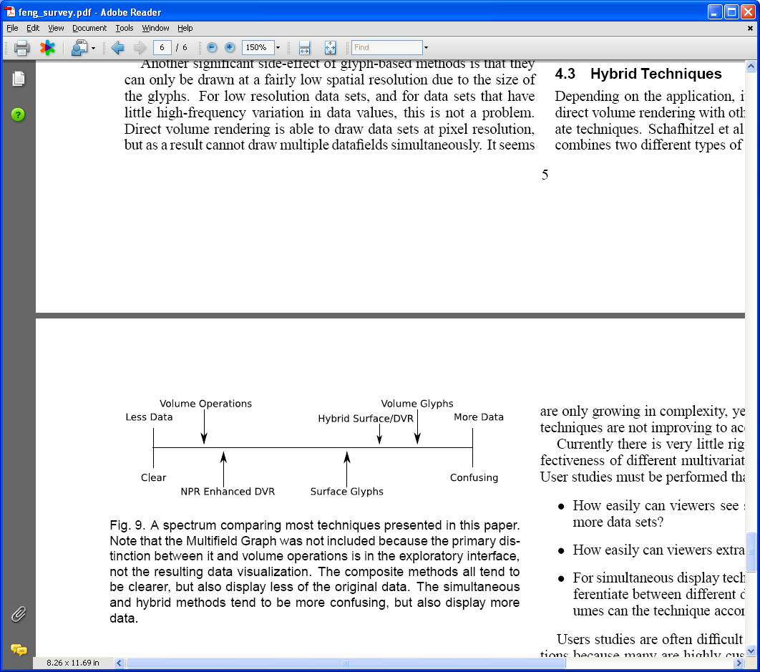

Here various techniques presented in the paper are compared based on how confusing they are. This comparison, then, becomes a more abstract description of the techniques than the detailed description of them in the individual sections. The more abstract the messages of a paper, the more intellectual and general the technical argument made by it.

The example above compares techniques based on an evaluation criterion – confusion. It is also possible to compare them based on some design criterion. The following example illustrates this:

Excerpt 7

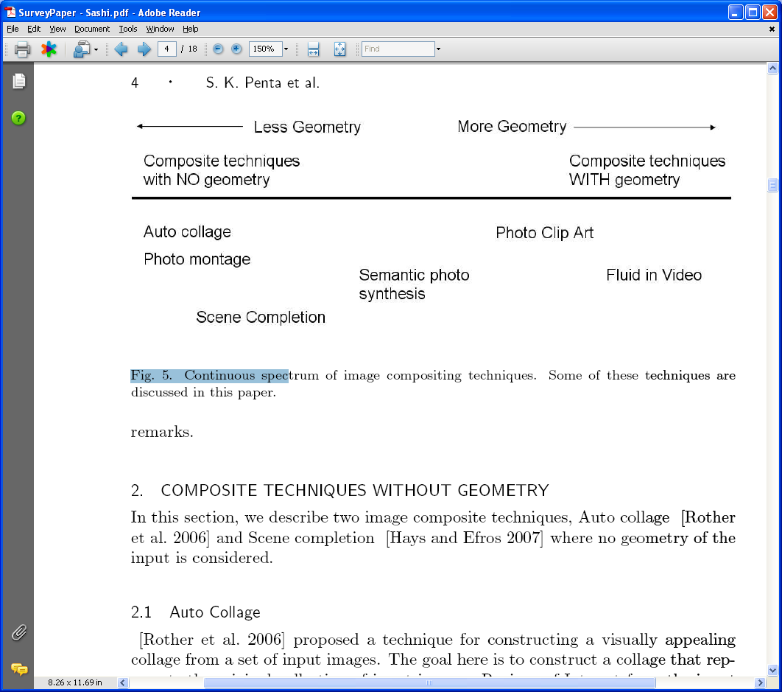

Here a series of image composition techniques are compared based on how much geometrical information they use to place the composed images in the composition. The amount of geometry used is not connected to the goodness of a technique. For example, in a collage, using geometry serves no purpose. The geometric spectrum is simply a way for us to understand the relationships in the designs of these techniques.

As mentioned earlier, normally there are several evaluation dimensions. Moreover, typically there are several design dimensions. Don’t be content with using only one of these dimensions to classify techniques. Give all important dimensions you can identify. For example, as we saw earlier, the direct volume rendering and isosurfaces techniques can be compared not only based on how confusing they are but also how computationally expensive they are and how much user effort they require. By covering all the dimensions you can identify, you will help the readers better understand the techniques.

Explain “subtle” concepts explicitly

The dimensionalized space can be given at the start of or end of the comparison. In either case, it is important to explicitly justify the placement of a technique along each dimension. It is possible that the description of a technique implies its placement in a spectrum. Even if it does, it is a good idea to explicitly justify the placement as the readers probably have to re-scan the descriptions of the techniques to understand their placement. If the classification is presented before the discussion of the techniques, then the discussion of each technique can justify its placement relative to the techniques presented before. If it is done at the end, then, of course, the justification must also come at the end.

Neither of the two excerpts above labels the points in the evaluation/design dimension, simply giving the relative order of the techniques. To be more precise, if the points can be described by small names, go through the effort of labeling the points in a dimension, to both help the reader better understand the spectrum and provide an extra level of abstraction in the discussion.

The more general advice is to explain “subtle” concepts explicitly. To determine what is subtle, imagine that your audience is your best friend in your discipline not in your area of research rather than your advisor or some other expert in your area. For example, if you are explaining some aspect of computer vision, imagine your audience is your best friend in computer science who knows nothing about computer vision. Authors typically under explain, even when targeting readers familiar with the domain of the paper, afraid of insulting the reader. Reviewers typically complain about under rather than over explanation. It is fairly likely that when you explicitly explain some point, you yourself will gain a better understanding of it or realize that the point is not valid. For example, by justifying the placement of points in an evaluation/design dimension and labeling points in it, you yourself will gain a better understanding of the relative differences among a series of techniques. There is a famous story of a professor being asked by a student to explain some relatively straightforward aspect of Einstein’s theory. After providing the explanation, he exclaimed that he finally understood the theory!

In general, it is very hard to know precisely how much to explain. That is why it is a good idea to practice your explanation on friends and colleagues before you commit yourself to a final talk or a paper, and take seriously reviewer comments about under-explanation.

Provide explicit definitions instead of buzzwords

Explaining subtle concepts explicitly implies that you should explicitly define all terms you need to make your point. When you don’t define a term, it becomes a buzzword to the readers/audience, who may wonder if there really is a concept behind it. Let us take a concrete excerpt:

Excerpt 8

Figure 1. Simple User Personae
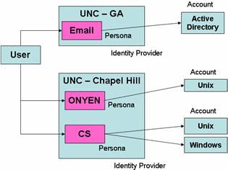

None of the terms used in the figure are defined in the paper from which the example was taken. Some of them such as email, Unix and windows do not need explanation as readers can be expected to be familiar with them, and more important, they are not really relevant to the point made by the paper. On the other hand, the paper is about digital persona and accounts, and the shows that they are different concepts. The examples chosen in the figure here do illustrate the difference. However, based on this information, it is not easy for the reader come up with a definition of digital account and persona that is consistent with their use in the figure. Thus, the author really needs to take the effort of providing the definitions; otherwise they are simply vaguely understood buzzwords.

Even a mathematical term might be vaguely defined. Consider the following:

Excerpt 9

A list of peaks in a spectrum are identified, and listed as a (mass, abundance) tuple.

When asked to explicitly define a peak, the author said that it was in fact a rather ill-defined concept. Explicitly acknowledging this might actually make the discussion more rather than less confusing.

Consider next the following excerpt:

Excerpt 10

A stopping term from the Mumford-Shah segmentation technique is adopted in this model and the entire curve evolution is conducted under the level set framework

Neither Mumford-Shah segmentation nor level sets are defined in the paper, but these appear to be well defined terms. It seems that it is enough to fix the problem by simply referencing papers/books that do define them. Even if the paper is being written for an expert audience, the paper would be more insightful if it explained the aspects of the level sets and Mumford Shah algorithm that are relevant to the conclusions of the paper. Ideally, a paper should be self contained and not require the readers to lookup references to understand its point. Put in another way, a related work section in a paper should not simply refer to previous work. It should typically also explain the insights in these works, putting them in some dimensionalized space. Often it is the quality of writing in this section that determines if the paper is accepted. In conferences such as SIGGRAPH with small page limits, it is hard to adhere to this principle. But, in most ACM and IEEE conferences there is enough space. Often the explanation of a concept is only a sentence or two, in which case space is not an issue. As implied above, it is important to explain only those aspects of a concept that are relevant to the conclusions of the paper.

Here is an example that defines the terms it uses:

Excerpt 11

A peptide is a linear molecule composed of amino acids. An amino acid, also known as a residue, is a small molecule which contains a side chain, an N terminal and a C terminal group. The side chain differs between different amino acids, but the N and C terminal groups remain the same. Two amino acids can be linked by their N and C terminus, forming a chain of amino acids. There are 20 naturally occurring amino acids, each containing different properties, such as mass and charge. Each amino acid can be referenced by a three or one letter code. Using the one letter codes, an amino acid sequence can be uniquely identified by a string of characters.

It might seem that the paper goes overboard in explaining terms. After all, the readers are supposed to learn about amino acids in school. However, it is also likely that it has been a while since the readers were at school. Moreover, it is likely that they never learnt about the N-terminals and C-terminals, which are important to the point of the paper. Finally it took just a few sentences to provide the definitions. When this definition was presented as part of a talk, the audience members, many of whom worked in the area, listened with rapt attention, even when the “obvious” fact that amino acids map to letters was presented. The impression created was that the author was a master of the subject rather than someone insulting the audience’s intelligence.

Define Before Use

Many programming languages require definitions before use, though those that expect the compiler to make two passes of the program relax this rule. In the case of a paper, the “processors” are humans, who should not have to read it multiple times.

Here is a violation of this rule, as shown by the two underlined phrases:

Excerpt 12

There is growing interest in using multicore platforms, which are becoming increasingly ubiquitous, in settings where soft realtime constraints are required. For example, one envisioned use of such platforms is as multi-purpose home appliances, with one machine providing many functions, including soft realtime applications like HDTV streaming and interactive video games. The spectrum of settings where multicore architectures are being used even includes handheld devices. The resulting increase in processing power on such devices enables MPEG video encoding/decoding software to be deployed on them. Such software belongs to the domain of stream-processing applications [6].

In the case of video decoding, the need to maintain perceptual quality imposes timing constraints for the decoding of each frame. While it is desirable to meet these requirements for each frame doing so might not always be possible. Therefore, certain frames may fail to be decoded on time or may be dropped. If such a situation happens, then it is necessary to ensure that the quality of the video sequence is not affected severely. Timing constraints that can occasionally be violated are called soft timing constraints and such systems are called soft realtime systems. These systems stand in contrast to hard realtime systems where all timing constraints must be met. Soft realtime constraints may be expressed in a variety of ways e.g. deadline tardiness bounds, the bounds on the maximum ratio of missed deadlines, etc.

The term “soft real time” is defined in the paragraph after it is used. This is a minor violation of the rule, as the reader is left confused for a relatively short time. Here is more major violation of it:

Excerpt 13

1.2 Overview of Segmentation Algorithms
…
The prior segmentation information is obtained by applying principal component analysis (PCA) on the landmark points, and like the ASM model, image gradient is used in their method to estimate the pose and shape parameters of any new segmentation boundary

……
2 Synthesis
….
2.1 Principal Component Analysis
Principal Component Analysis (PCA) is a technique to …

In this paper, the reference and definition of the term, “principal component analysis,” occur in two different sections. Worse, the definition occurs in a section that is supposed to synthesize the algorithms presented in the section in which the reference is given. Even worse, the definition takes a whole section, which implies that the term requires much explanation.

Both violations create the impression that the authors would make bad teachers and would not be able to organize material in a logical order. This is probably false as the most likely reason for a violation is that that the author did not carefully craft the paper. However, when you have only one chance to impress someone with a talk or paper, it can have a devastating effect.

I was once in a faculty-recruiting talk in which most of the terms used by the speaker were unfamiliar to me. Finally, towards the end of the end of the talk, one of these, “plenoptic functions,” was defined. Up to that point I was only mildly irritated and was attributing my confusion to being inadequately educated. However, when I realized that the speaker did not really expect everyone to know about these functions, I was really annoyed, and decided that he was a scatter-brained person unlikely to be, at the very least, a good teacher. This was the conclusion of most people not in his area of research! Fortunately, he had an excellent teaching resume, which overcame this objection.

Illustrate incrementally with examples

Often the definitions provided are difficult to understand unless they are illustrated with examples. Consider:

Excerpt 14
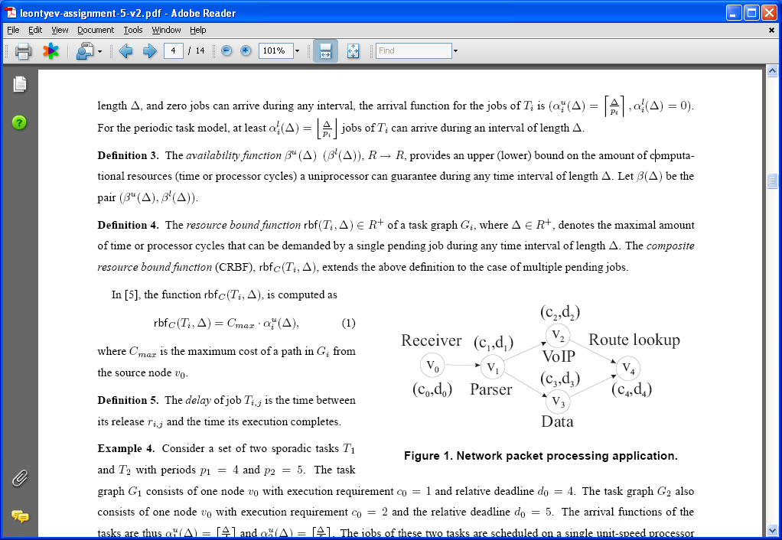

It is very difficult to understand the role and nature of the two definitions on their own. Fortunately, the paper later provides an example that addresses this issue. On the other hand, the reader may skim through the definitions if there is not enough illustration or motivation when they are presented. Therefore, rather than separating definitions and examples, it is preferable to mix them. Ideally, one or more running examples should be developed as motivation before the solution is presented and then each aspect of the solution such as a definition should be incrementally illustrated using the examples. The more symbols and superscripts the solution uses, the more important it is to incrementally illustrate it. In good talks this approach is usual – typically an abstract concept is along with some concrete illustration of it. This is also a good approach for papers, unless a series of definitions are needed before any aspect of the example can be given.

Provide figure descriptions in-place in the paper narrative

Often the example is a figure, as in the excerpt above. The incremental illustration approach does not work if the example is described only in the figure description. Providing detailed figure descriptions rather than one-line figure captions is a good idea as the busy reader can understand the work by simply looking at the figures. But, as mentioned before, you should focus more on those who are reading the paper in a linear fashion. Thus, be sure to explain each aspect of a figure at exactly the place in the argument where you want the readers to pay attention to it. You can, of course, duplicate the description in a long caption for the skimming reader, provided you have space.

The description of a figure should explicitly point out all interesting aspects of the figure. This is done in good talks, which don’t just present a figure and wait for the audience members to digest it. A good paper should follow the same rule and not rely simply on a paper reader having more time than a talk listener to deduce the point. This advice is a special case of the principle of being explicit.

Here is an excerpt showing this rule being broken:

Excerpt 15

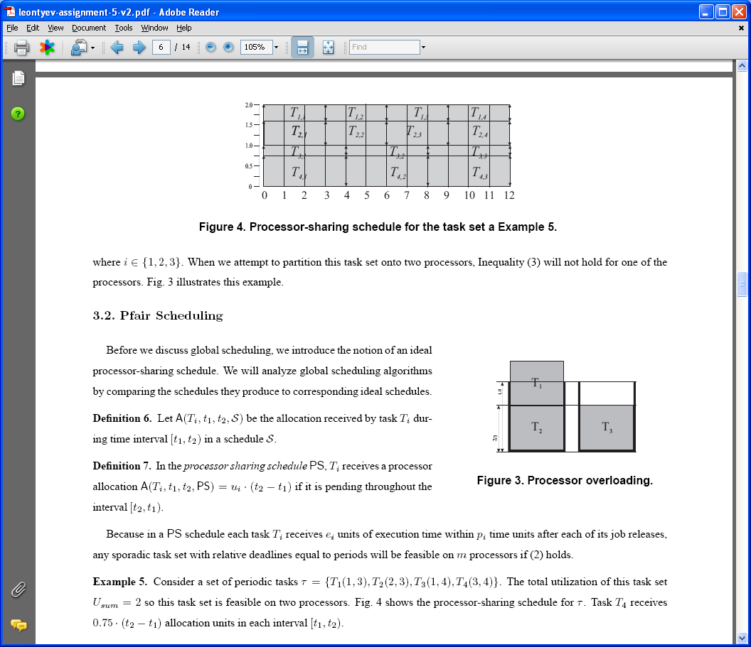
The paper gives us a terse explanation of the figure, never telling us explicitly the reason for the shown schedule, why Task T4 receives 0.75 (t2 – t1) allocation units, or why this allocation amount is interesting.

Use formal descriptions only if needed

Formal descriptions are particularly hard to follow. Therefore use them only if necessary. Consider:

Excerpt 16

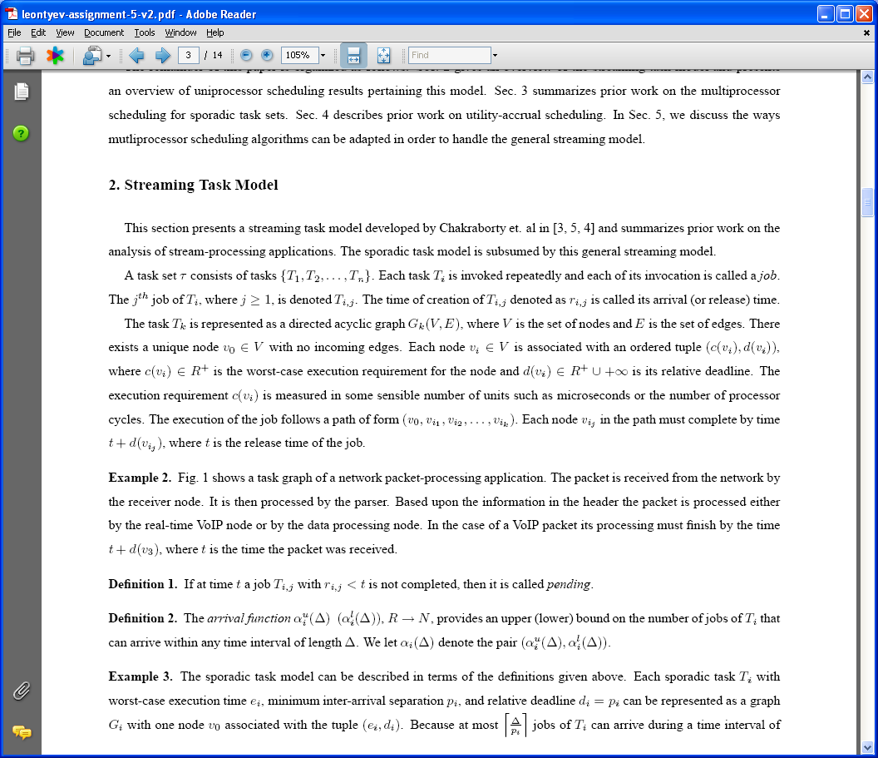

The excerpt tells us that a task is represented as a directed acyclic graph and then mentions that the nodes of the graph have deadlines and dependencies among them. However, it does not tell us explicitly that a (a) task is structured into subtasks, (b) each node represents a subtask, and (c) each edge connecting two nodes represents a dependency between the tasks corresponding to the nodes. As a result this “formal explanation” is not really complete – which is one of the goals of such an explanation. Worse, once this underlined informal description of the task is provided, the formal definition in terms of the various symbols is not necessary to make the point of the paper!

This advice of using formal descriptions only when necessary applies also to algorithms. Consider:

Excerpt 17

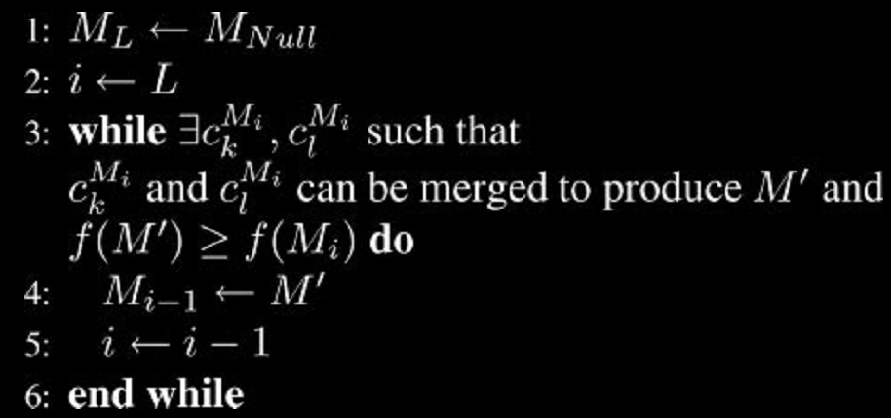

The paper does not explain or refer to any of the steps in the algorithm, which again, do not contribute to the explicit conclusions of the paper.

In summary, if you present formalism such as an equation, model, or algorithm, do something with it such as deriving it or illustrating it with an example. There is no creative effort in simply presenting a formalism, especially if developed by someone else!

This advice is a special case of the more general rule of not giving anything irrelevant to the focus of the paper.

Mention nothing irrelevant to the subject of the paper

The following excerpt shows how this rule can be broken even when formalism is not an issue. Consider:

Excerpt 18

….
In this paper, I survey the progress made on dynamic voltage scaling for asynchronous systems.

1.3 Self-Timed Systems

The self-timed circuits are a sub-class of asynchronous systems which are popularly used for voltage scaling. These systems use dual-rail code for data path and a four-phase handshake protocol for communication control.

The dual-rail protocol encodes the request signal …

Here, there is no connection between the last paragraph of section 1.2 and the first paragraph of section 1.3. This is not just a flow problem. Dual rail protocols are orthogonal to the concept of voltage scaling, which is the topic of the paper. When questioned about the reason for such seemingly irrelevant inclusions, authors typically say that the inclusions were provided for the sake of completeness. Unless you are writing an encyclopedia, you will never be complete. The goal of a technical paper should be to make an argument and not present some subset of facts in this world. Make sure you say everything necessary to make the argument and nothing more!

Use articles appropriately

In the excerpt above, the article “the” precedes the phrase “self-timed circuits”:

The self-timed circuits are a sub-class of asynchronous systems.

On the other hand, in the following excerpt, there is no article before the underlined phrase:

Excerpt 19

In this way the supply voltage will be adjusted to the actual workload, at all times maintaining the throughput requirements at lowest possible supply voltage.

Both usages are wrong. In general, an article helps specify some member of a set. When the set has only one member, no choice has to be made, hence no article in necessary. When the set has many members, an article should be used as part of the specification of the choice. There is only set of self-timed circuits, hence the article “the” should not be used in the first case. There are many possible supply voltages, hence “the lowest” qualification should be provided. The author of the excerpt above said that the sentence had so many instances of “the” already that he decided that adding another one would make it even more boring. It is more important to be grammatically correct than boring!

Based on the reasoning above, the terms “recent research,” “previous research,” and “future research” should not be qualified by an article because the union of research is broken into a unique set of (a) past research, (b) recent research, and (c) future research.

Use “that” and “which” appropriately

The terms “that” and “which” are not interchangeable. The former is used to identify some object by giving its discriminating property, while the latter is used to enumerate a property of an object that has already been identified. Consider following excerpt:

Excerpt 20

This is outside of the scope of this survey, which will instead describe a set of visualization techniques which apply specifically to volumetric data sets (i.e. spatially embedded in R³) that have multiple dependent variables.

It shows both correct and incorrect usages of “which” and “that”. The use of “that” is correct as the text after it identifies the class of data sets of interest. The first use of “which” is correct as the phrase, “this survey,” has already identified the survey of interest, and an additional property of the property is being given. The second use of “which,” on the other hand, is incorrect, as the text after it identifies the visualization techniques of interest. Thus, the correct usage is:

This is outside of the scope of this survey, which will instead describe a set of visualization techniques that apply specifically to volumetric data sets (i.e. spatially embedded in R³) that have multiple dependent variables.

Rewrite to avoid using “I”

One school of thought is that a single-author document should use the term “I” instead of “we,” while the opposing view is that “I” is too egotistical. To get around this irresolvable issue, it is best to rewrite so that neither of the pronouns is used. Sometimes these pronouns are used to indicate what the paper contains:

Excerpt 21

I will concentrate on self-timed systems …

In the next section, I will describe another voltage scaling technique …

In this paper, I surveyed the progress made on dynamic voltage scaling in the regime of asynchronous systems. In particular, I explored two voltage scaling techniques available in literature.

In this case, change the subject of the sentence from yourself to the paper or some part of it, as shown below:

This paper will concentrate on self-timed systems …

The next section will describe another voltage scaling technique …

This paper surveyed the progress made on dynamic voltage scaling in the regime of asynchronous systems. In particular, it explored two voltage scaling techniques available in literature.

In an acknowledgment section, you really need to refer to yourself rather than some part of the paper:

Excerpt 22

7. ACKNOWLEDGMENTS
We would like to thank Prof. Svetlana Lazebnik for the discussion on some parts of this paper. We would like to thank Prof. Prasun Dewan for valuable suggestions and ideas …

Fortunately, the title of the section implicitly says that you are thanking the persons identified. So you can simply give the contribution:

7. ACKNOWLEDGMENTS
Prof. Svetlana Lazebnik discussed parts of this paper. Prof. Prasun Dewan provided valuable suggestions …

However, sometimes you may indeed want to refer to yourself with a first person pronoun as the following excerpt from this paper shows:

Excerpt 23

I was once in a faculty-recruiting talk in which most of the terms used by the speaker were unfamiliar to me.

It is possible to refer to yourself as the “first author” and then use third person pronouns to refer to yourself:

The author was once in a faculty-recruiting talk in which most of the terms used by the speaker were unfamiliar to him.

However, the rewrite sounds a bit awkward, at least, to me. Both choices are, of course, acceptable.

Rewrite to avoid facing the “he/she” issue

It is also possible to rewrite to avoid addressing the he/she issue by replacing the single subject of a sentence with a collection of people. Consider the following text referring to a single reader.

In this excerpt, it is not really necessary to remind the reader that the radiation is emitted and detected by the NMI spectrometer, as it was only in the previous paragraph that he/she learnt this fact.

The second part of the sentence uses a singular third person pronoun only because the first part refers to a single reader. If we instead refer to the collection of readers, we can use “they” as the third person pronoun without being grammatically incorrect:

In this excerpt, it is not really necessary to remind the readers that the radiation is emitted and detected by the NMI spectrometer, as it was only in the previous paragraph that they learnt this fact.

Of course, it is not always possible to replace a single person with a group without changing the meaning of the paper.

Avoid use of “notice”

Many papers preface some point with the phrase “notice” or “note that.” This command is redundant – should every point you make not be noteworthy? Here is an illustrating excerpt:

Excerpt 24

Notice that the match posterior probabilities, P(σª_{j}<>σ^{b}_{k}| σª, σ^{b}, θ), give a probability that σª_{j} aligned to σ^{b}_{k} using the pairwise probabilistic model specified by data σª, σ^{b} and parameters θ [11]. The gap posterior probabilities, P(σª_{j}<> −| σª, σ^{b}, θ) & P(−<>σ^{b}_{k}| σª, σ^{b}, θ), give the probability that σª_{j} or σ^{b}_{k} align to a gap, −, using the pairwise probabilistic model specified by data σª, σ^{b} and parameters θ [11]. The gap factor G_{f} is assigned a value greater or equal to zero [11]. Note that G_{f} equal to zero gives the expected developer score, f_{D}, and G_{f} equal to 0.5 to gives the expected AMA score [11]. Note that f_{D} is a sensitivity measure that is equivalent to the sum-of-pair score and is the most widely used measure of multiple sequence accuracy [11]. Using the global alignment score f() , the following two weight functions, W^{Gf}_{maxstep} & W^{Gf}_{tgf} , were developed to weight all pairs of columns when selecting the next pair of columns to merge [11]. In practice the W^{Gf}_{maxstep} was used to maximize sensitivity by setting G_{f} equal to 0 and W^{Gf}_{tgf} was used to adjust for better specificity and seems to optimize at G_{f} equal to 4 when both methods were compared to current sequence alignment methods [11].

The sentence makes sense, and in fact, more readable, without the preface!

Avoid redundant referencing

Often you need to refer to many aspects of some referenced work. This is illustrated in the excerpt above in which reference [11] is mentioned many times. In such cases, it is sufficient to give the reference a single time, when introducing the work.

Avoid use of “clearly”

Papers often tend to use the preface clearly before making a point:

Excerpt 25
The loss of spectral resolution is clearly illustrated in Figure 4.

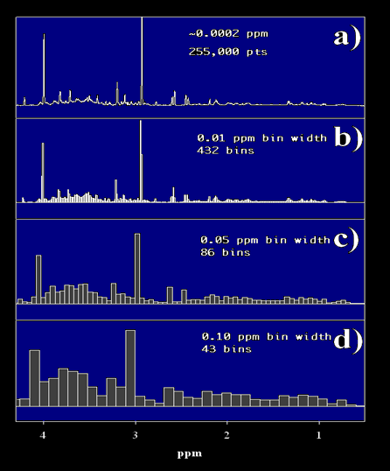
Figure 4: Binning of a ¹H NMR frequency spectrum, where a) shows the NMR spectrum without bins, b) shows the same spectrum with bins of width 0.01 ppm, c) shows bins of width 0.05 ppm and d) shows bins of width 0.10 ppm.

Like “notice,” the preface, “clearly,” serves no useful purpose. If the point is clear to the authors but not the readers, it simply makes them feel inadequate. Often the point is not that clear, and the authors want to believe it is clear so that they can avoid writing text to justify it. This is probably the case in the excerpt above, as the author gave a more explanation of the figure in the talk. It is not uncommon for a point called “clear” to not even be true!

Do not mix tenses

When surveying a series of techniques, it is possible to refer to each of them in the past or present tense. However, do not mix tenses, as in the excerpt below:

Excerpt 26

The first suggested solution, where a pairwise alignment is augmented as to produce the most appropriate target spectrum, has the advantage of being able to be implemented using any pairwise alignment scheme. …. The second solution of multiple sequence annealing provided a solution that could be adjusted through the gap factor to balance the relation of sensitivity verses specificity of a final solution.

Use acronyms sparingly

Try not to use an acronym for a term you define in the paper, as it forces the reader to either remember the expansion or repeatedly rescan the paper. Consider:

Excerpt 26

In the PEDF algorithm, tasks are statically assigned to processors and each task is scheduled on an EDF basis.

The paper is written for someone not in the area of real-time computing. For such a reader, the following rewrite is much clearer:

In the PEDF algorithm, tasks are statically assigned to processors and each task is scheduled on an earliest deadline first basis.

The expansion makes it clear what the EDF part of PEDF means.

The more acronyms you use, the bigger the recall problem. If the acronym is the subject of the paper, then it is acceptable to use it, as it will probably appears so many times that the reader will find it hard to forget its expansion. For example, it is ok to use MVV as an acronym for the paper titled “Techniques for Multivariate Volume Visualization”.

Conclusions

It is possible to make a variety of writing mistakes. This is the reason why there are complete books and courses devoted to this subject. Fortunately, not all authors make all of these mistakes. By focusing on the actual problems in survey papers written by eight UNC computer science graduate students, this paper has probably identified many of the common issues faced by the much larger group of English-speaking authors with college degrees who write papers that make technical arguments. In fact, each of my Ph.D. students has made a large number of these mistakes.

Based on the problems encountered in these papers, the advice is:

- Ensure that there is a flow between sentences in the same and different paragraphs.
- Material that cannot be connected to the rest of paper should be excluded from the paper.
- Repeat only to remind.
- When a new technique is presented, it can be connected to the discussion of techniques presented previously by identifying the (a) problems of one or more previous techniques overcome by the new technique, (b) ways in which the design of the new technique differs from the design of one or more previous techniques.
- A series of compared techniques should be placed in a dimensionalized evaluation/design space.
- The points along each dimension of these spaces should be explicitly labeled if short descriptive phrases can be identified for them.
- The placement of a technique in these spaces should be explicitly justified.
- All “subtle” terms should be explicitly defined. What is subtle can be determined by giving talks to practice audiences.
- Definitions of terms should come before their references.
- Incrementally illustrate each concept with an example.
- Descriptions of figures should be part of the main narrative, though if space permits, they can also be summarized in figure captions.
- Use a mathematical or computer language to define a concept only if you cannot do so precisely in English.
- If you do present a formalism, do something with it. For example, illustrate it with an example or derive it.
- Use articles, “that,” and “which” appropriately.
- Rewrite if possible to avoid using “I” and “He/She”
- Avoid prefacing points you make with “notice” and “clearly.”
- Avoid unnecessary repeated references to a work.
- Do not mix tenses when describing a series of previous works.
- Use acronyms sparingly.

It is very difficult to follow these rules – that is why writing is hard. In fact, this hurriedly written paper may have broken some of them. Hopefully, they can be used as a checklist before you submit your next paper to me.

