A Guide to Sync

Prasun Dewan

Sync is a system that allows multiple users to share a single logical (Java) object that is physically replicated on each user’s workstation. A user can make a series of changes to an object before sharing it with others. Moreover, multiple users can make these changes independently. Sync merges changes to different parts of an object through the server with which it is associated. A client can connect to multiple servers to fetch/deposit objects. In this document, we illustrate the main features of the system through an example interaction.

The system was developed in two stages. First, Jon Munson designed and implemented a system for asynchronous, disconnected changes to replicated programmer-defined objects that required the classes of these objects to extend system-provided classes. Next, Vibhor extended this system to allow (a) synchronous collaboration, and (b) object classes to delegate to rather than inherit from system-defined classes. The user-interfaces of the original system and extension are not integrated with each other, as we will see below.

sync.jprops
rmi registry
We will start a server on buzzard.cs.unc.edu. The server will advertise itself on an rmi registry on its machine. The clients will contact this registry to gain an rmi reference to the server. The port of the registry and other information is specified in the file sync.jprops which must in the directory from which the server and client are started. The file we will use has the contents:

sync.rmiregistry.port = 1099
sync.client.home = /net/buzzard/dewan/cb/sync/client
sync.server.home = /net/buzzard/dewan/cb/sync/server
domain = cs.unc.edu

Given this file, we must start the rmiregistry as follows.

rmiregistry 1099 &

Server and client directories
The file, sync.jprops, not only specifies the name of the rmi port but also the location of client and server directories. The server directory is expected to contain the file, server.jprops, which is read by the server when it is started. It is also the directory in which the server saves persistent versions of the objects it manages and the state it creates to maintain different versions of these objects. It is expected to contain the subdirectories, objects and deltas, as shown in the window below:
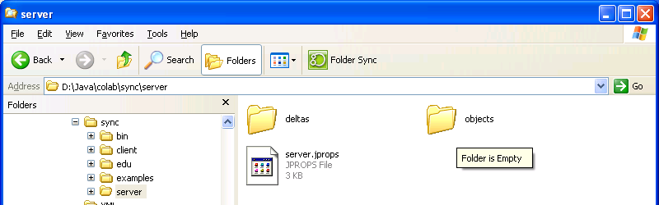

Figure 1 Server Directory Structure
Similarly, the client directory contains the file, client.jprops, which is read by the client when it is started. As shown below, it also is expected to contain subdirectory, objects, in which the client’s persistent state is stored.
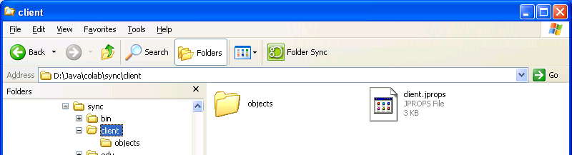
Figure 2 Client Directory Structure
If you wish to reset the state of the server and client, delete the items in the subdirectories of the server and client directories. If you don’t want your work to persist to another session, kill rather than shutdown the client and server. It is at shutdown that Sync writes to these directories.

More on server.jprops and client.jprops below.

Server
After setting our class path, we can start the server at buzzard using the following command:

java edu.unc.sync.server.SyncServer &

The server creates the following window:
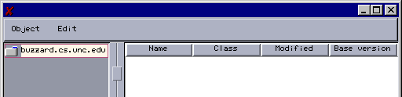
Figure 3 Server Window
It is like the Windows folder Explorer window in that it shows a folder hierarchy, with each item in a folder associated with a name and modified-time attribute. Unlike a Windows-folder, however, a Sync folder shows contains objects rather than files. The class attribute gives the name of class of the object. Moreover, Sync allows multiple versions of an object to co-exist. The base version attribute describes the latest version of object in the server. Finally, a Sync folder is like a Groove workspace in that it can be replicated on multiple computers. Unlike Groove, it is a client-server rather than a peer to peer system, as we see below.

Clients

We can directly create objects at the server using the window above. However, normally, objects managed by the server will be created indirectly through clients. Let us create clients at quartet.cs.unc.edu and swan.cs.unc.edu by executing the following command at each of the two computers:

java edu.unc.sync.server.SyncClient driver buzzard.cs.unc.edu &

The argument, buzzard.cs.unc.edu, indicates the name of its default server. The client uses the argument to automatically “mount” the server folder a la NFS, that is, open the server and creates a replica of the server directory in its local space. (As we see later, a client can be asked to dynamically mount other servers.) This is shown in the top client window below. This window is much like the server window except that it shows the buzzard replica as a component of the local directory. The buzzard.cs.unc.edu entry on the same level as local is simply a placeholder for the server – it can be used to execute commands that refer to the server. We will ignore it in this discussion.

The argument, driver, to the command asks for the second client window below to be created. This window supports real-time collaboration and some additional commands not provided by the top window. It was added to the original version of Sync – hence the lack of integration of the two windows.

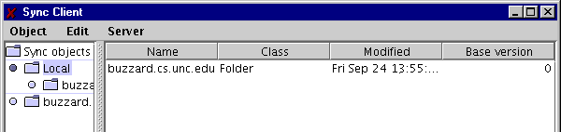
Figure 4 Client Window after Opening and Replicating Server
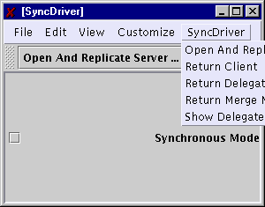
Figure 5 Client Driver to Set Collaboration Mode

Creating New Objects

Let us select the mounted server directory in the quartet client:

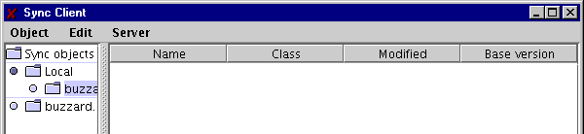
Figure 6 Selecting the Mounted Server Directory Before Adding an Object to It
As we see above the directory is currently empty. The Object→New command shows us the kind of objects we can create in this directory. We must select a folder, as shown in the figure above, before executing the command.
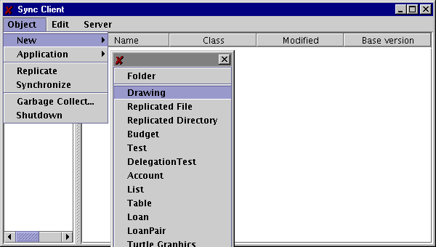
Figure 7 Adding a Drawing Model and View
As in a Windows folder, we can add new folders and files to the selected folder. In addition, we can add other kinds of objects listed in the menu shown above. As we will see later, it is possible to add new kinds of objects. Let us select the Drawing item, as shown above. The quartet client creates two windows: a canvas for drawing and a “merge matrix” window, shown below. We will ignore the merge matrix in this document.

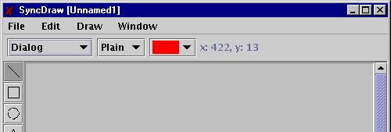
Figure 8 The Drawing User Interface
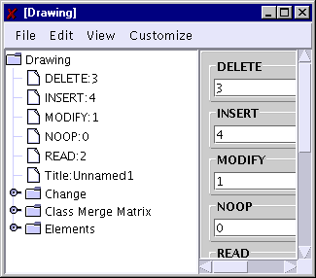
Figure 9 Drawing Merge Matrix

The quartet client also adds an entry representing the newly created drawing object to the replicated server folder, as shown below.
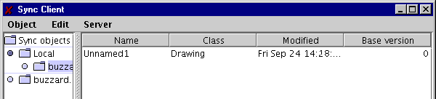
Figure 10 The Drawing Model Entry in Client Replica
This entry is not automatically replicated in the server at buzzard, or the other client at swan, as shown in the figure below.

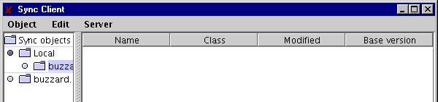
Figure 11 The Model is Not in Server Replica
Let us add a new Text object to the replicated server directory at swan by selecting it (figure above) and executing the Object→New→Text command, as shown below.

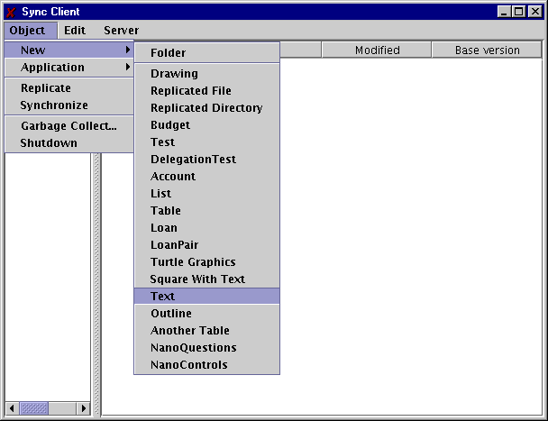
Figure 12 Adding a Text Model and View at Another Client
The swan client creates a window to enter a string.
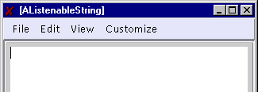
Figure 13 Text Application
In addition, it adds a new entry representing the text object to the replicated folder.

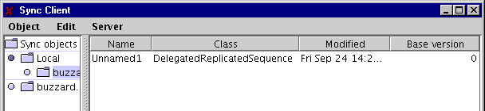
Figure 14 Text Model Entry in Local Client Replica
The type of the text object is called DelegatedReplicatedSequence because it was created using delegation rather than inheritance. This class acts as a proxy between the actual class of the text object and the original Sync system.

Synchronizing Concurrent Changes
Let us now do parallel work at quartet and swan. At quartet, let us add a rectangle to the canvas:

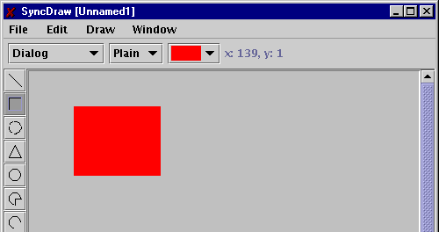
Figure 15 Adding a Shape at Quartet
At swan let us add enter some text:
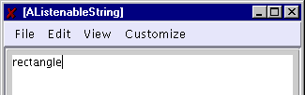
Figure 16 Adding Some Text at Swan
At this point, we are ready to check-in the two objects to the server. Before doing so, however, we must rename them as they currently have the same name. Like a Unix or Windows folder, a Sync folder requires each item to have a unique name. If we check-in two objects with the same name, the second one checked-in will replace the first one.

We can change the name of an entry double clicking on the name field, which gives us an editing cursor, and then editing the existing name. Let us change the name of the drawing object at quartet to “myDrawing,” and the name of the text object to “hisText:”
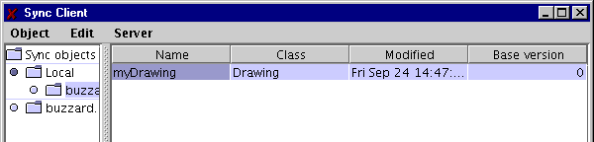
Figure 17 Changing Model Name at Quartet
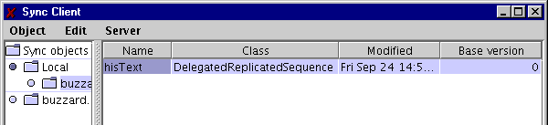

Figure 18 Changing Model Name at Swan
Let us first check-in the changes made at quartet. To do, we select the replicated folder as shown above and execute the Object→Synchronize command shown below. It is not possible to check-in parts of a folder, the entire replica must be chosen.

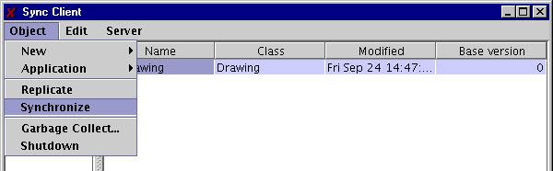
Figure 19 Synchronizing Quartet
If we look at the server’s folder window, we see the new entry has been added:

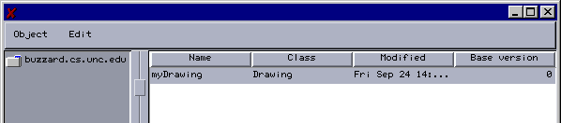
Figure 20 Server Replica Receives Quartet Changes
However, the new drawing item is not added to the swan replica of the shared folder:

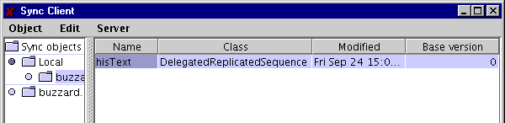
Figure 21 Swan Replica Does Not Receive Changes
Let us now execute the Object→Synchronize on the swan replica:
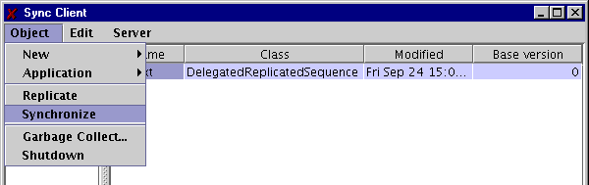
Figure 22 Synchronizing Swan Replica
The client and server now exchange changes that the other party has not seen. The client receives the drawing object:
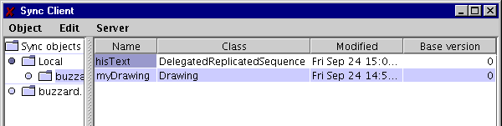
Figure 23 Swan Replica Receives Quartet Updates
Conversely, the server receives the text object.
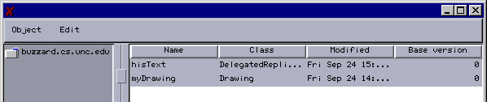
Figure 24 Server Replica Receives Swan Updates
The quartet client, however, is out of date at this point:
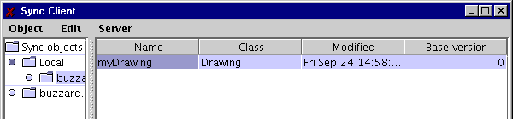
Figure 25 Quartet Replica Does not Receive Swan Changes
To make it current, we can execute the Synchronize command again at quartet:
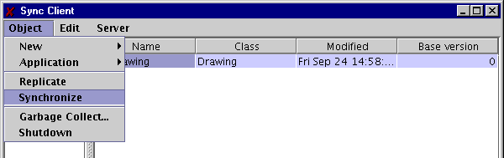
Figure 26 Synchronizing Quartet Again
It receives all changes checked-in at the server since the last time it synchronized:
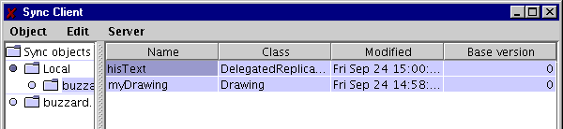
Figure 27 Quartet Replica Receives Swan Updates

Displaying an Object

Receipt of a new object does not automatically create an editor for it. We must select the entire entry and then double-click on it. Thus, if we double click on the new text object entry at quarter, we will be able to view it:

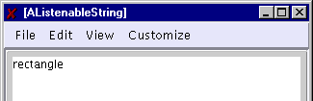
Figure 28 Creating a View for Received Object from Remote Client

Fine-Grained Synchronization
At quartet, let us insert some text at the beginning of the shared string.
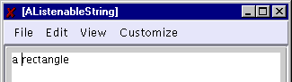
Figure 29 String Prefix Added at Quartet
At swan, let us add some text to the end of the shared string:
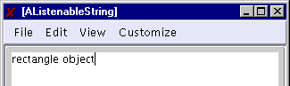
Figure 30 String Suffix Added at Swan
Let us similarly make concurrent changes to the drawing replicas. At quartet, let us add a new shape:
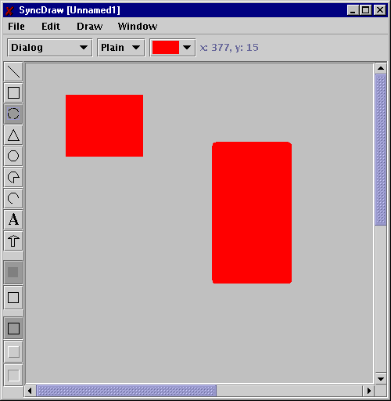
Figure 31 New Shape Added at Quartet

At swan, let us move the shared rectangle to a new position:

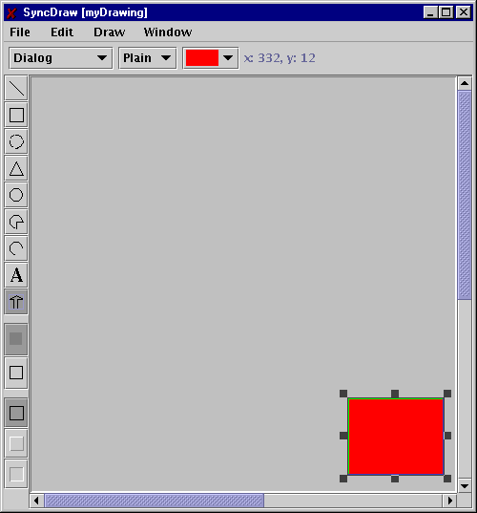
Figure 32 Original Shape Moved at Swan

Now let us first synchronize at quartet and then synchronize at swan. The windows at swan show the changes made at quartet, but not vice versa. We must execute the synchronize command again from quartet to receive the changes checked in by swan. At this point the drawing and text objects at both client sites show both sets of changes:
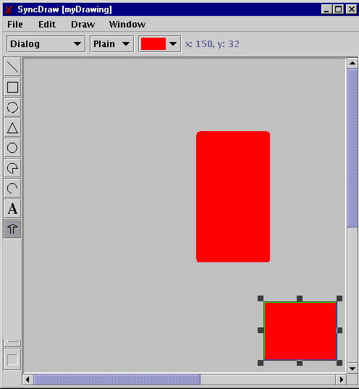
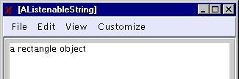
Figure 33 Synchronizing Quartet

As we see above, Sync does fine-grained merging to combine the two sets of changes.

Real-Time Synchronization
Sync also supports real-time synchronization, which allows users to automatically exchange changes made to replicated folder as side effects of changes to the objects in the folder. Let us check the real-time checkbox in the driver windows created at quartet and swan:
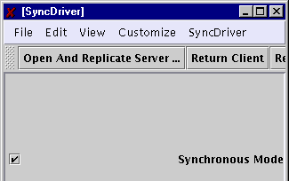
Figure 34 Asking for Incremental Push-based Synchronization at Quartet
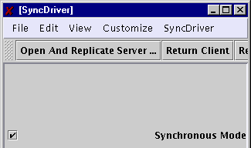
Figure 35 Asking for Incremental Push-based Synchronization at Swan

Now, incremental changes made to the text and drawing objects are automatically exchanged – there is no need to execute explicitly the synchronize command.
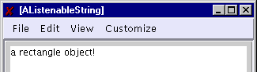
Figure 36 Real-time Sharing of Text Object
For example, if we add an exclamation mark to the shared string at quartet, it is automatically propagated to swan without requiring the users to explicitly execute the Synchronize commands. The communication may not appear to be in real-time because of the extensive print statements and the fancy merge algorithm employed by Sync.

Dynamically Opening and Replicating Multiple Servers
It is possible to replicate multiple servers at a client. Let us start the rmi registry and server at quartet. We see an empty folder:

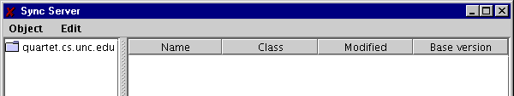
Figure 37 Starting a Server at Quartet

Now at swan, let us create a link to this server by executing the Open Server command.
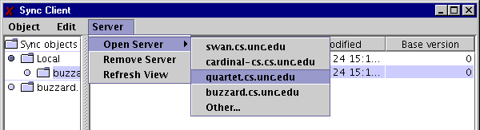
Figure 38 Opening the Server at Swan
The link is created on the same level as the local directory and the buzzard link.
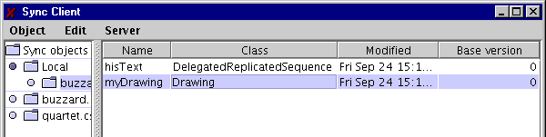
Figure 39 Entry for Opened Server
Let us now select the newly created link:

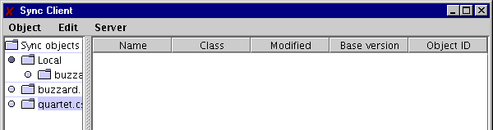
Figure 40 Selecting the Opened Server
and execute the Object→Replicate command:
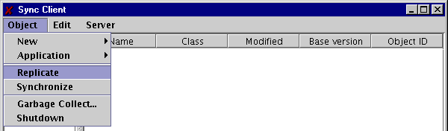
Figure 41 Selecting the Replicate Command
A replica of the quartet is mounted as a subdirectory of local:
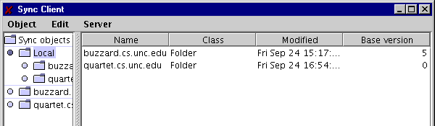
Figure 42 Server is Replicated in Local Directory
If we select it, we see that it is empty, as the buzzard directory was at the beginning of this interaction:

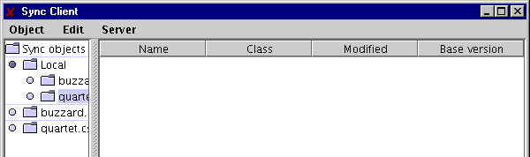
Figure 43 Selecting Local Replica of Quartet at Swan
As before, we can not add new objects to this directory:
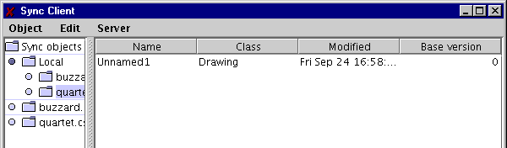
Figure 44 Adding an Object to Selected Replica
and then check them into the server:
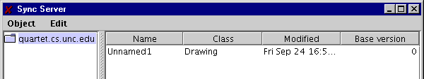
Figure 45 Synchronizing to Server Replica
If a server you want to open is not listed in the Open Server menu, use the other menu item to enter its name or put its in the client.jprops file discussed below.

server.jprops and client.jprops
Recall that these are files stored in the server and client directories, respectively, whose locations are given by the sync.jprops file. Their main purpose to define the semantics of the Object→New menu.

The following is an extract of the server.jprops file.

localhost=buzzard.cs.unc.edu
domain=cs.unc.edu
objects=Replicated_Directory Text
Replicated_Directory.class=SyncFiles.ReplicatedDirectory
SyncFiles.ReplicatedDirectory.editor=SyncFiles.FileEditor
Text.class = bus.uigen.AListenableString
bus.uigen.AListenableString.editor=SyncObjectEditor

The file indicates the name of the server and its domain. In addition, it describes the kinds of applications that can be created using the Objects→New menu at the server. The list of application kinds is entered in a line beginning with the string “objects=”

objects= Replicated_Directory Text …

Each name specified in the line is put in the Objects→New menu after replacing each underscore character with a space. The name stands for a model-view pair that together define an interactive application. The model defines the semantics of the application while the view defines its user interface. Sync replicates only the model part of an application, allowing each client to view the model independently. Thus, when you decompose an application into a model and view, put all the state you wish to share in the model.

The class of the model part of an application is specified by a line of the form:

<application name>.class= <Model Class>

while the class of the view of the model is specified by a line of the form:

<Model Class>.editor=<View Class>

Thus:

Text.class=bus.uigen.AListenableString

says that the class of the model part of the application named “Text” is bus.uigen.AListenableString. The line:

bus.uigen.AListenableString.editor=SyncObjectEditor

says that that view class associated with this model class is SyncObjectEditor.

As we see below, SyncObjectEditor is a generic user-interface class for Sync model classes. It is possible to define your own user-interface classes, as illustrated by the definition of the model and view of the application that replicates (OS) folders and displays them:

Replicated_Directory.class=SyncFiles.ReplicatedDirectory
SyncFiles.ReplicatedDirectory.editor=SyncFiles.FileEditor

The client.jprops file is very similar to the server.jprops file, as shown in the following extract:

servers=swan.cs.unc.edu cardinal-cs.cs.unc.edu quartet.cs.unc.edu buzzard.cs.un
c.edu
objects=Replicated_Directory Text
Replicated_Directory.class=SyncFiles.ReplicatedDirectory
SyncFiles.ReplicatedDirectory.editor=SyncFiles.FileEditor
Text.class = bus.uigen.AListenableString
bus.uigen.AListenableString.editor=SyncObjectEditor

Like the sever file, it lists the applications that can be started from the client and the models and the model and view of each application. Unlike the server file, it does not mention the local host or domain. Instead, it specifies a list of servers:

servers=swan.cs.unc.edu cardinal-cs.cs.unc.edu quartet.cs.unc.edu buzzard.cs.unc.edu

Each of these server names is put in the menu Object→Open Servers.

When you add a new application, you must add information about it to server.jprops and each client.jprops you have created. If all your clients share a common file, then you need to edit only one of them. If you will not start the application from the server, you need to change only the client file.

Inheritance-based Approach

Ideally, it should be possible for Sync to replicate any Java model. However, this is impossible as an arbitrary object is a blackbox and Sync need to know some semantic information about the object. For example, to support fine-grained replication of a text object, it must know how to decompose it into its elements.

In the original version of Sync, the application programmer conveyed the necessary semantics by creating new model classes as subclasses of Sync predefined model classes. Sync defines several atomic model classes such as ReplicatedInteger and ReplicatedString. In addition, it defines
three structured model classes, ReplicatedRecord, ReplicatedSequence, and ReplicatedDictionary, which represent objects whose structure corresponds to a record, variable-length sequence, and hashtable. These three predefined classes do not specify the side effects that that occur when methods are invoked on them – that is the job of the programmer-defined subclasses of these classes. All replicated classes inherit from Replicated.

To illustrate these classes, consider the following extract from the ReplicatedDirectory class

public class ReplicatedDirectory extends ReplicatedDictionary implements FileWrapper {
…
public Replicated remove(Object key)
{
Replicated value = super.remove(key);
if (value instanceof FileWrapper) {
File file = ((FileWrapper) value).getFile();
if (file.exists() && !delete(file)) toBeDeleted.addElement(file);
}
return value;
}
}

As we see above, a (file-system) directory is simply represented as a subclass of ReplicatedDictionary, with the keys and values of the dictionary holding the names and contents of the items in the directory. As also illustrated above, the subclass takes appropriate side effects when Dictionary methods are called.

Similarly, the model of the drawing application we saw above is an extension of the ReplicatedSequence class:

public class Drawing extends edu.unc.sync.ReplicatedSequence {
String title;
public Drawing() { super(10); }
public void setTitle(String title) {this.title = title;}
public String getTitle() {return title;}
}

Each shape in the drawing is stored as an element of the sequence. The only method this class overrides is the constructor. In addition, it provides two additional methods to set and get the title.

To illustrate the use of other Sync atomic and record types, consider the following code:

public class Budget extends ReplicatedRecord {
public ReplicatedFloat Overhead = new ReplicatedFloat(0);
public ReplicatedInteger NumberOfResearchers = new ReplicatedInteger(0);
public float getTotal() {
return Overhead.floatValue()+ NumberOfResearchers().intValue()*RES_COST;
}
}

Here, we have extended ReplicatedRecord to indicate that the object structure is that of a record with a fixed number of fields of possibly different types. Each of these fields must be declared as public to allow Sync to access them. Moreover, each field must of a replicated type to allow it to be replicated.

While the above based approach is convenient in comparison to the one we see later, these examples illustrate several problems with it:
- Arbitrary element types: The elements of a sequence and dictionary can be arbitrary replicated objects. The subclasses cannot constrain these to more specific types, as the signatures of the methods to access the elements are defined by Sync.
- Encapsulation broken: The fields of a replicated record must be made public, which forces programmers to break encapsulation.
- Inheritance problems: In a single-inheritance system like Java, a replicated class cannot inherit from a programmer-defined class.
The last item in the list is one of several disadvantages of inheritance based approaches in general. The alternative is to use delegation (http://www.cs.unc.edu/~dewan/114/notes/13.Delegation.htm) and programming patterns. We see below this solution.

Delegation-based Approach
It is possible to turn any inheritance-based solution to a delegation-based one. This would allow us to overcome the third problem described above. To address problems 1 and 2, we rely on programming patterns and standard events. Programming patterns are relationships among signatures of object methods that convey semantic information about it. Standard events are notifications sent by models to their views and other observers that follow a prescribed protocol. For each of the three structured classes, we will define a set of programming patterns and standard events that, if followed in the implementation a programmer-defined class, creates a class that delegates to rather than inherits from the structured class. The delegation will be done through a proxy class.

Records
To illustrate, consider the following equivalent of the Budget example above:

public class Budget implements Serializable{
float overhead = 0;;
int numberOfResearchers = 0;
public float getOverhead {
return Overhead;
}
public void setOverhead(float newVal) {
overhead = newVal;
propertyChange.firePropertyChange("Overhead", null, new Float(newVal));
propertyChange.firePropertyChange("total", null, new Float(getTotal()));
}
public int getNumberOfResearchers() {
return numberOfResearchers;
}
public void setNumberOfResearchers(int newVal) {
numberOfResearchers = newVal;
propertyChange.firePropertyChange("numberOfResearchers", null, new Integer(newVal));
propertyChange.firePropertyChange("total", null, new Float(getTotal()));
}
public float getTotal() {
return getOverhead() +getNumberOfResearchers().*RES_COST;
}
PropertyChangeSupport propertyChange = new PropertyChangeSupport(this);
public void addPropertyChangeListener(PropertyChangeListener l) {
propertyChange.addPropertyChangeListener(l);
}
public void removePropertyChangeListener(PropertyChangeListener l) {
propertyChange.removePropertyChangeListener(l);
}
}

This class illustrates the patterns and events defined for ReplicatedRecord. To define a record field, F, of type T, the programmer defines the following two methods for reading and writing, respectively, the field:

T getF();
void setF(T newVal);

Thus Sync record fields are defined by JavaBean properties. As in a JavaBean, changes to properties must be announced using property events defined by the JavaBean framework. The standard class, PropertyChangeSupport can be used to register observers and broadcast property changes to these observers. A primitive value must be transformed into the appropriate object value when it is announced using firePropertyChange. The second parameter of firePropertyChange is the old value of the changed property, which Sync ignores. Thus, it is legal to use null for it. The methods for registering and un registering observers must follow the exact signatures given above.

When Sync instantiates the above class, it creates an instance of DelegatedReplicatedObject, which acts as a proxy between the original inheritance-based world of Sync and the delegation-layer added to it. To the original Sync system, the Budget instance is represented by the proxy. It is the class of this proxy rather than Budget that is used to label a Budget instance in the Sync folder browser.

JavaBeans does not define patterns and events for objects whose (logical) structure is a sequence or hashtable. Therefore, we need to define special patterns and events for them.

Sequences
The following is an example of an object whose structure is a sequence:

package outline;
import java.util.Vector;
import java.util.Enumeration;
import bus.uigen.VectorChangeSupport;
import bus.uigen.VectorMethodsListener;
import bus.uigen.VectorListener;
public class AnOutline implements java.io.Serializable{
Vector contents = new Vector();
public void addString() {
addElement("");
}
public void addOutline() {
addElement(new AnOutline());
}
public void addElement(Object element) {
contents.addElement(element);
vectorChangeSupport.elementAdded(element);
}
public void removeElement(Object element) {
contents.removeElement(element);
vectorChangeSupport.elementRemoved(element);
}
public Enumeration elements() {
return contents.elements();
}
public void setElementAt(Object element, int index) {
System.out.println("AnOutline:" + element + "at:" + index);
contents.setElementAt(element, index);
vectorChangeSupport.elementChanged(element, index);
}

VectorChangeSupport vectorChangeSupport = new VectorChangeSupport(this);

public void addVectorMethodsListener(VectorMethodsListener vectorListener) {
vectorChangeSupport.addVectorMethodsListener(vectorListener);
}
public void removeVectorMethodsListener(VectorMethodsListener vectorListener) {
vectorChangeSupport.removeVectorMethodsListener(vectorListener);
}
/* the ones below needed for automatic user interface generation */
public void addVectorListener(VectorListener vectorListener) {
vectorChangeSupport.addVectorListener(vectorListener);
}
public void removeVectorListener(VectorListener vectorListener) {
vectorChangeSupport.removeVectorListener(vectorListener);
}
}

The class defines a sequence of elements of type Object. In general, to define a sequence of elements of type T, a class must define methods with the signatures:

public void addElement(T element);
public void removeElement(T element);
public Enumeration elements() ;
public void setElementAt(T element, int index);

In addition, it must define the following methods for adding and removing observers:

public void addVectorMethodsListener(VectorMethodsListener vectorListener) {
vectorChangeSupport.addVectorMethodsListener(vectorListener);
}
public void removeVectorMethodsListener(VectorMethodsListener vectorListener) {
vectorChangeSupport.removeVectorMethodsListener(vectorListener);
}

The class VectorChangeSupport is the equivalent of PropertyChangeSupport for keeping track of the observers and broadcasting events to them. Whenever the object changes, inserts, adds, removes an element from the sequence, it should call the appropriate method in this class, as shown above.

The methods addString(), addOutline(), addVectorListener(), and removeVectorListener() are not used by Sync. The first two are just convenience functions for calling addElement(). The second two are needed to use the facilities for automatic user interface generation mentioned below.

Hashtables
Finally, consider the following example to show how a Hashtable structure is defined:
package table;
import java.util.Hashtable;
import java.util.Enumeration;
import bus.uigen.HashtableChangeSupport;
import bus.uigen.HashtableListener;
public class ATable implements java.io.Serializable {
String name = "";
Hashtable table = new Hashtable();
public Enumeration keys () {
return table.keys();
}
public Enumeration elements () {
return table.elements();
}
public void put (String key, String value) {
table.put(key, value);
hashtableChangeSupport.keyPut(key, value);
}
public Object remove (String key) {
Object retVal = table.remove(key);
hashtableChangeSupport.keyRemoved(key);
return retVal;
}
HashtableChangeSupport hashtableChangeSupport = new HashtableChangeSupport(this) ;
public void addHashtableListener(HashtableListener hashtableListener) {
hashtableChangeSupport.addHashtableListener(hashtableListener);
}
public void removeHashtableListener(HashtableListener hashtableListener) {
hashtableChangeSupport.removeHashtableListener(hashtableListener);
}
}

In general, to define a hashtable associating keys of type T1 with elements of type T2 we must provide the following methods:
public Enumeration keys ();
public Enumeration elements ();
public void put (T1 key, T2 value);
public Object remove (T1 key);

Also, the table must provide the following methods for adding and removing observers:
public void addHashtableListener(HashtableListener hashtableListener) ;
public void removeHashtableListener(HashtableListener hashtableListener) ;
Like PropertyChangeSupport and VectorChangeSupport, the predefined class, bus.uigen.HashtableSupport keeps track of the observers and announces events to them. The put and remove methods must forward changes to this delegate class.

Compositions

Sync handles compositions of these classes. For example, the elements of a sequence can be objects whose structures are records, and vice versa.

User Interface
There are three approaches to creating the user-interface:
- Use SyncObjectEditor, which is built on top of ObjectEditor – a user-interface generator.
- Build a custom implementation of the user-interface, based perhaps on some freeware you have found on the web.
- Incorporate a custom implementation of the user-interface to ObjectEditor.

Automatic UI Generation
If we follow the programming patterns described above to create a new model object, it is possible to use SyncObjectEditor & ObjectEditor to automatically create the user interface of the model. Look at the test and graphics editing manuals at http://www.cs.unc.edu/~dewan/oe/ to understand how this works.

Creating a Sync View
We can also define our own Sync view. The nature of the view is illustrated by the SyncObjectEditor class:

import bus.uigen.*;
import edu.unc.sync.*;
import edu.unc.sync.server.*;
import java.util.*;
public class SyncObjectEditor implements SyncApplication, RT_SyncApplication{
SyncClient syncClient = null;
SyncServer syncServer = null;
private Vector editors = new Vector(1);
public SyncObjectEditor() {
System.out.println("SyncObjectEditor created");
}
public void addObject(Replicated o, String name) {
Delegated proxy = (Delegated) o;
Object model = proxy.returnObject();
Sync.delegatedTable.put(model, proxy);
uiFrame editor = ObjectEditor.edit(model);
editors.addElement(editor);
editor.setVisible(true);
}
public Replicated newObject(String className, String name) {
Object model;
try{
Class clss = Class.forName(className);
model = clss.newInstance();
}
catch(Exception e){
e.printStackTrace();
}
Replicated proxy = DelegatedUtils.convertObject(model);
Sync.delegatedTable.put(model, proxy);
((Delegated)proxy).registerAsListener();
uiFrame editor = ObjectEditor.edit(delegator);
editors.addElement(editor);
editor.setVisible(true);
return proxy;
}

public void doRefresh() {
uiFrame editor;
for (Enumeration e=editors.elements(); e.hasMoreElements();) {
editor = (uiFrame)e.nextElement();
try { editor.doImplicitRefresh(); }
catch (Exception ex) {}
}
}

public void init(Object invoker)
{
if (invoker instanceof SyncClient) {
syncClient = (SyncClient) invoker;
System.out.println("sync client invoked:" + invoker);
} else if (invoker instanceof SyncServer) {
syncServer = (SyncServer) invoker;
System.out.println("SyncServer invoker:" + invoker);
}
}
}

As shown above, the view must implement the interfaces SyncApplication, RT_SyncApplication. We consider below the methods in these interfaces.
The method :
public void addObject(Replicated o, String name)
is called whenever a new object created at a remote location is displayed by the local view. The name parameter specifies its name in the folder in which it was created. The Replicated parameter is either a model with which this view class is associated or the proxy for the model, based on whether the model was created using the inheritance or delegation approach. If the delegation approach was used, as in the case of SyncObjectEditor, then the Sync call returnObject() can be invoked on the proxy to return the real model. The next step is to create the user interface of the model. In this example, another class, ObjectEditor, is asked to display the extracted model. See www.cs.unc.edu/oe for a description of ObjectEditor.

The method:
public Replicated newObject(String className, String name)
is called when the user asks for a new model object to be created through a local view. Again, name is the name of the object in the folder in which it was created. className is the name of the class of the model. The method instantiates the model class. In the inheritance approach, the model is returned, while in the delegation approach, a proxy for the model is created and returned after binding it to the model. In the delegation approach, the proxy must be registered with the system by invoking the method, registerAsListener() on it. In either case, the local user interface of the model must be created.

As shown above, Sync provides facilities to create a proxy and bind it to a model using the call:

Replicated proxy = DelegatedUtils.convertObject(model);

The doRefresh() method is called whenever changes to the model are received from a remote site. If the model notifies the view using the notification events described above, then this method need not do anything. Otherwise, it should display the new state of the model.

The init() method is called when an instance of the view class is created. The argument specifies whether the view was created at a server site or a client site.

Incorporating a custom UI into ObjectEditor
An alternative to following this framework is to simply add the custom user interface to ObjectEditor. See the ObjectEditor customization manual http://www.cs.unc.edu/~dewan/oe/. The advantage of this approach is that you don’t have to worry about converting between proxies and regular objects and also you have created something that is independent of Sync and applies to single-user interaction also. This approach may be hard to use if you are reusing existing view code that creates its own frame as ObjectEditor expects to create its own frame and top-level menus.

The code shown above has not been compiled or run though it based on working code. Please look at the Sync examples directory for working (but perhaps less readable) code!

