COMP 190-088: Systems Performance Analysis

Assignment # 3

Due on: 3/24/05

Note:

- Plot all data graphs using gnuplot.

- For all computations, clearly show all intermediate steps. Do not simply write the final answer.

- You’re encouraged to discuss “approaches” with each other, but you must formulate the solution details on your own.

- Please typeset your homework in a font no smaller than 12 pt.

- Please be clear. Writing your arguments as points rather than as long paragraphs would make it easier to read and grade.

- In this problem, you will experiment again with the Apache web server and Surge http client request generator on the class testbed, and will profile the resource usage of the server.

  - Your goal is to use LTT to measure, as a function of the number of concurrent thread in Surge, the fraction of time spent by the Apache server:
    - In the processor (including accessing memory or file I/O)
    - In network I/O

  - For each setting of number of Surge threads,

    - Construct a Markov chain for Apache’s transition between these resources (each state is one or none of the 2 resources---processor, network I/O, idle).

    - Do the models change with the number of threads? If so, what conclusions can you draw about the impact of client load on Apache’s behavior?

    - How valid is the Markovian assumption for this system (test it visually)?

Be smart in selecting the different settings of number of threads to try out; the total number of settings should not be too large, but the settings should sample the complete range of values that are likely to be interesting.

And again, also remember that the NICs set up so that each client request experiences a random amount of network delay on the link to the server. This delay is different for different http client requests and is selected randomly. This implies that different runs of Surge with the same command line parameters will yield different results. So make sure you repeat each experiment several times to get the mean behavior.

Save all your scripts and data! You might need it in a subsequent homework.
[60 points]

- Consider a single-server system with discouraged arrivals in which the arrival rate is only λ/(n + 1) when there are n jobs in the system. The inter-arrival times, as well as the service time, are independent and identically distributed with an exponential distribution. Using a birth-death process model for this system, develop expressions for the following (assume infinite buffers):

  - State probability pn of n jobs in the system
  - State probability p0 of the system being idle
  - Mean number of jobs in the system, E[N]
  - Effective arrival rate λ′
  - Mean response time E[R]
[20 points]

- Consider a two-server system with arrivals at the rate of ½ (requests per second) and the service rate of each individual server of ½ (requests per second). Let the buffer capacity of the system be 3 requests. (Note that these are the same settings as used in the lecture discussion.)

If a server fails at rate f and the repair time takes 1/r time units, compute and compare the throughput of the following system configurations:
  - Common-queue system
  - Random-line system
  - Shortest-line system
[30 points]

- In what ways may the following pictorial representation of oil prices in 1980 and 1981 be misleading?

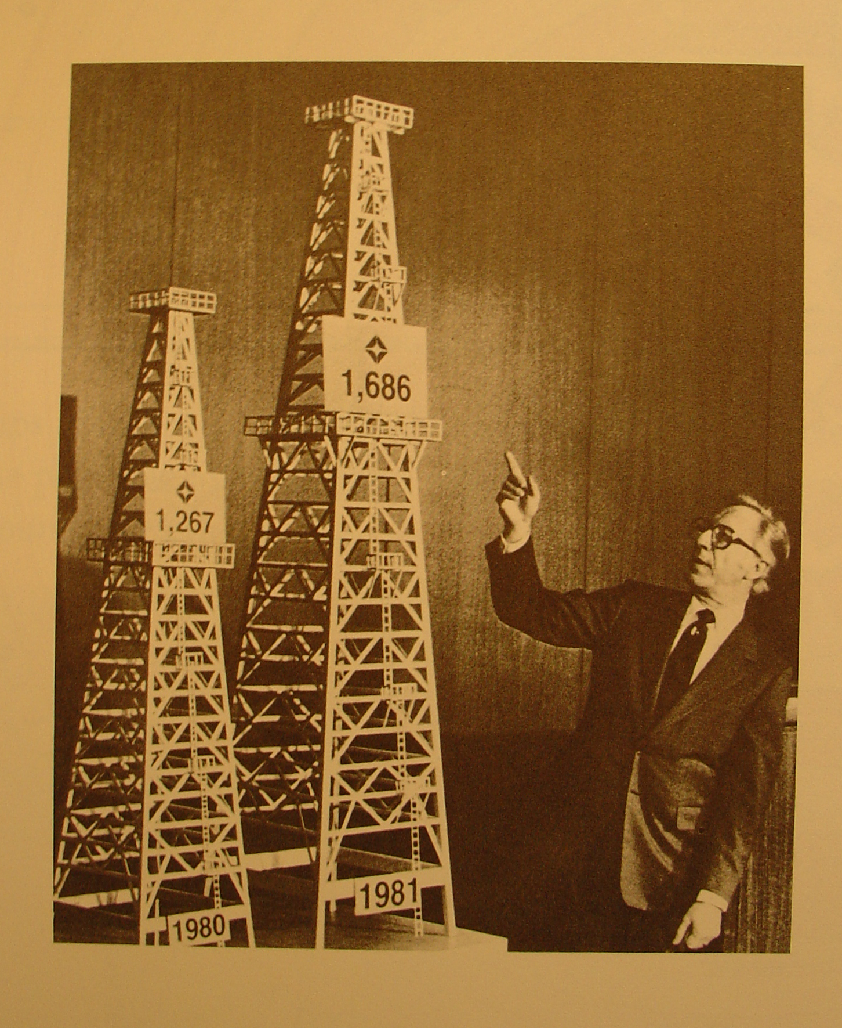

[10 points]

