Particle Dynamics
Comp768: Physically-Based Modeling, Simulation and Animation

Review of Basics
Work done by the force F(x) on a particle is W = ∫ F(x) dx

Example: Spring Force
F_{s} = -k x W_{s} = -1/2 kx²

Example: Kinetic Energy
F = ma W_{k} = ½ mv²

Linear momentum of a single particle of mass m with velocity v is
p = mv

Collision between a Particle and Fixed Obstacles
In our discussion of motion, we have been treating a particle as an entity without spatial extent. You can think of it as an infinitesimal sphere. But sometimes it is OK to treat something larger as a particle. The bottom line is that we do not consider the volumetric distribution of mass. Even if a particle is big, its mass should be concentrated at a point.

Now if two particles have finite sizes, they may collide each other. We can also consider a rather artificial situation, where we have a fixed obstacle. For example, if we have a rigid wall firmly attached to the earth, we can assume the wall does not move. Since we can concentrate the movement of a single particle, we will start with the collision between a particle and a fixed obstacle.

Collision Response

So far, we looked at examples where the forces act on a particle are continuous functions of time and space. For example, gravity and linear spring forces do not change abruptly. But if the particle collides with another particle or a fixed obstacle, the forces between them are very large and act in a very short time.
Let’s consider a particle with mass m and velocity v collides against an immovable wall. The surface of the wall is frictionless, and this collision is elastic. What does it mean? Let’s look at the collision in microscopic scale. The wall can be seen as a very slippery board held by many springs from behind.
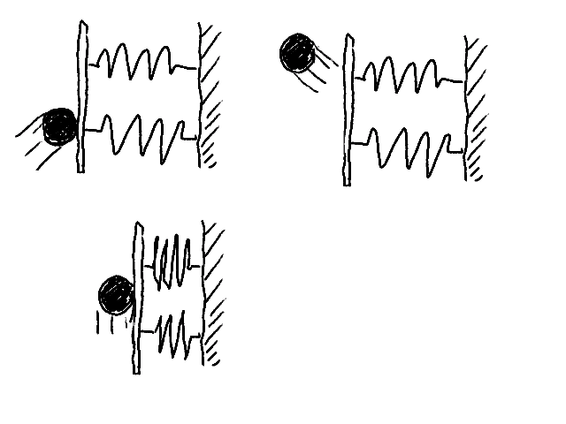
As soon as the particle touches the plate, it starts pushing the plate, and compresses springs behind it. The particle is pushed backward by spring forces, so it speeds down and eventually stops at a point, then the plate pushes the particle back while decompressing the springs. This is what happens in the normal direction. If the collision is elastic, kinetic energy should be conserved. Therefore, magnitude of velocity stays the same, but the direction should be flipped. In the tangential direction, the particle slides on the plate in the entire duration of the collision. Since the surface is frictionless, no tangential component of velocity will be changed.
$\begin{aligned}v_{n}^{'}=−v_{n} \\ v_{t}^{'}=v_{t}\end{aligned}$where v_{n} and v_{t} are normal and tangential components of the velocity of the particle before collision. And, v’_{n} and v’_{t} are the corresponding components of the velocity after collision.
If we approximate this spring force and the duration of collision by F and τ, their product is the same as the difference of momentum before and after the collision;
$mv_{n}^{'}−{\text{mv}}_{n}=−2{\text{mv}}_{n}=Fτ=P$Since we consider the wall as a rigid body, the spring is infinitely stiff. As the spring’s stiffness goes to infinity, F goes to infinity, hence τ goes to zero. Forces work in such a short time are called impulsive forces, and the product P is called impulse. The time τ is too short for ordinary forces such as gravity to affect the particle. When we deal with impulse, we can ignore all other ordinary forces.
If the collision is inelastic, the energy of the particle will be partially lost.
$v_{n}^{'}=−{βv}_{n}$where β (0≤β≤1) is a material dependent constant.

Contact Point Determination
As we saw in the previous section, we can trace the trajectory of a particle step by step. Let’s continue to use the particle-wall example. In each time step, collision between the particle and the wall should be checked. If collision is found, that means the particle is inside the wall, which should not happens. The collision response can be computed only if we know the exact time and position of the collision
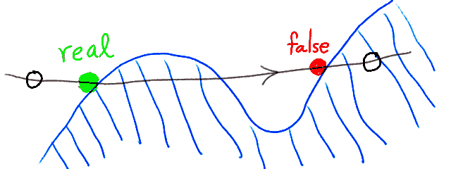
Let’s suppose the particle is outside the wall at the time t. and inside at the time t+Δt. Now, all we know is that the collision happened sometime between t and t+Δt. We can go back to t and integrate the ODE for only Δt/2, then check the collision again. If there is a collision, go back again, otherwise proceed integration. In either case, the step size is halved. Recursive application of this procedure will converge to the exact contact point (bisection method). This method is one of discrete sampling methods, because it is only concerned about discrete points between time steps. It may miss actual contact as shown in the figure below. As we will learn later from lectures on collision detection, we can estimate the time to collision based on the distance between the particle and the obstacle, and the velocity and the acceleration of the particle. We will discuss this scheduling scheme prior to the lectures on rigid body dynamics.
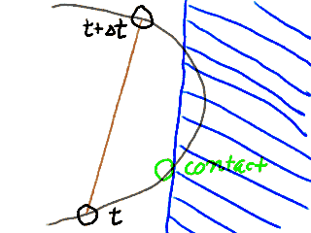
Another way to prevent such “pass-through” problems is to consider the trajectory as a curve. The easiest way is linear interpolation between t and t+Δt. The real trajectory is an unknown curve, so this method may miss the real contact, too.

We can use higher order curves by interpolating multiple points. (It is similar to multipoint methods of ODE solution, but note that the typical multipoint methods interpolate derivatives not positions of particles.) It may alleviate the problem, but there is no guarantee. The interpolation can be done before ODE solution. Instead of tracing the trajectory as successive points, we can “fit” high degree curves (usually piercewise polynomial) to the given ODE. It is called finite element methods (FEM). We will study them in a later section.

Now, given a trajectory as a closed form function, how can we find the “first” contact point? If algebraic equations of the obstacle are known, we can solve ODE and the contact point at once by using Differential Algebraic Equation (DAE). We will discuss the method later in the constrained dynamics section.

