Augmented Desktop

Ryan Schubert
University of North Carolina at Chapel Hill
res@cs.unc.edu

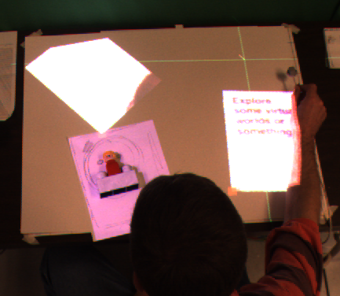
- A user interacts with two virtual documents and a physical document on the augmented desktop surface.

Abstract

There are certain properties of physical documents and electronic documents that make one or the other preferable in some situations as opposed to others. For instance, a physical document can be held, moved around, and is easier on the eyes to read, whereas an electronic document can be easily edited, copied, or searched. This project aims to help bridge the gap between physical and electronic representations of documents by providing a few limited means of interacting with both simultaneously as well as transferring information between the two media.

Keywords: intelligent environments, augmented reality, projected AR

Introduction
This project provides a implementation solution to a system that allows a user to interact simultaneously with physical and virtual pages on a desk. The user can quickly and intuitively rearrange the placement of virtual pages as well as being able to make a virtual copy of a physical page which can then be manipulated. A projector is used for displaying virtual documents while a mounted camera is used to capture physical documents and could later be extended to perform more important tasks such as automatic feature detection or image-based tracking.

Equipment Configuration
The setup for this project is based around a desk or table with a non-shiny white top surface. Projecting down onto the desk from above is a standard projector, ideally mounted either directly overhead or on the side away from where a user will be using the desk. Also mounted on the ceiling is a camera, such that the field of view captures the entire desk surface.

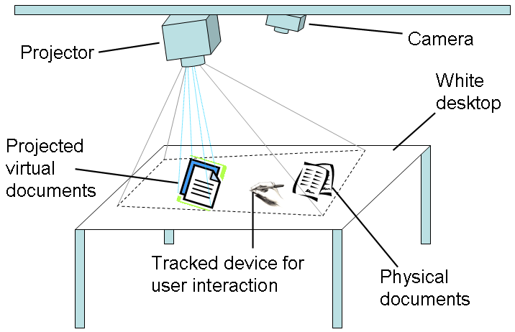
- The setup of the augmented desk area.
Depending on the specific means of tracking, additional equipment may be necessary. For the development of this project a Polhemus tracker was used.

Projector calibration
The projector is not constrained to being oriented directly above and perpendicular to the desk surface, but rather it can be advantageous to have the projector more on the side opposite where a user will be sitting to avoid the user occluding the projected area. In this project the projector was actually located significantly to the side of the desk, and angled inwards. Because of the possible distortion in the resulting projection onto the plane of the desk surface, the application requires a calculated projection matrix that will map from points in desk-space into the correctly corresponding normalized device coordinates that will result in a point being projected onto the correct location. Obtaining this projection matrix requires measuring several combinations of corresponding NDC and desk-space points and then solving the over-constrained linear equations such that the result is a matrix that when multiplied with a point specified in homogeneous desk-space coordinates, results in the correct screen-space coordinates to project to the original desk-space location.
Note that for this project the projection matrix calculated actually converts from x, y, z coordinates in desk-space into screen-space, even though the z component is not used at this time and is therefore always zero. This results in a 4 by 3 matrix, which must be expanded with a row of zeroes in the third column position to obtain the 4 by 4 projection matrix to use with OpenGL for the rendering.

Camera calibration
Similar to the projection calibration, a conversion between desk-space and image-space in the camera view must be calculated. However, for the sake of simplicity in this project, because all points of importance on the desk were all at the surface, all that was needed was a mapping from 2D desk-space to 2D camera image-space. Data points were taken for this calibration by projecting points at known desk-space locations (using the projection matrix determined in the projector calibration step), capturing an image with the camera, and then finding the image-space coordinates of the corresponding points.

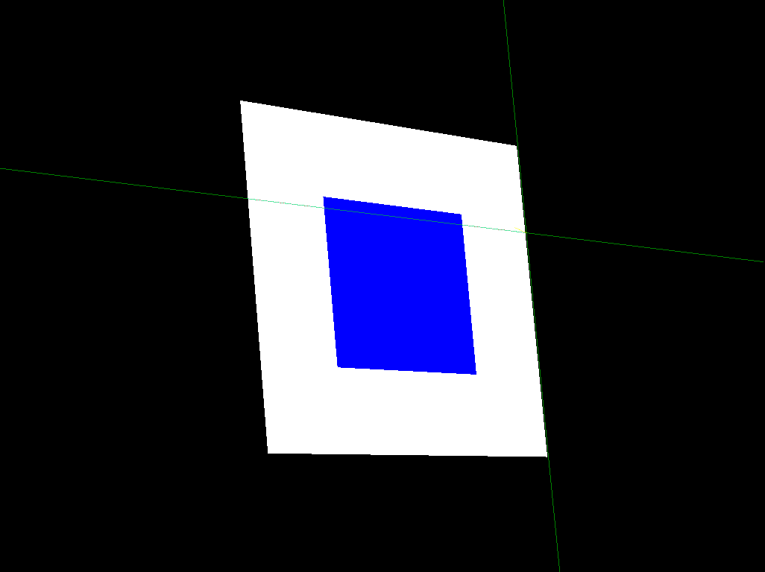
- Screenshot of the pattern used for camera calibration. Note that the corners of the squares are at +-10 and 20 cms in desk-space and are not specified in screen-space.
In this manner an arbitrarily located and oriented quadrilateral on the table can be mapped into the corresponding area in the captured image, which can then be used as a texture on another virtual object. This process is important for producing a virtual copy of a physical document in the workspace.

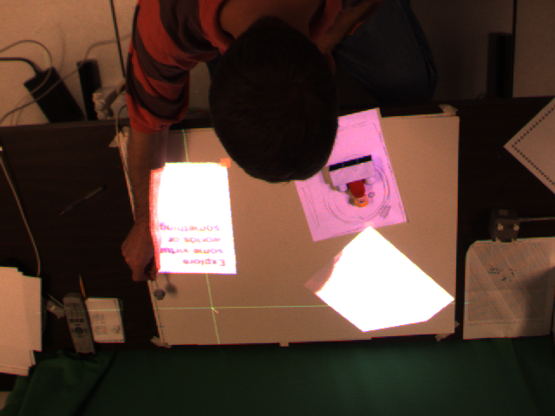
- An example of an image captured from the camera, showing the desktop surface with two virtual documents and a physical document.

Tracking
Good tracking is essential for an augmented desktop environment of this type. A magnetic Polhemus tracker was used in the initial development with several good and bad consequences. The Polhemus returns an abundance of tracking information with a relatively noninvasive setup, including x, y, and z position and 3D orientation as a quaternion. Although only the x and y tracking information was absolutely necessary, the z tracking was used to implement the ‘lifting’ method of interacting with virtual documents on the desk and the orientation was used to allow a user to intuitively rearrange documents at arbitrary orientations on the desk surface.

Tracker calibration
The Polhemus was calibrated in a very quick and non-robust method, largely due to the fact that the large distortion was far more significant as a source of tracking error than poor calibration. It was assumed that the magnetic field generator was positioned such that the x and y directions were already oriented correctly.

By recording the tracked values at the desk-space origin and a known offset (-20 cm, -20 cm was used) the x and y conversion scales and offset could be calculated to convert from the tracker values to corresponding desk-space coordinates.

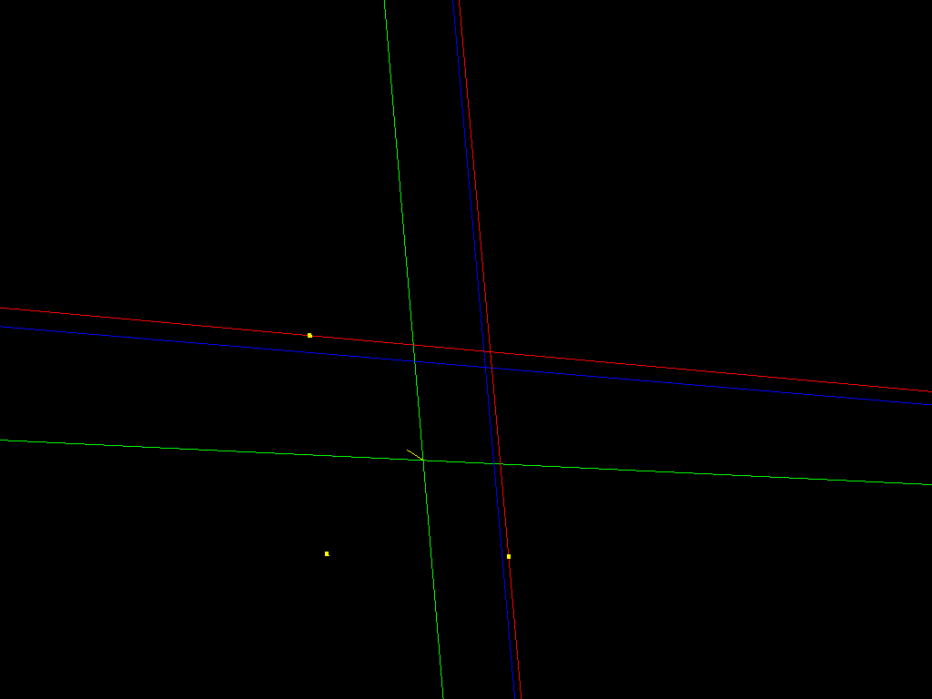
- The screen image used for tracker calibration. The red lines project onto the desk-space x axis and y axis to show the origin. The yellow spots are at -20 cms along each axis. The green crosshairs show the current tracked position. The blue lines show uncalibrated tracker distance from the table-space origin.

Ideal tracking for an augmented desktop
Despite its benefits the Polhemus is not an ideal tracking device for this application, for several reasons. First and foremost the Polhemus introduces far too much error due to distortion. Any nearby metal objects will affect the magnetic field used for tracking, causing significant changes in the reported position and orientation. Also, even in the absence of metallic objects, the range within which the magnetic field is sufficient for accurate tracking is small, leading to extreme amounts of distortion as the tracked device moves out of that range. In the initial development of this project the Polhemus tracker’s origin was placed on the middle left side of the work area, however, the amount of distortion could be reduced to some degree if the origin had been moved to the top middle, directly across from where a user would be sitting since that would minimize the average distance of the tracked device from the origin.
Ideally, tracking for an augmented desktop such as this should be accurate enough that the user need only concentrate on where the physical tracked device is, rather than requiring some sort of virtual representation of the current tracked location, which may or may not be quite the same as the physical location. For this means, image-based tracking would be a great improvement over the current Polhemus-based design. Image-based tracking would eliminate the tracker distortion, would not constrain the user to using a tracked device with a cable attached, and would allow the user to utilize the entire desktop surface as long as the mounted camera had a good view of the whole area.
Image-based tracking would also tie well into a more broad idea of integrating such an augmented desktop environment with a more elaborate intelligent environment in which the desk is only one of many tracked areas that would ideally be able to deal with multiple casual users.

Features
In general terms, the current system supports the following features: the user can move and rotate any virtual documents by ‘picking them up’ at the handles on the corners of the pages; the user can add or delete virtual pages on the desktop; and the user can specify a four-sided region of the desktop to use as a source for a new virtual page.

Manipulating virtual pages
All virtual pages in the augmented desktop environment contain small handles in their bottom left corners. By placing the tracked device over the handle of a page and ‘lifting’ the tracked device up, that page is selected and will then follow the position and orientation of the tracked device.

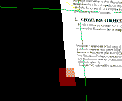
- The semi-transparent red square is the handle for manipulating this virtual page. The current tracked cursor position is shown with the green crosshairs.
In this method a user can quickly and intuitively rearrange virtual documents on the desk surface. Note that page orientation is always relative to the orientation it had when first picked up—that is, the page will not snap to the absolute orientation of the tracked device, but only account for relative rotation after being picked up. This allows a user to pick up and manipulate pages without worrying about the tracked device orientation when first grabbing a page.

Adding and deleting virtual pages
Currently, new pages can be added to the desk by means of a key press, resulting in a new page at the default location and with the default texture. A page’s texture can be changed by selecting it (picking up a page will automatically make it the currently selected page) and applying the current user-specified captured region from the desk. Pages can be deleted simply by selecting them and pressing the delete key. There are currently no means for saving either the contents of a specific page or the current layout and informational state of the desktop.

Creating a virtual copy of a physical page
Copying a physical page from the desk into a virtual document is currently accomplished by having the user manually specify the four corners of the source page by placing the tracked cursor over them and pressing a key (“1”, “2”, “3”, and “4” corresponding to the bottom left, bottom right, top right, and top left corners). Another key saves the current camera image along with the u, v texture coordinates specifying the desired sub-region. The full camera image can then be applied to a virtual page along with the correct texture coordinates to result in a virtual page textured with the contents of the physically specified region.

Conclusions
This project successfully showed a simple implementation of an augmented desktop environment where a user could interact with physical and virtual documents together. It highlighted the need for good tracking and explored some potential methods for user interaction with such an environment. Note that while this project demonstrated the concept of unifying physical and virtual documents, due to limitations on the projector and camera quality and resolutions, the virtual pages required a much larger font size to be readable than would a standard printed page.

Future work
There are still many improvements that can be made over the current system. Implementing some sort of image-based tracking rather than using the Polhemus would have the benefits of being even less invasive to the user, allow for a greater tracked range and could greatly reduce the tracker distortion. This would, however, come at the cost of much more computation as well as other issues such as occlusion, which is not a problem with the Polhemus.
An improved camera and projector would allow for much better quality projections onto the desk surface, making it easier to read smaller sized words, and increasing the quality of virtual copies of physical documents. A better camera would also likely improve an image-based tracking system if it were integrated into the system.
A database of electronic copies of known pages could also be maintained such that when a physical page on the desk was identified, the system could automatically select the corresponding electronic copy if the user wanted a virtual copy to manipulate.
There is still plenty of additional features for page and document manipulation that is needed as well. Having the ability to move virtual documents ‘up’ and ‘down’ in overlay ordering, providing support for multiple page documents, and in combination with automatic physical object recognition the system could handle occlusion issues more robustly than currently where a virtual page will be projected onto whatever happens to be in that space.

Acknowledgements
Thanks to Kirstin Williams and Stephen Guy for working with me in determining the projection matrix for the projector setup, along with help from Henry Fuchs and Rick Skarbez.
Referernces
- 2001. Integrating paper and digital information on EnhancedDesk: a method for realtime finger tracking on an augmented desk system. ACM Trans. Comput.-Hum. Interact. 8, 4 (Dec. 2001), 307-322. DOI= http://doi.acm.org/10.1145/504704.504706
- Coen, M. H. 1998. Design principles for intelligent environments. In Proceedings of the Fifteenth National/Tenth Conference on Artificial intelligence/innovative Applications of Artificial intelligence (Madison, Wisconsin, United States). American Association for Artificial Intelligence, Menlo Park, CA, 547-554.
- Cooperstock, J. R., Fels, S. S., Buxton, W., and Smith, K. C. 1997. Reactive environments. Commun. ACM 40, 9 (Sep. 1997), 65-73. DOI= http://doi.acm.org/10.1145/260750.260774
- Iwai, D. and Sato, K. 2006. Limpid desk: see-through access to disorderly desktop in projection-based mixed reality. In Proceedings of the ACM Symposium on Virtual Reality Software and Technology (Limassol, Cyprus, November 01 - 03, 2006). VRST '06. ACM Press, New York, NY, 112-115. DOI= http://doi.acm.org/10.1145/1180495.1180519
- Kobayashi, M., and Koike, H. EnhancedDesk: Integrating Paper Documents and Digital Documents. Asia Pacific Computer Human Interaction (Japan 1998), IEEE.
- Mackay, W. E. and Fayard, A. 1999. Designing interactive paper: lessons from three augmented reality projects. In Proceedings of the international Workshop on Augmented Reality : Placing Artificial Objects in Real Scenes: Placing Artificial Objects in Real Scenes (Bellevue, Washington, United States). R. Behringer, G. Klinker, and D. W. Mizell, Eds. A. K. Peters Ltd., Natick, MA, 81-90.
- Rekimoto, J. and Saitoh, M. 1999. Augmented surfaces: a spatially continuous work space for hybrid computing environments. In Proceedings of the SIGCHI Conference on Human Factors in Computing Systems: the CHI Is the Limit (Pittsburgh, Pennsylvania, United States, May 15 - 20, 1999). CHI '99. ACM Press, New York, NY, 378-385. DOI= http://doi.acm.org/10.1145/302979.303113
- Robertson, C. and Robinson, J. 1999. Live paper: video augmentation to simulate interactive paper. In Proceedings of the Seventh ACM international Conference on Multimedia (Part 2) (Orlando, Florida, United States, October 30 - November 05, 1999). MULTIMEDIA '99. ACM Press, New York, NY, 167-170. DOI= http://doi.acm.org/10.1145/319878.319923

