Symptalk Project Description

Summary

SympTalk is an AI symptom assessment for multiple languages to create a multilingual health assistant capable of assessing symptoms and providing recommendations for care. This system will serve as a bridge to improve accessibility to healthcare information for diverse populations by offering language support. It will be developed as a mobile app with with an accompanying web interface making sure it is accessible and user-friendly.

Application Domain

The application targets the intersection of healthcare and technology focusing on enhancing accessibility for non-native speakers and individuals in underserved areas where language barriers impede access to quality healthcare. By integrating natural language processing and AI-powered diagnostic tools this application can provide accurate symptom assessments.The software will be primarily developed as a mobile application to ensure accessibility for on-the-go users. A web application could also be created for users who prefer desktop access. The mobile-first approach aligns with the increasing reliance on smartphones globally.

Target Audience

The software will serve individuals who experience language barriers in healthcare settings such as immigrants, refugees, and travelers. It will also support healthcare providers in understanding patient concerns in multilingual contexts.

Problem Statement

Language barriers in healthcare can lead to misdiagnosis, delayed treatment, and frustration for both patients and providers. Current symptom checkers often lack multilingual support or are limited to a few major languages excluding large populations. This application addresses these gaps by providing language-specific symptom assessments, supporting real time translations, and recommendations.

Key Features

-Multilingual NLP Engine: Supports text and voice input in multiple languages, translating user symptoms into medically relevant terms for analysis

-Symptom Assessment: AI-driven algorithms will analyze inputs to provide tailored recommendations (self-care, see a doctor, emergency, etc.)

-APIs for translation services, like Google Translate or Microsoft Azure Translator, will be used to enhance multilingual capabilities

Impact

This project has the potential to democratize healthcare by providing language-appropriate symptom assessments to millions of users worldwide. It will allow non-native speakers to make informed decisions about their health and improve communication between patients and providers.

Most Common Languages spoken in the US excluding English:

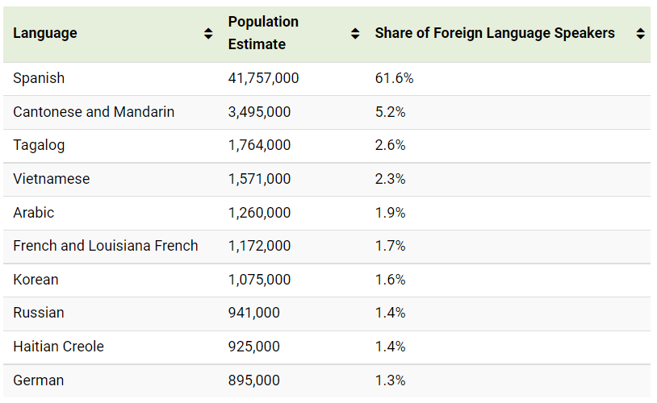

Similar Concept:

[Ada Health](https://ada.com/) is a popular AI-powered health assessment platform that provides symptom checks and health recommendations. It uses natural language processing to assess symptoms.

Key Features:

* Symptom assessment for large range of health conditions
* Multilingual support for limited languages like English, German, French, Spanish, Portuguese, Romanian, and Swahili
* Ada employed domain-specific medical NLP and constantly updated its knowledge base with medical insights from diverse regions.
* Compliance with GDPR and HIPAA regulations.