Sensors to Improve the Safety for Wheelchair Users

Klaus Schilling, Hubert Roth, Robert Lieb, Hubert Stützle
FH Ravensburg-Weingarten, Postfach 1261, D-88241 Weingarten
Tel. ++49-751-501 739, Fax ++49-751-48523, e-mail schi@ars.fh-weingarten.de

1. Summary
Sensor systems supporting autonomous navigation of mobile robots have been developed for different commercial application areas. These approaches have been transferred to electrical wheelchairs to assist disabled people in their mobility, by warning of obstacles in the way and by assisting in the navigation to return back home. The technical approach is based on a low-cost sensor data fusion of a ranging system, active markers, encoders and a GPS-system. This sensor configuration not only enables increased safety functions, but also provides additional useful capabilities for the hospital environment, like convoy driving of several wheelchairs, or autonomous driving on given courses.

Keywords : Navigation, obstacle detection, autonomously guided vehicle, sensor data fusion, range sensors, GPS, wheelchair

2. Introduction
Mobile robots with capabilities to autonomously reach a target location despite obstacles are designed for a broad range of applications :
- transport robots for material transfers in industrial production [3],[4],
- vehicles for planetary surface investigation in the framework of space exploration [5],
- rovers carrying equipment for inspection and repair in dangerous environments [7].
Essential for viable solutions are appropriate sensors, data processing and control systems to solve the navigation tasks reliably. This includes in particular capabilities to avoid obstacles, to localise the actual position, to determine relative distances to specific objects and to accurately reach given target locations.

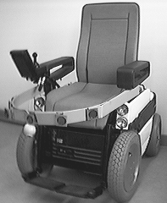

Fig. 1 : The sensor supported electrical
wheelchair INRO
In the national research project INRO (Intelligenter Rollstuhl ≅ intelligent wheelchair) the main objective was to transfer related sensor technology to support disabled users of electrical wheelchairs. Although needed functionalities are similar to the commercial applications developed earlier in the robotics centre in Weingarten as addressed above, specific adaptations are required with respect to
- the user interaction, allocating a suitable supporting function to the sensor and control system,
- economic constraints,
- high reliability requirements with respect to the user’s safety.
In cooperation with local centres for disabled peoples and wheelchair manufacturers the concrete objectives were defined and implemented.

3. Project Objectives
The design and implementation of a sensor and control system to support the user of an electrical wheelchair with respect to navigation and obstacle detection has been the objective of the national research project INRO. This includes realisation of functionalities like
- reliable avoidance of obstacles, including also concave obstacles, like descending stairs or wholes,
- convoy driving of several wheelchairs, enabling one nurse to perform excursions with a group of disabled people by just controlling the first vehicle,
- autonomous repeating of teached routes indoors and outdoors, allowing to store typical transport tasks in the computer on-board, which the nurse can initiate on request,
- assistance to achieve a safe return to the home, if the user orientation has been lost during a trip,
- information of the nursing staff in case of emergency on the vehicle´s location and characteristic parameters.
The aim is to increase this way the capabilities for mobility also for severely handicapped people as well as the safety of transports.

4. The Wheelchair System
Two commercial electrical wheelchairs have been equipped within the project with sensorics and a notebook PC for data processing. By an interface electronics the PC is connected via serial ports to the drive motor control, the range sensor system, the differential GPS and the radio modem. The parallel port is used for the active marking sensor. In addition a joystick is employed as user input device and a display as user output device. Characteristic wheelchair features are
- velocity adaptable within 4 velocity ranges : 2.5 km/h, 5 km/h, 7.5 km/h, 10 km/h,
- servo steering via the rear wheels with a minimum radius for turning of 0.8 m,
- warning lights, which are activated during turning,
- odometry by incremental dead reckoning,
- internal communication by serial link RS 232.
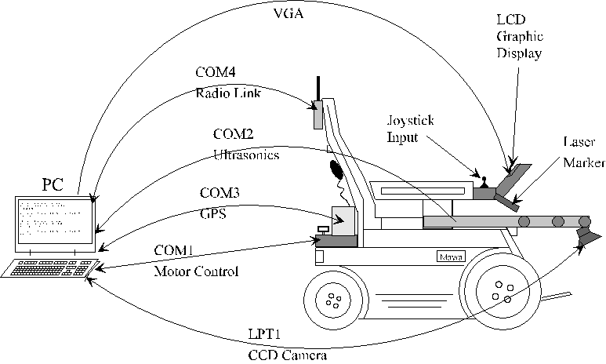

Fig. 2 : Schematic of the wheelchair sensor and control system

By the radio modem, communication with the central guarding station is maintained, allowing to initiate quick reactions in case of emergencies as position parameters and vehicle status parameters can be received from the sensor system.
5. The Sensor System
The standard electrical wheelchair already integrates sensors, like the encoders for motor control and velocity measurement, the input device (i.e. a joystick). Within INRO additional sensors have been integrated :
- a ring of five ultrasonics for obstacle avoidance, indoor navigation and convoy driving,
- an active marking system to detect low and concave obstacles,
- a differential global positioning system for outdoor navigation.
These sensor devices and their functionality to support the wheelchair user are discussed in the following chapters.

5.1 The Ultrasonic Ranging System
A ring structure, carrying five ultrasonics and the active marking sensor, is attached to the front side of the wheelchair. This ring can be opened to enter the chair. The ultrasonics with obstacle detection in a cone with opening angle of 20° are pointed in such a way, that the area between 2 - 3 m in front of the vehicle is covered. Data processing to derive control command advice is based on a fuzzy logic scheme similar to [3]. Ultrasonic systems are often used in wheelchair systems [1], [2], [8], but the practical use is limited, as they mainly detect larger obstacles, which are well visible by the persons anyway. Thus in this project a combination with the active marking sensor is used to improve the obstacle detection performance.

Due to the tuning possibilities of the own development of processing electronics, the ultrasonic system is used for two additional tasks
- convoy driving : the wheelchair can thus automatically follow a wheelchair driving in front. The ultrasonics provide the information about range and direction of the vehicle in front to a control algorithm, trying to keep a fixed distance.
- indoor navigation : here actual range profiles combined with odometry data are compared with a prestored map of the building to derive the actual position. A more detailed description of this procedure has been published in [6].

5.2 The Active Marking Sensor

Fig. 3 : The active marking sensor project-
ing 3 lines. From the deformation of lines the obstacle’s properties are derived.
Ultrasonic sensors have problems to detect concave obstacles (descending stairs, kerbstones, wholes etc.) as well as flat obstacles on the floor, as a inclined incidence of the beam will be reflected away and the sensor will receive no echo. Thus to support safe driving, in addition to ultrasonic sensors, complementary sensor types are needed. In the framework of INRO an active marking system is implemented, combined of a laser marker projecting 3 lines vertical to the drive direction and a CCD-camera to detect these lines. From the deviation between expected line position and deformed measured lines, the data processing scheme derives the position and shape of obstacles. For suitable light conditions this approach exhibits good performance also for concave and flat obstacles, thus well com-

plementing the ultrasonic system. To increase operational speed and robustness, several implementation improvements have been realised :
- an optical high-pass filter suppresses all wavelengths below the one of the laser,
- the wavelengths above the visible spectrum are cut off by a filter integrated into the camera,
- an automatic brightness adaptation is implemented,
a horizontal edge filter is realised by data processing software.

5.3 The Global Positioning System Sensor
A suitable sensor to determine outdoors the position of the wheelchair is a global positioning system (GPS) receiver. From these data, in connection with a local map of the area stored in the computer on-board, advice can be generated for the disabled person to reach a given target. In particular, if he has lost orientation, this system can safely guide him back home. To increase the position accuracy, in the project a low-cost differential GPS (DGPS) is used, exhibiting deviations below 5 m.

5.4 The Sensor Data Fusion
Thus for a broad range of situations the sensor system supports a safe mobility for disabled or elderly persons, using electrical wheelchairs. The software automatically selects by sensor data fusion the most appropriate sensor combination related to the actual situation :
- for navigation : DGPS outdoors or alternatively combined ultrasonic range profile comparisons and odometry data indoors,
- for obstacle detection : the active marking sensor and the ultrasonic range sensor data are combined.
While this navigation sensor fusion is on a logical level, sensor data fusion on a technical level based on mathematical sensor models is performed in obstacle detection and in deriving navigation information from the ultrasonic range profile, given maps and odometry (cf. [6]). The user only receives the final recommendation from the computer system, without having to take care of the different processing steps.

6. Conclusions
This paper provides a survey on different low-cost sensor modules, increasing safety in mobility for users of electrical wheelchairs. The implemented functionalities include navigation as well as obstacle avoidance support. As different sensor types are included to cover the same function, this system operates reliably for a broad range of environmental conditions. Within the hospital environment, these capabilities assist the nursing staff by enabling the following functions : convoy driving of several wheelchairs, autonomous transports on given routes, quick contact to the disabled person in case of emergencies.

Acknowledgements
The authors thank the German Ministry for Science band Research (BMBF) for the financial support of the project „Intelligenter Rollstuhl (INRO)“.

References

[1] Miller, D., M. Slack, Design and Testing of a Low-Cost Robotic Wheelchair Prototype, Autonomous Robots 2 (1995), p.77 - 88.

[2] Pires, G., N. Honório, C. Lopes, U. Nunes, A.T. Almeida, Autonomous Wheelchair for Disabled People, Proceedings "IEEE International Symposium on Industrial Electronics", Guimaraes 1997, Vol.3, p. 797 - 801.

[3] Schilling, K., H. Roth, B. Theobold, Fuzzy Control Strategies for Mobile Robots, Proceedings EUFIT`93, p. 887 - 893.

[4] Schilling, K., J. Garbajosa, M. Mellado, R. Mayerhofer, Design of Flexible Autonomous Transport Robots for Industrial Production, Proceedings "IEEE International Symposium on Industrial Electronics", Guimaraes 1997, Vol. 3, p. 791 - 796.

[5] Schilling, K., L. Richter, M. Bernasconi, C. Jungius, C. Garcia-Marirrodriga
Operations and Control of the Mobile Instrument Deployment Device on the Surface of Mars, Control Engineering Practice 5 (1997), p.837 - 844.
[6] Schilling, K., R. Lieb, H. Roth, Indoor Navigation of Mobile Robots Based on Natural Landmarks, Proceedings "3rd IFAC Symposium on Intelligent Components and Instruments for Control Applications", Annecy 1997, p. 527 - 530.

[7] T.B. Sheridan, Telerobotics, Automation, and Human Supervisory Control, The MIT Press, 1992.

[8] Virtanen, Ari, A Drive Assistant, Horizons 1/96, VTT Finland, p. 17 - 18.

