COMP 14.
Assignment 4 (due July 11) Tic-tac-toe

Tic-tac-toe (60p)
Description of the problem:
Write a GUI-based tic-tac-toe game. The program should display a Tic-Tac-Toe board and request the players to input the position of a nought or a cross. The game ends when one player gets 3 in a row or all the positions are filled. At that point the dialog window should display the result of the game and a question such as “Do you want to play again? (y/n)”.
Initially, the board should look something like this:
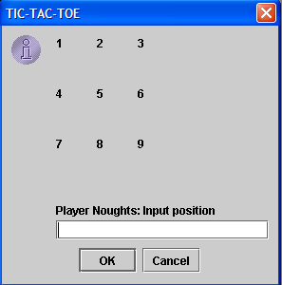
At some point in the game, it may look like this:
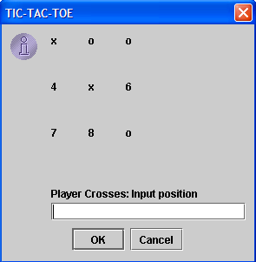
And at the end of the game, it should look something like this:
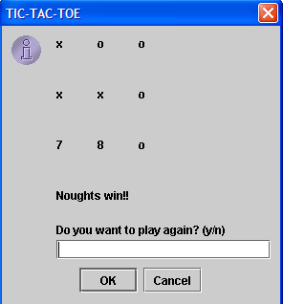
The program should have at least 2 loops:
- Outer loop for each game. The program will exit this loop when the players decide not to play any more.
- Inner loop for each play. There will be a maximum of 9 plays, but this loop will end earlier if one of the players wins.
In the minimum version of the assignment, you don’t need to check if the inputs are correct or not. However, you may do this for extra credit.
Suggestion 1: Store the whole text of the board as a String. After each play, replace the corresponding number by a nought or a cross. You will find an example (TicTacToeBoard.java) to create the text for the board on the Code webpage.
Suggestion 2: Create a variable for each position in the board, and store in this variable if that position holds a nought, a cross, or nothing.

Distribution of the grading (max for each item):
(5p) Detailed algorithm, with proper indentation and indication of loops and selection statements.
(5p) Identify the main variables needed by the program. Indicate data type (or class) and name of the variable. Classify the variables in 2 groups: those that have to be stored during the whole game (outer loop), and those that are only needed in each play (inner loop).
(5p) Coding style: appropriate naming of file, class and variables; comments; neat formatting.
(5p) Correct synthesis of outer and inner loop as specified above.
(5p) The program loops properly over different games.
(5p) Each individual game loops properly over different plays.
(10p) Positions in the board are updated correctly based on the plays.
(15p) Victories and ties are detected correctly.
(5p) Short report commenting the problems you had while completing this assignment, and how you solved those problems.

Extra credit:
(10p) Discard the input at each play if it is not a number indicating a position in the board. Prompt the same dialog until the input is a position.
(10p) Discard the input at each play if it is a position that is already covered. Prompt the same dialog until the input is a free position.
(5p) Prompt the message “Do you want to play again? (y/n)” repeatedly if the input is not “y” or “n”.

Additional information:
1) In this assignment you will need to output a dialog window with a message and title, and you will also need to request an input. For that, you may want to use the method:
String JOptionPane.showInputDialog(null, String message, String title, icon)
2) In order to replace a character in a String, use the method:
String String.replace(char charToBeReplaced, char charReplacedWith)
This method returns a String where the specified character has been replaced. You can find this method in Appendix E in the book.

