COMP 14.
Assignment 5 (due July 17) ACC Tournament

ACC Tournament (75p)
Description of the problem:
The goal of this assignment is to become familiar with Object-Oriented Programming. For that, you will have to write a GUI-based program that displays the evolution of the semifinals of the ACC Tournament.
A typical run of the program would display the following sequence of dialog windows:
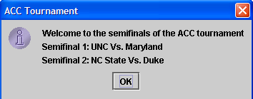
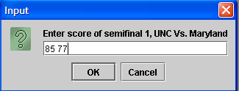
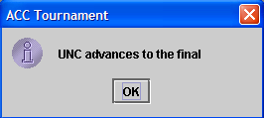
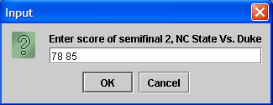
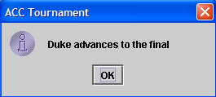
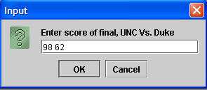
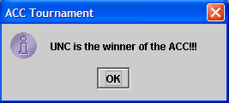
This program has to be coded using 3 classes:
-class Team → stores the name of a team (a skeleton of this class is given on the webpage)
-class Game → stores references to two teams involved in a game
-class ACCTournament → this is the main class of the program, where you will code the main method, create the necessary objects, make GUI calls, etc.
Start by creating 4 Team objects. In this example, the 4 teams are UNC, Duke, NC State and Maryland.
Then, create 2 Game objects, for the 2 semifinals.
Obtain the scores of the semifinals, determine the winners, and create a Game object with the 2 finalists.
Finally, obtain the score of the final and determine the winner.
The Game class will have a method gameWinner() that receives the score as a String parameter, and outputs the winner team. Note, don’t output a String, output the Team object itself!!
In order to create the messages for the dialog windows, you will have to code the toString() method of the Team and Game classes.
The toString() method of the Team class should return a String containing the name of the team. The toString() method of the Game class should return a String of the type “team1 Vs. team2”. As you can see, these are used several times to create the dialogs. Note (check by debugging) that using string concatenation (the + operator) in making the return expression calls the toString() functions of each of the 2 Teams objects contained in the Game object.
You must code each class in a separate file. For extra credit, store them all in a jGRASP project, and, once you’re done with the assignment, create a Java archive .jar file and submit it by email.
In this assignment there is no need to submit an algorithm or a report.

Distribution of the grading (max for each item):
(25p) Make 3 separate files containing the 3 classes. No compile errors allowed.
(5p) Data members and constructor(s) of the Game class.
(10p) gameWinner() method of the Game class.
(10p) toString() method of the Game class.
(5p) creation of Team objects in the main method.
(10p) creation of Game objects in the main method.
(10p) correct GUI interface and detection of game winners

Extra credit:
(5p) If one of the teams involved in the game is Duke, append to the dialog a message saying “Beat DOOK!!”. You have to detect that the team is Duke by using data from the Team object; no assumptions on the order in which you input teams, etc.
(5p) If the winner of a game is UNC, append to the dialog that reports the winner a message saying “Go Heels!!”. Again, you have to detect that the team is UNC by using data from the Team object, no assumptions on the order in which you input teams, etc.
(5p) Instead of writing the scores as “70 60”, with a space between the numbers, write them as “70-60”.
(10p) Store all 3 files in a jGRASP project, create a Java archive .jar file and submit it by email as a separate attachment.
(25p) Instead of having the names of the 4 teams written in the code, read them from a text file using FileReader.

