COMP 14.
Assignment 7 (due July 26) Euro-Dollar Conversion Applet

Euro-Dollar Conversion Applet (75p)
Description of the problem:
In this assignment you will create your first web page with an applet.
The web page can look something like this:
Enter the amount of Euros in the 1st cell, or the amount of Dollars in the 2nd cell.
The conversion factor is 1 Euro=1.2078 Dollars.

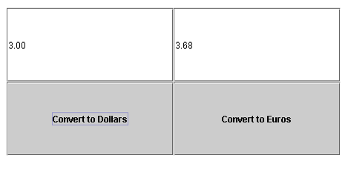

The window consists of two text fields and two buttons. In the left text field you introduce an amount in euros. In the right text field you introduce an amount in dollars. By clicking “Convert to Dollars”, the euros in the left box are converted to dollars and printed in the right box. Similarly if you click “Convert to Euros”.
The text that you want to write in your webpage, how fancy to make it, etc. is all your choice. Hint: you may get the latest currency conversion rate from Google.
The assignment should be solved by first creating a Java application that can be executed from jGRASP, and then convert it to an applet.
Requirements, Grading and Guidelines:
1. (25p) Create a GUI application that performs the conversion from dollars to euros, using JFrame. The GUI should look like the final applet.
In this GUI, add two text fields and two buttons. You will also need two action listeners (button handlers). You may create action listener objects from the same class or from two different classes.
Turn in the .java file with your code.
2. (25p) Get AFS working and set up a web page online. Give it a title and put some text and an image inside its body. Send me the link to this web page.
3. (25p) Convert the application to an applet, and include it in the webpage above.
Also, turn in the .java file with your code.

Extra credit:
(25p) Add action listeners to the text fields so that the user can just type in a value and press Enter for conversion, instead of pressing the corresponding button. You may use the same action listeners you used for the buttons. Hint: look at the temperature converter example in Chapter 6.

