An Interactive, Non-invasive NPR Renderer

Adrian Ilie
Department of Computer Science
University of North Carolina at Chapel Hill

Abstract
Many interactive 3D applications’ visual styles can be non-invasively changed to new, different, and interesting visual styles. This is done by intercepting the OpenGL graphics library and changing the drawing calls. However, OpenGL only receives low-level information from an application. Special features such as ridges, valleys and silhouettes, of a polygonal scene are usually displayed by explicitly identifying and then rendering 'edges', using connectivity information. Special features of polygonal models can nevertheless be displayed at the hardware level without connectivity information: new polygons with appropriate color, shape and orientation are introduced based only on the vertices of the existing polygons.
This project presents a synergy of these two approaches: intercepting and replacing OpenGL library calls to modify the visual style of an application [1], and rendering special features of polygonal models by introducing new polygons [2].

1. Introduction.
Many different visual styles are possible for interactive 3D applications. However, most applications’ visual styles are tightly coupled to the applications themselves, and prototyping new visual styles and experimenting with different visual styles is difficult. This project uses a technique that effectively divorces an application’s visual style from the application itself.
The goal is to explore varying visual styles of an existing application, by altering its visual style non-invasively. To achieve these alterations, we are limited to intercepting the output of the application at a common level: calls to the graphics library.
The challenge is that the only information received from the application is low-level drawing commands and primitives, and this precludes many current stylized rendering techniques.
However, interesting stylized renderers are possible, enabling non-invasive style alterations. One way is to devise methods to gather more high-level information by extracting and maintaining state information at the drawing library level. The traditional approach is to reconstruct and traverse the scene polygon graph, then decide on the desired rendering attributes for each polygon. However, this is a cumbersome process, and usually not supported by rendering APIs or hardware. Rendering hardware is typically more suited to working on a small amount of data at a time. For example, most pipelines accept just a sequence of triangles and all the information necessary for rendering is contained in the individual triangles.
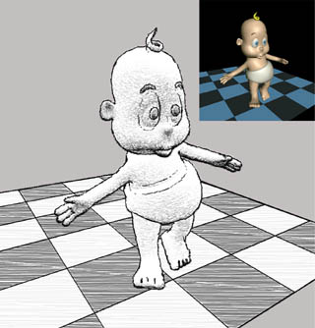
Figure 1: A stylized rendering (from [1]).

In the absence of special data structures, recovering connectivity information requires random traversals of the scene graph. Maintaining this information also increases the memory requirements.
Sharp features convey a great deal of information with very few strokes. Technical illustrations, engineering CAD diagrams as well as non-photo-realistic rendering techniques exploit these features to enhance the appearance of the underlying graphics models.
In this project, we use the framework for developing non-invasive modifications to the visual style of applications. We also recognize the importance of sharp features, and employ a technique that renders them without needing anything else but the local information.
While this method may not produce imagery to rival state of the art non-photorealistic rendering systems, it can be dynamically applied to the application.

2. Intercepting OpenGL calls.
In [1], the authors present a general method to replace the system's OpenGL library with a custom library that implements the standard interface and calls the real system library when needed. The real library is dynamically loaded and a name mapping mechanism is provided.
In this project, we use a less general approach. The application we modify the visual style of is a well-known shareware game, Quake. The authors of [1] replaced all the calls in the source code to calls to rendering libraries that are loaded dynamically. We use this pre-existing structure to plug in an implementation of the NPR renderer described in [2]. The next section provides a short description of the rendering process.

3. Rendering sharp features.
The most commonly used features are silhouettes, creases and intersections. For polygonal meshes, the silhouette edges consist of visible segments of all edges that connect back-facing polygons to front-facing polygons. A crease edge is a ridge if the dihedral angle between adjacent polygons is less than a threshold. A crease edge is a valley if the angle is greater than a threshold (usually a different, and larger one). An intersection edge is the segment common to the interior of two intersecting polygons.
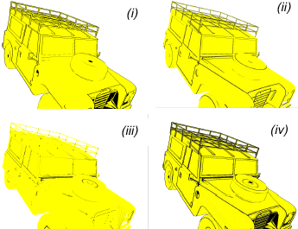
Figure 2: Sharp features: silhouettes (i), ridges (ii), valleys (iii), and their combination (iv) (from [2]).

We assume that the scene consists of oriented convex polygons. This allows us to distinguish between front and back-facing polygons for silhouette calculations, and ensure correct notion of dihedral angle between adjacent polygons

3.1. Silhouettes.
The basic idea in our approach is to enlarge each back-facing polygon so that the projection of the additional part appears around the projection of the adjacent front-facing polygon, if any. If there is no adjacent front-facing polygon, the enlarged part of the back-facing polygon remains hidden behind existing front-facing polygons. The normal of the back-facing polygon is flipped to ensure that it is not culled during back-face culling. To achieve a given width in the image space, the degree of enlargement for each back-facing polygon is controlled, depending on its orientation and distance with respect to the camera.
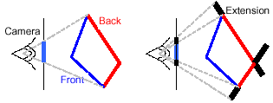
Figure 3: Silhouettes as extensions of back-facing polygons (from [2]).
3.2. Ridges.
For ridges and valleys, we modify each front-facing polygon. We want to display in black the visible part of each edge for which the dihedral angle between adjacent polygons is less than or equal to a user selectable global threshold θ, superimposed on the original model if desired.
We add black colored quadrilaterals (or quads for short) to each edge of each front-facing polygon. The quads are oriented at angle θ with respect to the polygon as seen in Figure 4(ii) and (iii). The visibility of the original and the new polygons is performed using the traditional depth buffer. As shown in Figure 4(iv), at a sharp ridge, the appropriate ‘edge’ is highlighted.
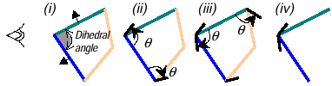
Figure 4: Ridges. (i) Front-facing polygons, (ii) and (iii) black quads at threshold angle θ are added to each edge of each front-facing polygon, (iv) at a sharp ridge, the black quads remain visible (from [2]).

When the dihedral angle is greater than θ, the added quadrilaterals are hidden by the neighboring front-facing polygons. Figure 5(i) and (ii) show new quadrilaterals that remain hidden after visibility computation in 4(iii).
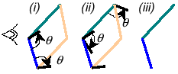
Figure 5: Ridge without sharp angle. (i) and (ii) Black quads are added, (iii) the quads remain invisible after rasterization (from [2]).

3.3. Valleys.
Given a user-selectable global threshold φ for dihedral angle, we would like to display, say in black, visible part of each edge for which the dihedral angle is greater than φ, superimposed on the original model if desired.
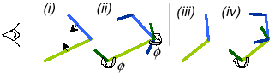
Figure 6: Valleys. (i) Front-facing polygons (ii) black quads at angle φ are added to each edge of each face. When the valley is sharp, the quads remain hidden. (iii) and (iv) When the valley is not sharp, the quads become visible (from [2]).

We add black quadrilaterals at angle φ to each edge of each front-facing polygon as shown in Figure 6. When the dihedral angle is greater than φ (Figure 6(i) and (ii)), new quadrilaterals appear behind the nearest front-facing polygons. On the other hand, when the valley is not sharp (Figure 6(iii) and (iv)), the new quadrilaterals appear in front of the neighboring polygons.
This is the exactly reverse of the situation for ridges, and hence leads to a more complex algorithm. To ‘show’ quads that remain occluded and ‘hide’ quads that appear in front of nearest front-facing polygons, we use two depth buffers for visibility. The two depth buffers, z1 and z2, are identical except that depth values in z2 are slightly larger than corresponding values in z1. The front envelope of cyan colored region shows values in z1 and the far envelope shows values in z2. In addition to the traditional greater-than-test and less-than-test, we also need a new Boolean depth test, called between-test. It returns true when the incoming fragment has depth value between the existing values in z1 and z2. The color buffer is updated if the depth value passes the between-test, while the depth buffer is not modified.
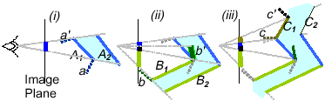
Figure 7: Steps in rendering valleys (from [2]).

3.4. Intersections.
Although intersections are not encountered in quality graphics models, imprecise conversions or processing can result in intersection of polygons. The technique to detect intersection between two visible front-facing polygons for a given viewpoint is very similar to the procedure for rendering sharp valleys.

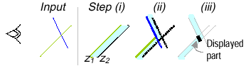
Figure 8: Two intersecting polygon interiors (left) are displayed by finding parts trapped between the two depth buffers (from [2]).

Bibliography.

[1] Alex Mohr, Michael Gleicher: “Non-Invasive, Interactive, Stylized Rendering”. The 2001 ACM Symposium on Interactive 3D Graphics.

[2] Ramesh Raskar: “Hardware Support for Non-photorealistic Rendering”, Siggraph/Eurographics Graphics Hardware, LA, 2001.

