Non-Photorealistic Rendering Techniques for a Game Engine

Adrian Ilie
Department of Computer Science
University of North Carolina at Chapel Hill

Abstract
Many interactive 3D applications’ visual styles can be changed to new, different, and interesting visual styles without modifying their source code. This is done by intercepting the OpenGL graphics library and changing the drawing calls. Two of the most interesting visual styles are sharp features and cartoon-style rendering.

Sharp features convey a great deal of information with very few strokes. Technical illustrations, engineering CAD diagrams as well as non-photo-realistic rendering techniques exploit these features to enhance the appearance of the underlying graphics models.

Cartoon-style rendering attempts to emulate the work of artists in animation movies. Cartoon characters are intentionally "two-dimensional": cartoonists typically use solid colors that do not vary across the materials they represent.

This project presents a synergy of these approaches: intercepting and replacing OpenGL library calls to modify the visual style of an application [1], rendering special features of polygonal models by introducing new polygons [2], and rendering the scene in cartoon style [3,4,5].

1. Introduction.
Many different visual styles are possible for interactive 3D applications. However, most applications’ visual styles are tightly coupled to the applications themselves, and prototyping new visual styles and experimenting with different visual styles is difficult.

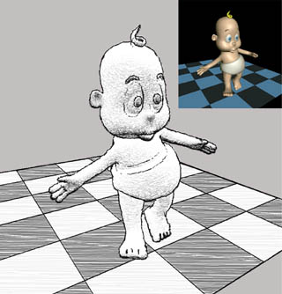
Figure 1: A stylized rendering example (from [1]).

The goal of my project is to explore varying visual styles of an existing application, by altering its visual style non-invasively (without major modifications to its source code). To achieve these alterations, I was limited to intercepting the output of the application at a common level: calls to the graphics library.

The challenge is that the only information received from the application is low-level drawing commands and primitives, and this precludes many current stylized rendering techniques. In the absence of special data structures, recovering connectivity information requires random traversals of the scene graph. Maintaining this information also increases the memory requirements.

One way to solve this problem is to devise methods of gathering more high-level information by extracting and maintaining state information at the drawing library level. The traditional approach is to reconstruct and traverse the scene polygon graph, then decide on the desired rendering attributes for each polygon. However, this is a cumbersome process, and usually not supported by rendering APIs or hardware.

Another solution is to render new visual styles without making use of connectivity information. Two ways this can be accomplished are introducing new polygons with appropriate color, shape and orientation; and using special shading and texturing techniques. I illustrate these techniques for special features and cartoon-style rendering.

Special features such as silhouettes and sharp ridges of a polygonal scene are usually displayed by explicitly identifying "edges", using connectivity information and then rendering them in a different style. These features can also be displayed without the need for connectivity information if new polygons with appropriate color, shape and orientation are introduced based only on the information at the vertices of the existing polygons. I illustrated this technique in Section 3.

Another interesting NPR area is cartoon-style rendering. This effect can also be implemented non-invasively, using just local information and 1D textures. I illustrated this technique in Section 4.

While my method may not produce imagery to rival state of the art non-photorealistic rendering systems, it can be dynamically applied to a real-time rendering application: a game engine.
2. Intercepting OpenGL calls.
In [1], the authors present a general method to replace the system's OpenGL library with a custom library that implements the standard interface and calls the real system library when needed. The real library is dynamically loaded and a name mapping mechanism is provided. They use the custom library to introduce new functionality, such as different rendering styles that can be changed at run time.

In this project, I used a slightly less general yet conceptually similar approach. Following the example of the authors of [3], I augmented the features available in a game engine to include new rendering styles. The application I modified the visual style of was a well-known shareware game, Quake. The authors of [1] replaced all the calls in the source code to calls to rendering libraries that are loaded dynamically, implementing several rendering styles. I used this pre-existing structure to plug in an implementation of the NPR techniques described in [2,3,4,5]. The next sections provide a short description of the rendering process.

3. Sharp Features Rendering.
The most commonly used features are silhouettes, ridges and intersections. For polygonal meshes, the silhouette edges consist of visible segments of all edges that connect back-facing polygons to front-facing polygons. A crease edge is a ridge if the dihedral angle between adjacent polygons is less than a threshold. A crease edge is a valley if the angle is greater than a threshold (usually a different, and larger one). An intersection edge is the segment common to the interior of two intersecting polygons. (from [3])

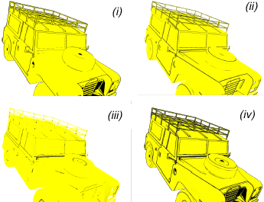
Figure 2: Sharp features: silhouettes (i), ridges (ii), valleys (iii), and their combination (iv) (from [2]).

In this project, I only implemented silhouettes and ridges. Due to the fact that the models are coarsely tessellated, creases provide very little detail.

I assumed that the scene consisted of oriented convex polygons. This allowed me to distinguish between front and back-facing polygons for silhouette calculations, and ensure correct notion of dihedral angle between adjacent polygons.
3.1. Silhouettes.
The basic idea in the approach presented in [3] is to enlarge each back-facing polygon so that the projection of the additional part appears around the projection of the adjacent front-facing polygon, if any. If there is no adjacent front-facing polygon, the enlarged part of the back-facing polygon remains hidden behind existing front-facing polygons, due to the fact that back-facing polygons have a higher depth value. The normal of the back-facing polygons need to be flipped to ensure that they are not culled during back-face culling. The authors of [3] describe several techniques to achieve a given width in the image space. The degree of enlargement for each back-facing polygon is controlled, depending on its orientation and distance with respect to the camera. In this project I implemented a simpler version that enlarges all polygons by the same value in world space, so silhouettes of objects further away are thinner.

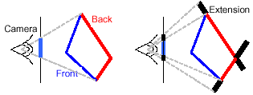
Figure 3: Silhouettes as extensions of back-facing polygons (from [2]).

3.2. Ridges.
I only considered one type of creases: ridges. While the approach described in [3] works well for highly tessellated models, this is not the case for the models in a game engine, where a lot of the detail comes from texturing. For ridges, I processed all front-facing polygons. I wanted to display the visible part of each edge for which the dihedral angle between adjacent polygons is less than a threshold θ.

I added colored quadrilaterals (or quads for short) to each edge of each front-facing polygon. The quads are oriented at angle θ with respect to the polygon as seen in Figure 4(ii) and (iii). The visibility of the original and the new polygons is evaluated using the traditional depth buffer. As shown in Figure 4(iv), at a sharp ridge, the appropriate edge is "highlighted".

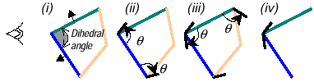
Figure 4: Ridges. (i) Front-facing polygons, (ii) and (iii) quads at threshold angle θ are added to each edge of each front-facing polygon, (iv) at a sharp ridge, the quads remain visible (from [2]).

When the dihedral angle is greater than θ, the added quadrilaterals are hidden by the neighboring front-facing polygons. Figure 5(i) and (ii) show new quadrilaterals that remain hidden after visibility computation in 4(iii).

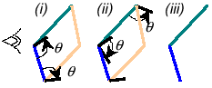
Figure 5: Ridge without sharp angle. (i) and (ii) quads are added, (iii) the quads remain invisible after rasterization (from [2]).

4. Cartoon-style Rendering.
Cartoon characters are intentionally "2D". The drawing technique is inherited from hand-drawn animations. Cartoonists deliberately reduce the amount of visual detail in their drawings in order to draw the audience into the story and to add humor and emotional appeal. Rather than shading the character to give it a three-dimensional appearance, cartoonists typically use solid colors that do not vary across the materials they represent.

Often the cartoonists shade the part of a material that is in shadow with a color that is black or a darkened version of the main material color. This helps add lighting cues, as well as cues to the shape and context of the character in a scene. The boundary between shadowed and illuminated colors is a hard edge that follows the contours of the object or character.

Another cue used by cartoonists is highlighting small areas with white or a lightened version of the main material color. This achieves an effect similar to specular highlighting, but the boundary is a hard edge just as in the previous case.

The result is similar to the cartoon character shown in Figure 6 below, which has both dark areas, as well as highlights.

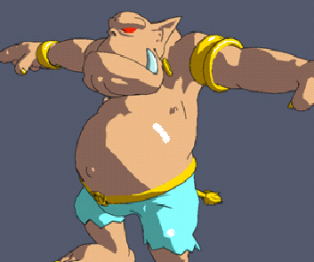
Figure 6: Olaf, rendered in cartoon style
(adapted from [4]).
To implement this effect, I needed a new illumination model, in which the light values are not smoothly interpolated across the surface. This can be accomplished by using a 1D texture and assigning the texture coordinate of each vertex to a number proportional to the amount of light the vertex receives. As shown in Figure 7, such a texture has three colors: darkened, normal and highlighted.

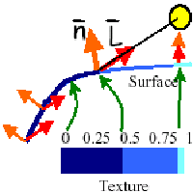
Figure 7: Generation of texture coordinates from the amount of light a surface receives
(adapted from [4]).

This texture, when applied using regular texture mapping, produces the desired results: areas that receive less light are colored with the darkened color, areas directly under the light are highlighted, and areas in between are illuminated using the regular color.

To get the hard boundary between the three regions, I also needed to turn off filtering for the 1D texture. This avoids blending the colors and gives me the desired banded look. As the authors of [5], I noticed that this ended up being beneficial for performance as well, since just taking the nearest color instead of interpolating is faster.

5. Integration in the Game Engine.
In the case of the Quake game engine, the authors of [1] already moved the relevant drawing functions to a library, so all I needed to do was to implement new functionality on top of this framework.

I implemented the cartoon-style described in Section 4 only for the models of moving objects, since they were the only ones that had lighting information available. Silhouettes and ridges were used to augment the models.

Since the wall models had no lighting information at the vertices, I had to choose a different approach. I used a texture that has a "hand-painted" look, and drew the edges using a "charcoal" style: a combination of a thick line with some jittered thinner lines.

For the walls, I also combined the texture with the precomputed light maps the game engine provides, to get the final look shown on the next page.

6. Conclusion.
This project is a synergy of several approaches that modify the visual style of an application without major modifications to its source code.

The approach was to extract all the graphics library calls and group them in a dynamic library, then implement additional functionality for different rendering styles.

Unlike other approaches that attempt to reconstruct the models from the calls received by the library, I used techniques that only need local information to draw the models in a new style: a technique that adds new polygons for edges to render sharp features and a technique that uses texturing to simulate cartoon-style rendering.
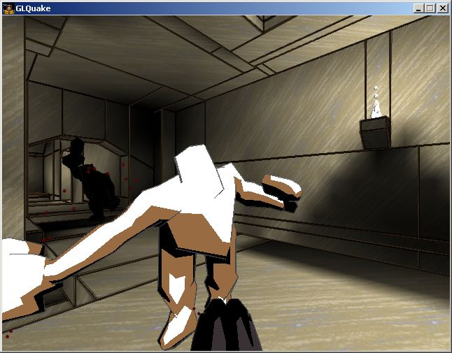
Bibliography.
[1] Alex Mohr, Michael Gleicher: "Non-Invasive, Interactive, Stylized Rendering". The 2001 ACM Symposium on Interactive 3D Graphics.
[2] Ramesh Raskar: "Hardware Support for Non-photorealistic Rendering", Eurographics 2001.
[3] Bert Freudenberg, Maic Masuch, Thomas Strothotte: "Walk-Through Illustrations: Frame-Coherent Pen-and-Ink Style in a Game Engine", Siggraph/Eurographics Graphics Hardware, LA, 2001.
[4] Adam Lake, Carl Marshall, Mark Harris, Marc Blackstein: "Hardware Support for Non-photorealistic Rendering", Siggraph/Eurographics Graphics Hardware, LA, 2001.
[5] Jeff Lander: "Shades of Disney: Opaquing a 3D World", Game Developer Magazine, March 2000.

