Consider the geodesics on a 90° cone (other than the generators). Do all such geodesics intersect themselves at right angles? Provide an argument for "yes" or a counterexample for "no."

All such geodesics intersect themselves at right angles on a 90° degrees cone.
We pick a geodesic at random and prove it intersects itself at a 90° angle.

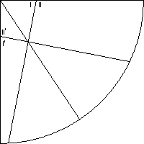

Figure 1: geodesics on a 90° cone

Angles I and I’ are equal to each other and angles II and II’ are equal to each other, since they are the angles the geodesic makes when crossing a generator.
Also, I+II=I’+II’=I+II’=180°.
Since angles I and II’ are opposite angles in a quadrilateral and their sum is 180°, the other two opposite angles have to have their sum equal to 180°, as the sum of all angles in a quadrilateral is 360°. One of those two opposite angles is the cone angle (90°), and the other angle is the angle the geodesic makes when it intersects itself.
It follows that the geodesic intersects itself at a 90° angle.
Since we chose the geodesic at random, it follows that every other geodesic exhibits the same behavior.

