Read problem 6.4 (pages 69-74) and discuss the extent to which the SAS Theorem is true (or not true) on a sphere.

My intuition is that on the sphere both two “small” triangles and two “large” triangles can be congruent, but a “small” triangle would not be congruent with a “large” triangle.

The two triangles in figure 6.7 in the book would not be congruent since it’s really just Side-Side, not Side-Angle-Side. The angle between the two sides is different. From figure 6.7 it would seem that, unless the two disjoint extremities of the two sides are opposite points (in which case we have an infinity of geodesics connecting them), the angle between the two sides is enough to disambiguate which of the two geodesics connecting the extremities we consider as the third side of the triangle. However, this is not true. The following pairs of triangles do have two sides and the angle between them equal, yet they are not congruent:

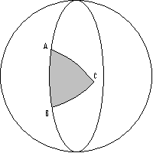 and 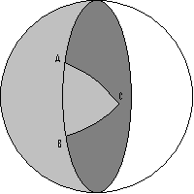 or 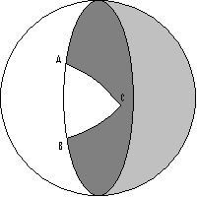 and 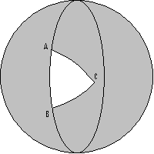

These triangles differ by a hemisphere, so they are not congruent, yet they do have angle ACB and sides AC and AB equal. Also, their other two corresponding angles differ by 180 degrees. But, if we define “small” triangles as being less that a hemisphere, or having angles less than 180 degrees, and “large” triangles as being the opposite, Side-Angle-Side holds for the same kind of triangles.

The extreme case is when the angle between the two sides has 180 degrees. In this case, the two given sides form a line and the disjoint extremities have to be opposite points (otherwise the third side of the triangle overlaps the first two). Then there are infinitely many triangles with the same two sides and the angle between them, which obviously cannot be all congruent.

So, unless the angle between the two sides has 180 degrees, and if the triangles are of the same kind (both “small” or both “large”), Side-Angle-Side is true on a sphere.

