Comp 734 - Assignment 1:
Distributed Halloween Simulation Project

Date Assigned: Wed Aug 24, 2011

First Completion Date: Wed Sep 7, 2011

Second Completion Date: Wed Sep 14, 2011

Third Completion Date: Wed Sep 21, 2011 (We may have one more based on how much is covered in class)

The goal of the assignment is allow you to discover, on your own, some of the fundamental issues in distributed systems. You will take an existing non distributed program - a Halloween simulation - and create a distributed version of it. It will be trivial to interface with this simulation. You have considerable freedom in the exact nature of the distributed simulation you create – thus, this assignment is more like a project than an assignment. You will be graded on how sophisticated the semantics, architecture, and implementation of your simulation are. You have three weeks, which should be enough time to create an attractive project.

Non Distributed Simulation
The non distributed simulation is a project I gave to my Fall Comp 401 (http://www.cs.unc.edu/~dewan/comp114/f10/) class. You will work with the code of one of the students in the class – Beau Anderson – who created a particularly nice simulation. As you saw in class, the simulation created two windows, a command window, and a graphics window. The command window is used to manipulate the objects shown in the graphics window.

As shown in Figure 1, each graphics window consists of (a) one or more houses, each with a path and a candy container; and (b) a movable avatar with a candy container. The move command can be used to move the avatar in both the x and y directions, as shown in Figure 1(a).
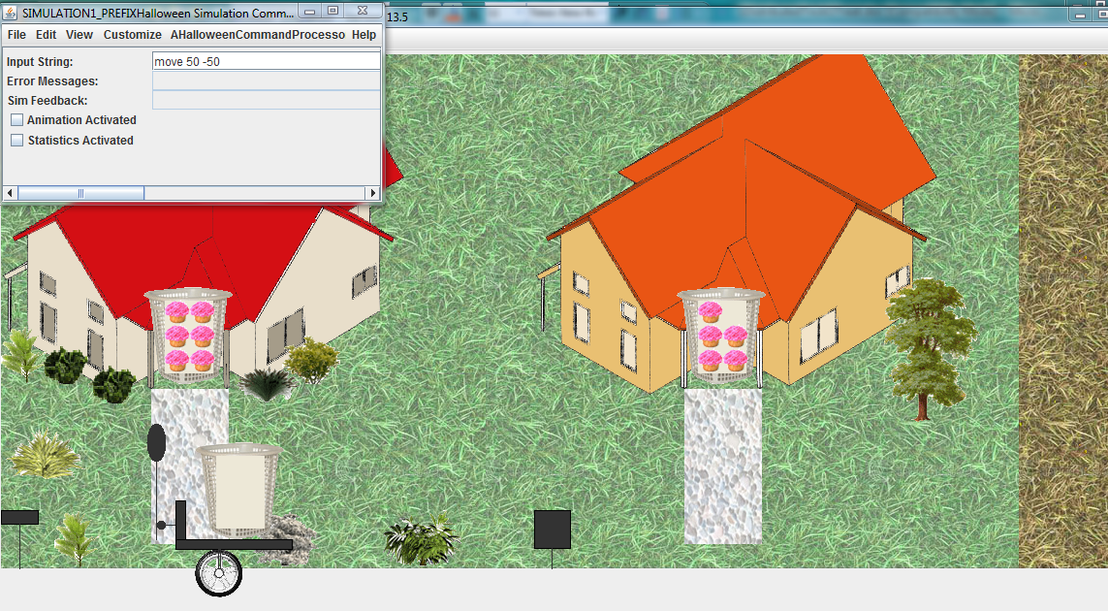
- Avatar moves into path of leftmost house

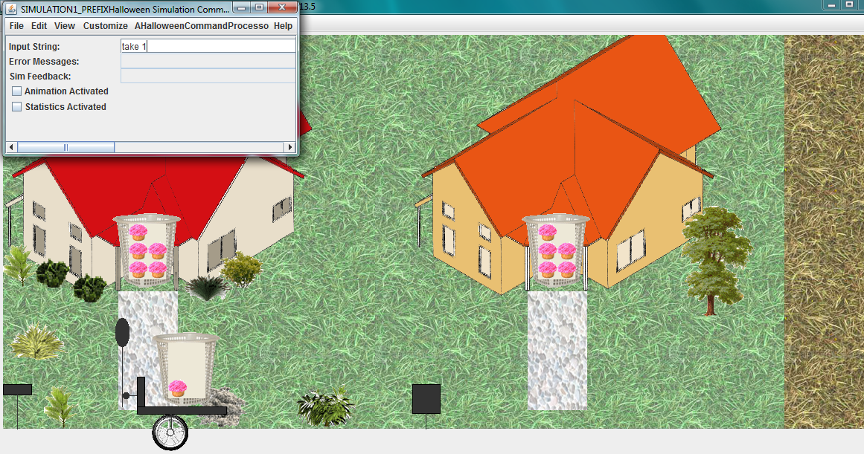
- Avatar takes one candy
Figure 1Beau's Non Distributed Simulation
If the feet of the avatar are in the path of a house, then the take and give commands can be used to transfer candies between the house and avatar containers. In addition, commands are provided to add and remove a house in the simulation, and undo or redo previous commands. The following is the syntax of the commands:

<Command> → <Move Command> | <Add Command> | <Remove Command> | <Take Command> | <Give Command> | <Undo Command> | <Redo Command>
<Move Command> → move <number> <number>
<Take Command> → take <number>
<Give Command> → give <number>
<Add Command> → addHouse
<Remove Command> → removeHouse
<Undo Command> → undo
<Redo Command> → redo

You can ignore most implementation details of the non distributed simulation. All you need to know is how to trap and execute a command entered by the user. I have created a Java program and Eclipse project, Coupled Halloween Simulations, which shows how this is done. It couples two simulations in the same process – your task will be to couple simulations in (possibly an arbitrary number of) processes – this means you must run a different program for each process. The project references both Beau’s code and a user-interface library I wrote, ObjectEditor, which is used by Beau’s code. All three pieces of code are available from the course home page. The Eclipse project must be uncompressed, while ObjectEditor and Beau’ code are also compressed, but can be used in this form as they are referenced as external libraries in the Eclipse project. You need to change the paths in the project in order to use them correctly.

At least one student wanted to control when the local user's command is processed. I have updated a new version both of the simulation and also the coupled simulation project to show that this can now be done. The simulation now checks with each registered vetoer if it should execute a command. If no veto occurs, it does the command and fires the event. You can use this to delay or deny a command execution.

Distributed Simulation

You should create a distributed version of this simulation by allowing the program to be run by two or more processes and coupling the processes in one or more ways. You are free to use any distributed abstraction (such as sockets, NIO, Web services, RMI) to create your implementation.

Some of the issues you need to address in order to create the distributed simulation are:
- What distributed abstractions do you use for inter-process communication? You will be using sockets in the next assignment and are free to use them in this assignment also if you don’t want to learn a different abstraction.
- Do you allow a fixed or arbitrary number of simulation processes to be coupled?
- How to these processes know about each other?
- Are there any processes other than the simulation processed involved in mediating the connection and communication between the simulation processes?
- How do you handle failure of one or more processes in the simulation?
- Are there special commands (such as locking and access control commands) entered by the user for controlling the nature of the distributed simulation?
- How exactly are the processes coupled, that is, what is the local and remote effect of a user command?
- What is the event flow to enable the coupling – trace the sequence of actions that take place in each process when a user command is entered?
- How are messages sent by different processed synchronized, if at all?
Also discuss any design/implementation decisions you have made, giving both the pros and cons of these choices.
Future assignments and class material will be addressing these issues in depth. Thus, you are free to address these in a simplistic manner – as mentioned before the only requirement is inter-process coupling of some form. These have been mentioned here for the more ambitious students who wish to try their own solutions to these problems early in the course.

Suggested Steps
In the class demos I demonstrated several features of the distributed simulation:
- Peer to peer, direct, communication between simulation processes.
- A central, session manager, process that allows simulation processes to rendezvous with each other.
- Ability to simulate network delays.
- Ability to order messages correctly in peer to peer communication with delays.
- Indirect communication among processes through a relayer.
- Easily change between consistent and inconsistent P2P communication.
- Easily switch between and P2P and relayed communication.
- Ability to give a latecomer the current state when it joins rather than the current state.
- Ability to replicate an integrated session manager and relayer for fault tolerance. There were several degrees of fault tolerance demonstrated. When a relaying session manager replica dies:
  - a new simulation process can connect to other simulation processes through some other replica session manager.
  - At the start of a request to join the session, the return value can be sent by another replica.
  - In the middle of a message relay section, after it has relayed messages to some simulation processes, the message is related to the remaining simulation processes.
These can server as a guide to what you do. As before, you have complete freedom in what exactly you do. Also here are some intermediate goals for you:
- On Sep 7, as I said in class, you should couple simulations in two different processes. You should also have a session manager allowing an arbitary number of processes to rendezvous with each other.
- On Sep 14, you should be able to simulate delays among different processes and show the ordering inconsistencies caused by these delays. You should also implement communication through a relayer and show that these inconsistencies do not occur in relayed communication.
- It is fairly likely that we will continue with this project for at least one more week and there will be another deadline on Sep 21. At this point, you should do a least two more features listed above.
- If we delay by one additional week, implement two more features.

Submission Instructions
For each submission date, submit a printed document (a) showing screen shots, or better, a YouTube video, demonstrating the working of your program, and (b) answering the questions above for the project done so far At the end of the assignment, I will see a demo from each of you. The folder dewan.cs.unc.edu/comp734 has a directory writeable by everyone, which you can use for submission.

